Lesson 2: Count and Compare Collections
- Let’s count and compare collections.

Warm-up: How Many Do You See: 10 and Some More
How many do you see?
How do you see them?
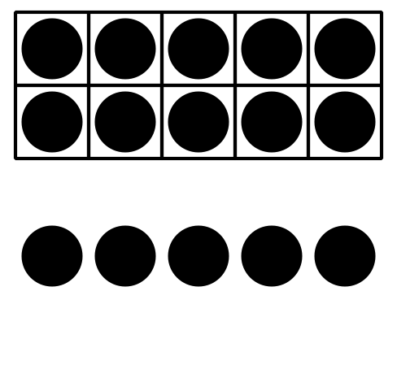
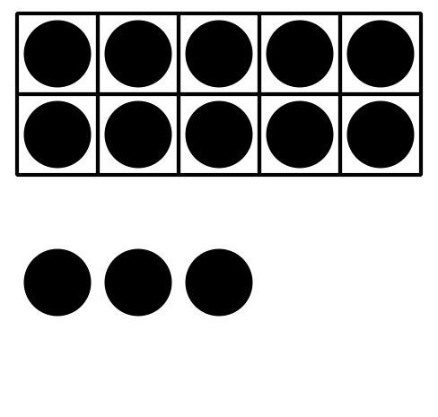
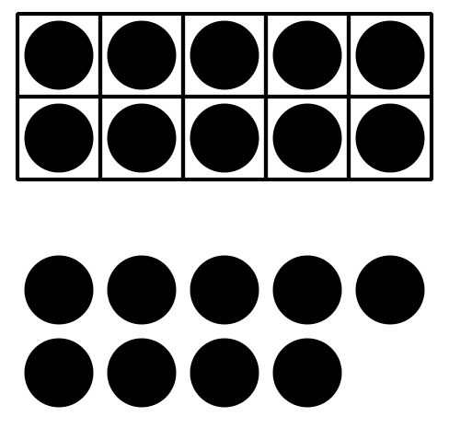

2.1: Counting Collections
How many objects are in your collection?
Show your thinking using drawings, numbers, or words.
_______________

2.2: Comparing Collections
How many objects are in your collection?
Show your thinking using drawings, numbers, or words.
_______________

2.3: Centers: Choice Time
Choose a center.
Less, Same, More
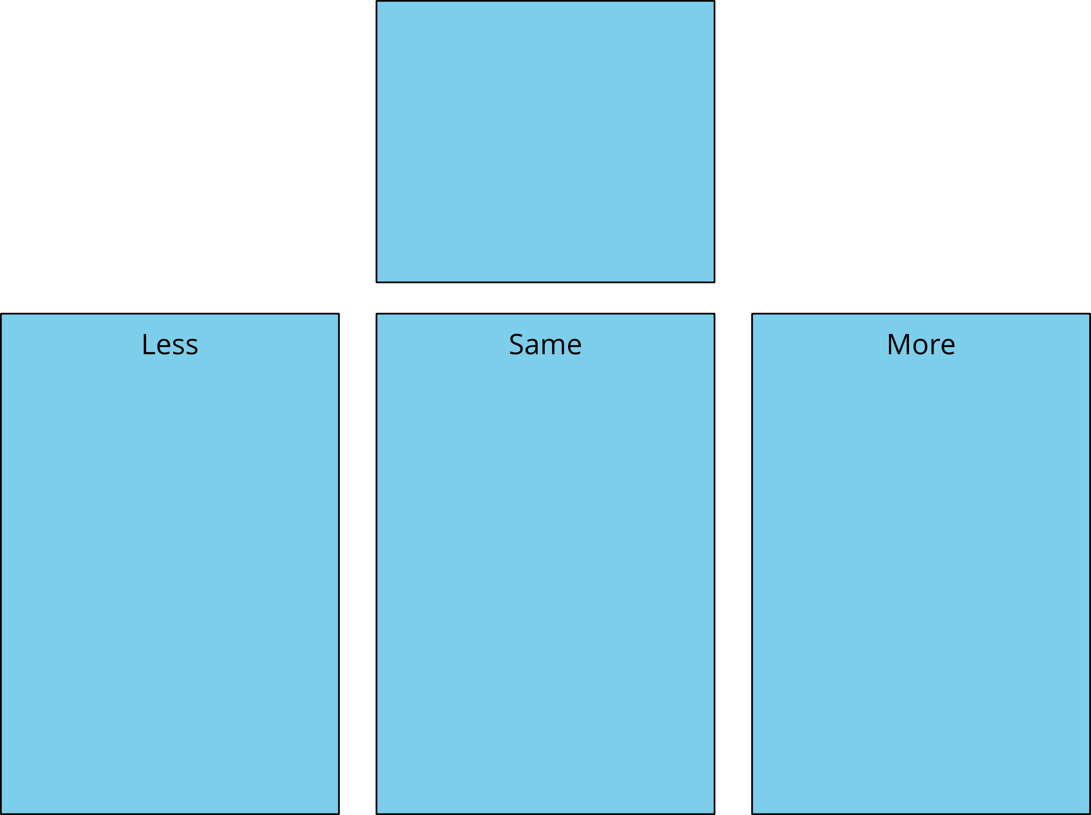
Math Fingers
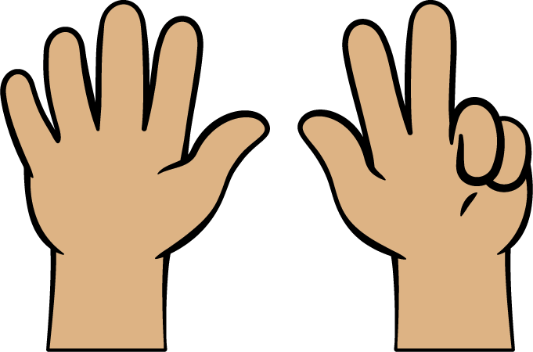
Tower Build
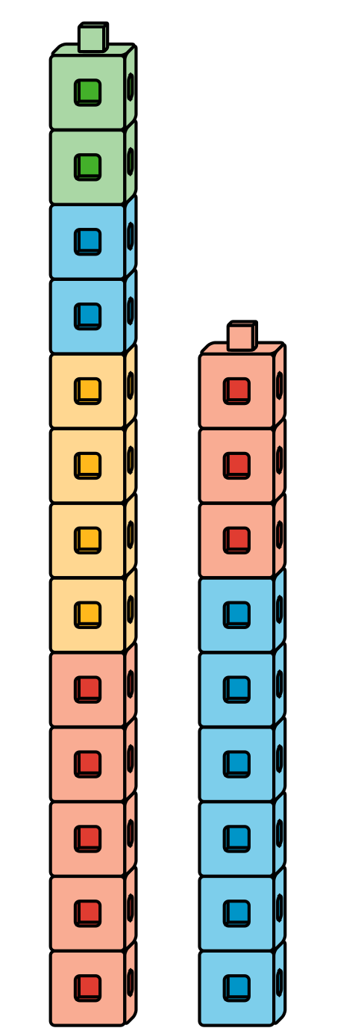
Math Stories
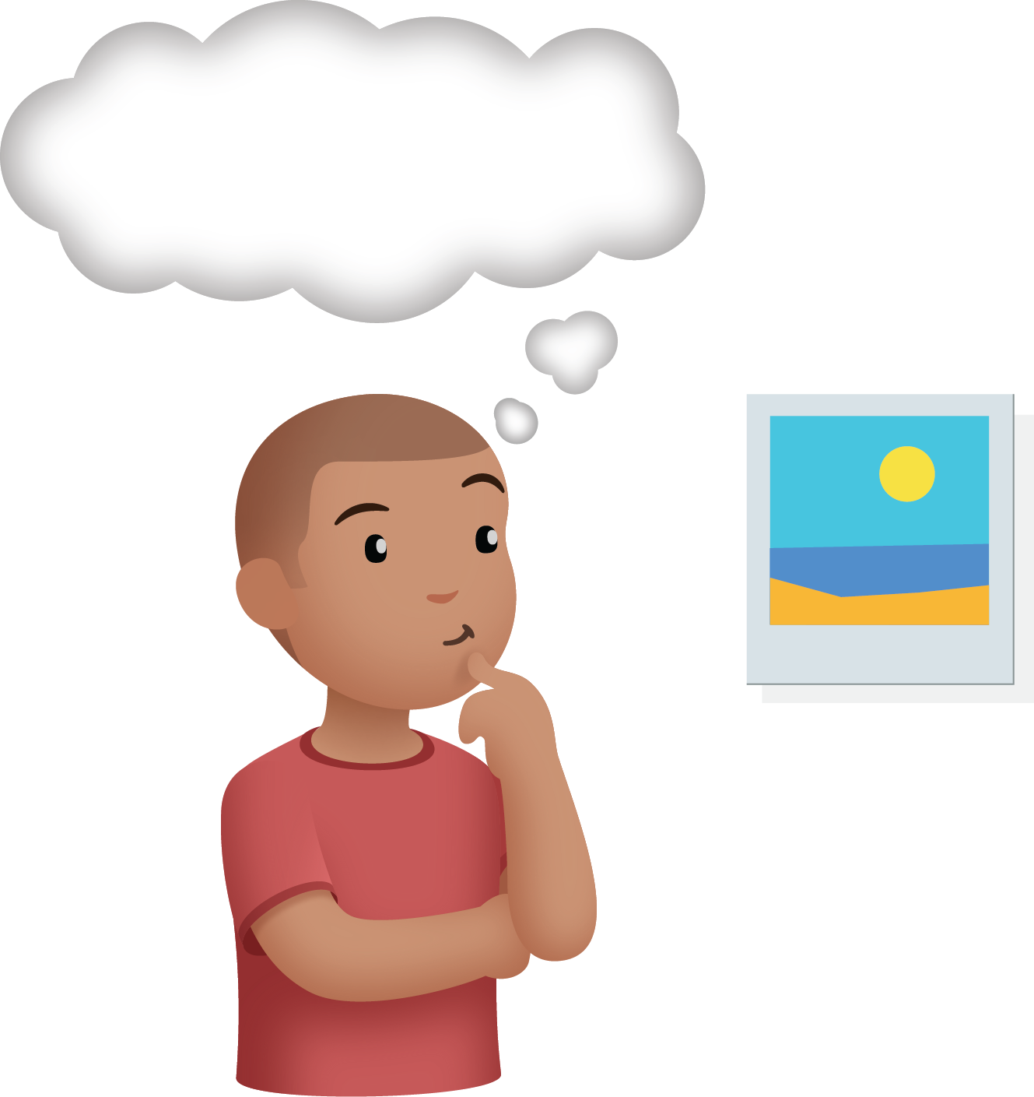
Which One
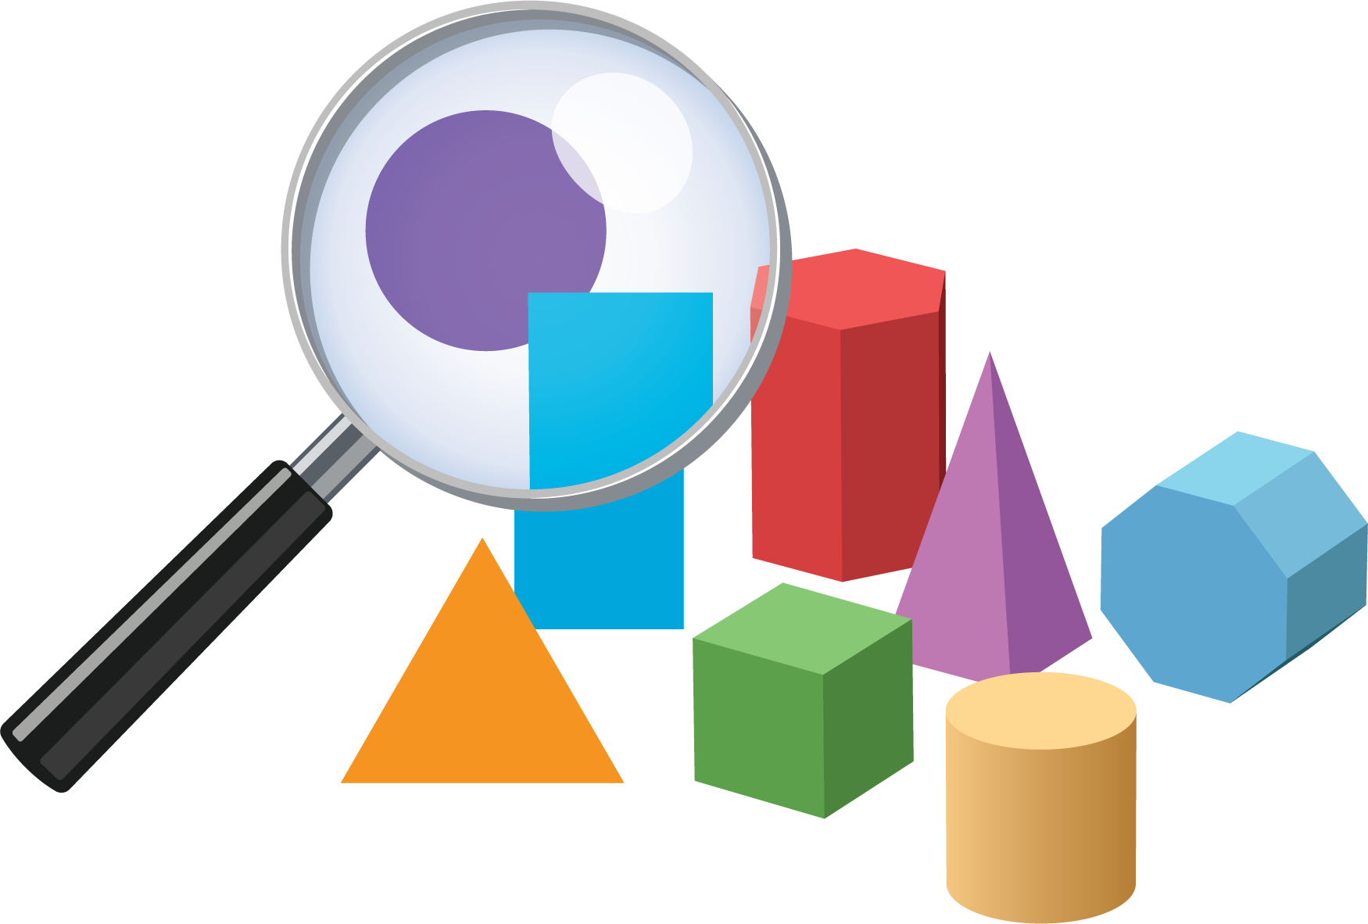
© CC BY 2021 Illustrative Mathematics®

