Lesson 12 Practice Problems
- Technology required
- The mean amount spent on daycare yearly by random samples of 10 families are listed.
- $7,213 | - $13,512 | - $6,543 | - $8,256 | - $9,106 | - $12,649 | - $10,256 | - $9,553
- $7,698 | - $10,156

- Use the values to estimate the mean amount spent on daycare yearly for the population, and provide a margin of error (round to the nearest dollar).
- Technology required
- 25 random samples of 30 people each were measured for their daily water usage. The mean for each sample is included in the dot plot.
- 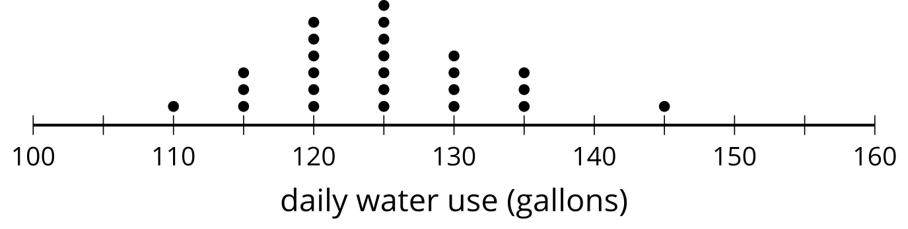
- Use the values to estimate the mean water usage for the population. What is the margin of error for this estimate based on these values? (Round to the nearest tenth of a gallon.)
- Select all of the values for the population mean that would be plausible based on an estimate of 105 cm with a margin of error of 21 cm.
  - 76 cm
  - 87 cm
  - 105 cm
  - 113 cm
  - 154 cm
- A normal curve with a mean of 70 and a standard deviation of 20 is shown. Shade the region under the curve between the mean and one standard deviation greater than the mean. How much of the data falls within the shaded region?
- 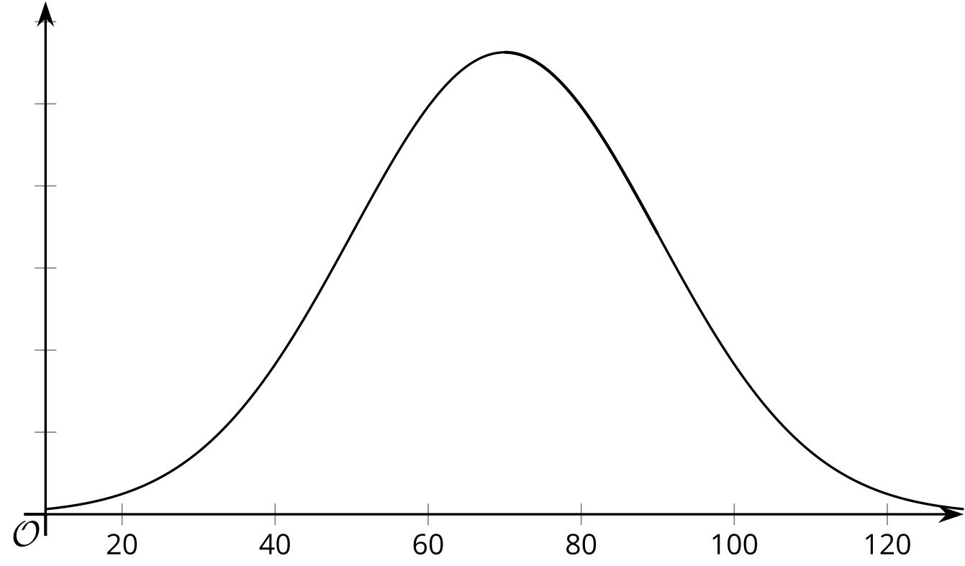
- (From Unit 7, Lesson 6.)
- Noah and Clare are studying the noise level, in decibels, outside of their school in the morning. They sample in 15 minute time periods in the morning to determine whether the noise level reaches 90 or more decibels. They each take a random sample to find the proportion of 15 minute time periods where the noise level reaches 90 or more decibels. Noah's sample contains 12 fifteen minute time periods, and Clare’s sample contains 25 fifteen minute time periods.
- After collecting data, they run 200 simulations each to determine an estimate for the proportion of the 15 minute time periods where the noise level reaches 90 or more decibels. How do you think Noah's reported margin of error compares to Clare’s? Explain your reasoning.
- (From Unit 7, Lesson 11.)
- Two activists are both interested in finding the proportion of people in town who are recycling. They each collect a random sample and use the proportion of people who recycle in the sample to run 200 simulations to determine a margin of error. The first activist claims the proportion of people in town who recycle is 0.65 with a margin of error of 0.08. The second activist claims the proportion of people in town who recycle is 0.57 with a margin of error of 0.02.
  - Why do you think the estimated proportion of people in town who recycle is different for the 2 activists?
  - Why do you think the margin of error is different for the 2 activists?
- (From Unit 7, Lesson 11.)
© CC BY 2019 by Illustrative Mathematics®

