Unit 1 Lesson 9: What is Your Favorite ______________ ?

WU How Many Do You See: Dots and More Dots (Warm up)

Student Task Statement
How many do you see?
How do you see them?
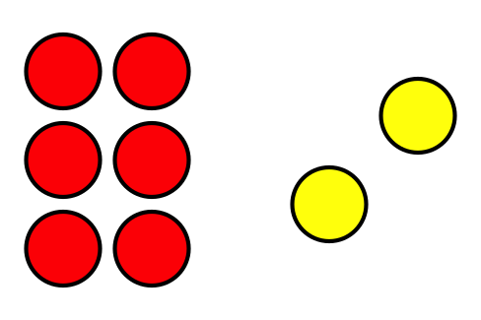
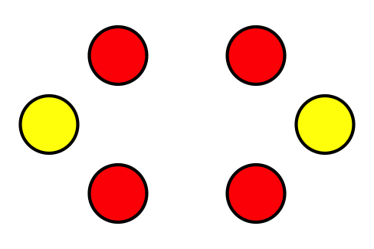
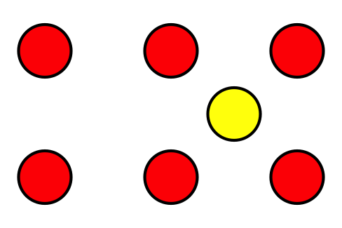

1 A Class Survey

Student Task Statement
What is your favorite ___________________________________________?
If you chose ___________________, take a red cube.
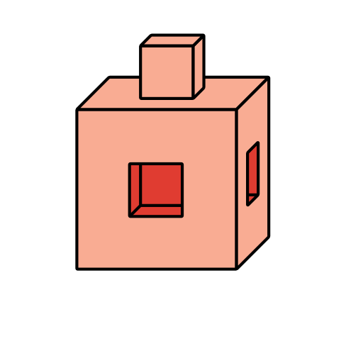
If you chose ___________________, take a blue cube.
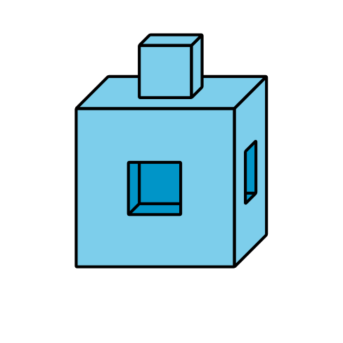
If you chose ___________________, take a yellow cube.
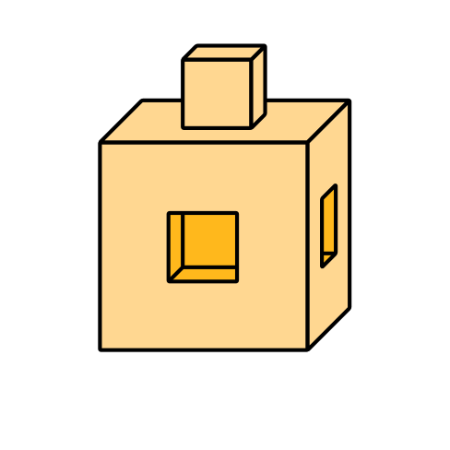

2 Show Our Class Data

Student Task Statement
Show the survey data about our class’s favorite
___________________________________________________.

3 Different Ways to Show Data

Student Task Statement
© CC BY 2021 Illustrative Mathematics®

