Unit 4 Lesson 5: Subtract with Objects

WU How Many Do You See: Subtraction (Warm up)

Student Task Statement
How many do you see?
How do you see them?
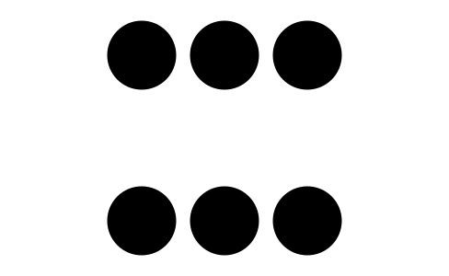

1 Subtract Counters

Student Task Statement
- Count out 8 counters.
Take away 3 counters.
- There are
- counters left.
- Count out 10 counters.
Take away 6 counters.
- There are
- counters left.
- Count out 7 counters.
Take away 1 counter.
- There are
- counters left.
- Count out 9 counters.
Take away 3 counters.
- There are
- counters left.

2 Introduce 5-Frames, Subtract

Student Task Statement

3 Centers: Choice Time

Student Task Statement
Choose a center.
5-frames
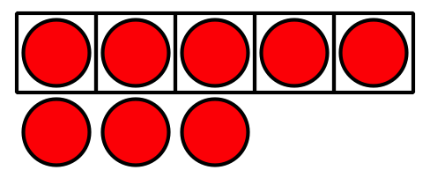
Roll and Add
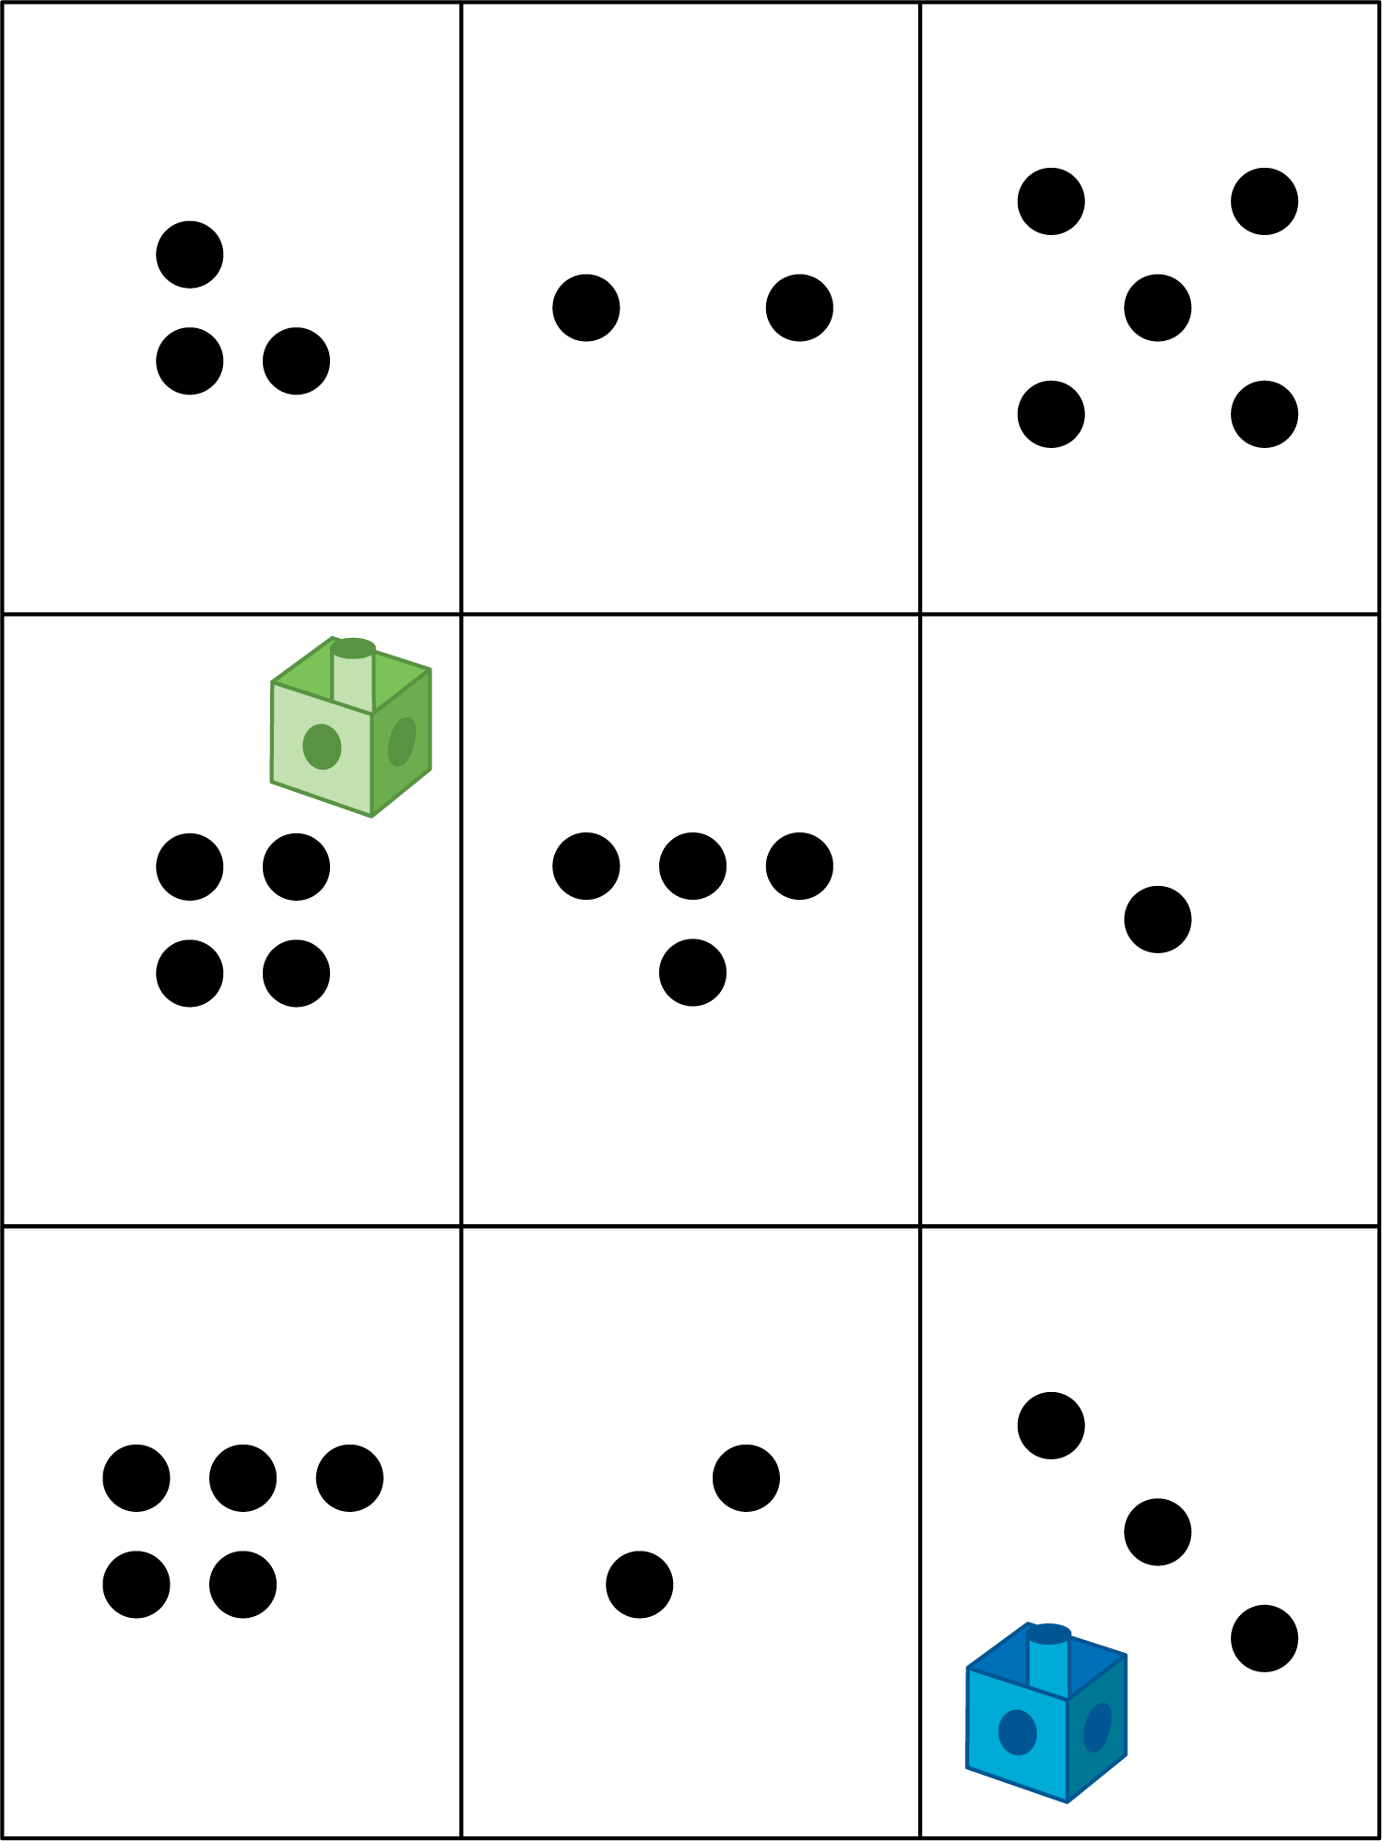
Math Libs
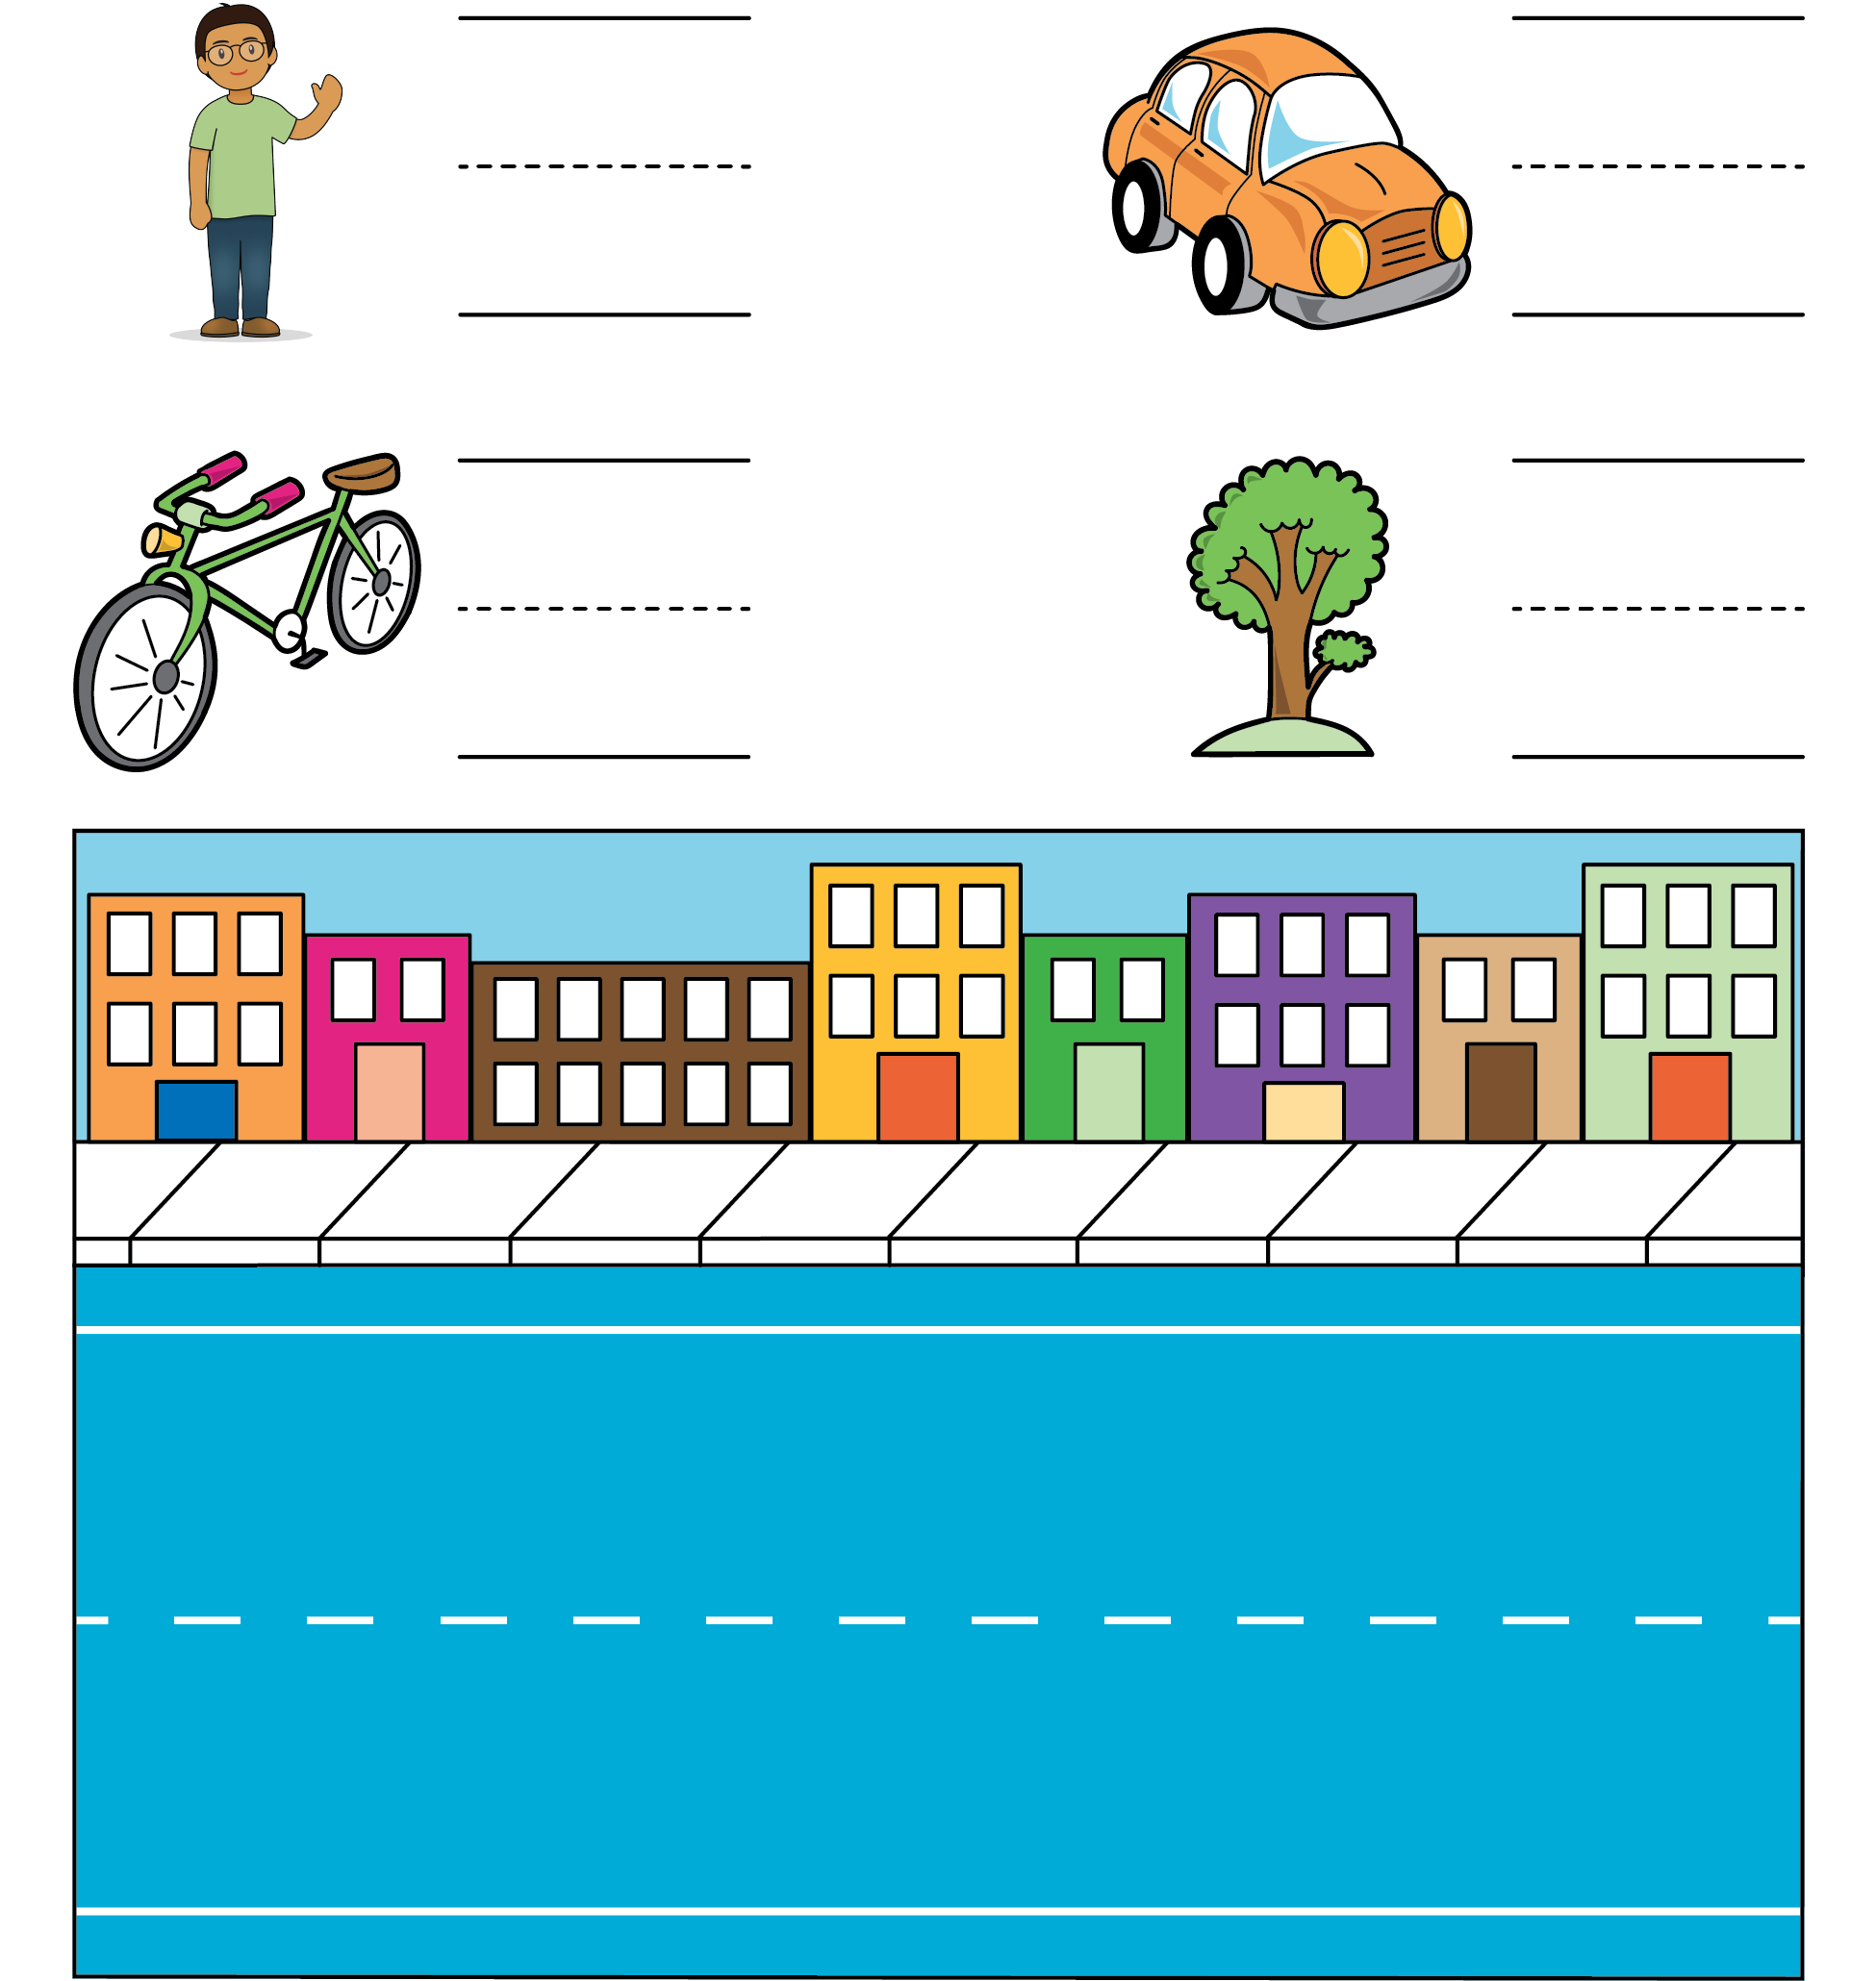
Match Mine
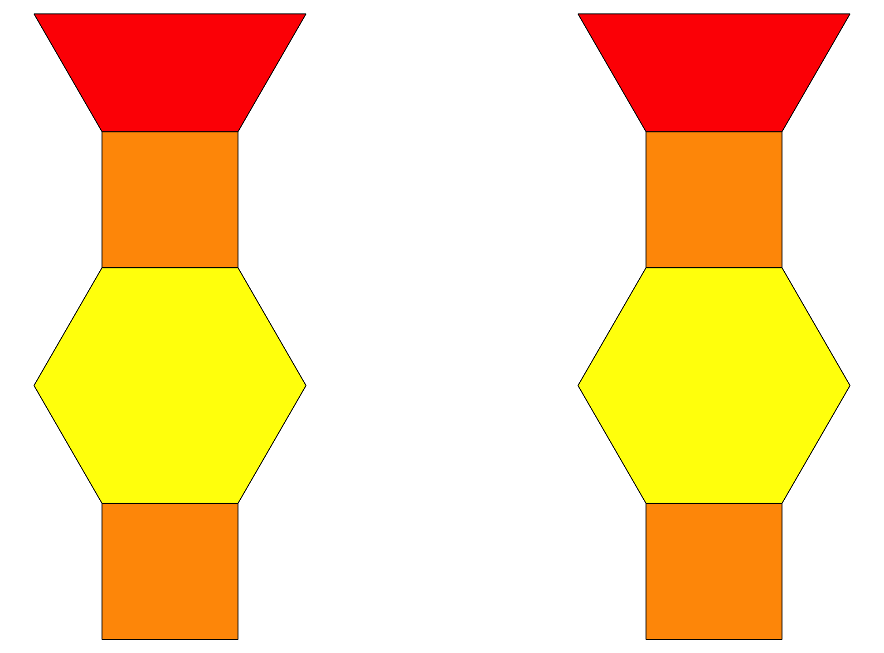
© CC BY 2021 Illustrative Mathematics®

