Lesson 12: Multiply Multiples of Ten

Warm-up: Notice and Wonder: Tens
What do you notice? What do you wonder?
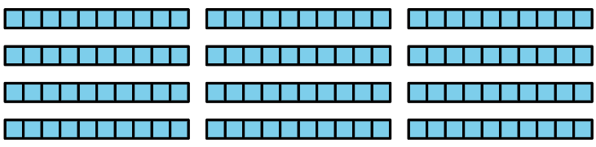

12.1: A Whole Lot of Dollars
Six friends are playing a board game that uses play money. The paper bills come in $5, $10, $20, $50, and $100.
- Every player received $100 to start. Which of the following could be the bills that a player received?
- Write an expression to represent the play bills and the amount in dollars.
- bills | - expression | - dollar amount
- one $100 bill
- four $20 bills
- ten $10 bills
- ten $5 bills
- five $20 bills
- twenty $10 bills
- twenty $5 bills
- two $50 bills
- At one point in the game, Noah had to pay Lin $150. He gave her that amount using the same type of bill.
  - Which bill and how many of it could Noah have used to make $150? Name all the possibilities.
  - Write an expression for each way that Noah could have paid Lin.
- The table shows what the players had at the end of the game. The person with the most money wins. Who won the game?
- Write an expression to represent the bills each person has and the amount in dollars.
- player | - bills | - expression | - dollar amount
- Andre | - nine $10 bills and ten $5 bills
- Clare | - fourteen $10 bills
- Jada | - ten $10 bills and three $50 bills
- Lin | - eight $20 bills
- Noah | - six $50 bills
- Tyler | - twenty-one $10 bills

12.2: Two Strategies
- Two students used base-ten blocks to find the value of $8×30$.
- 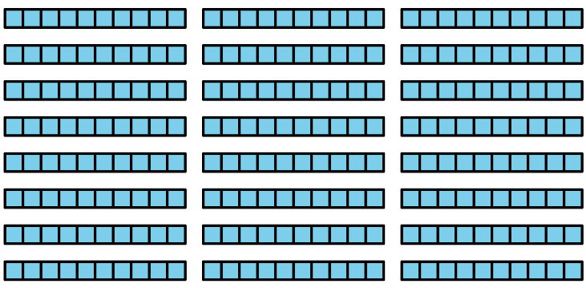
  - Jada counted: 30, 60, 90, 120, 150, 180, 210, 240, and said the answer is 240.
  - Kiran said he knew $8×3$ is 24, then found $24×10$ to get 240.
- How are Jada and Kiran’s strategies alike? How are they different?
- Find the value of each expression. Explain or show your reasoning.
  - $5×60$
  - $8×50$
  - $4×30$
  - $7×40$
  - $9×20$
© CC BY 2021 Illustrative Mathematics®

