Lesson 4: Numerical Patterns
- Let’s explore numerical patterns.

Warm-up: Which One Doesn’t Belong: Stacked Squares
Which one doesn’t belong?
A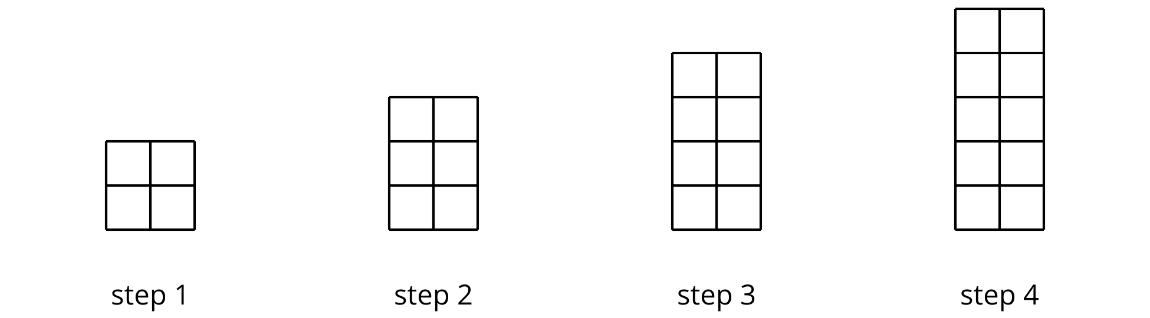
B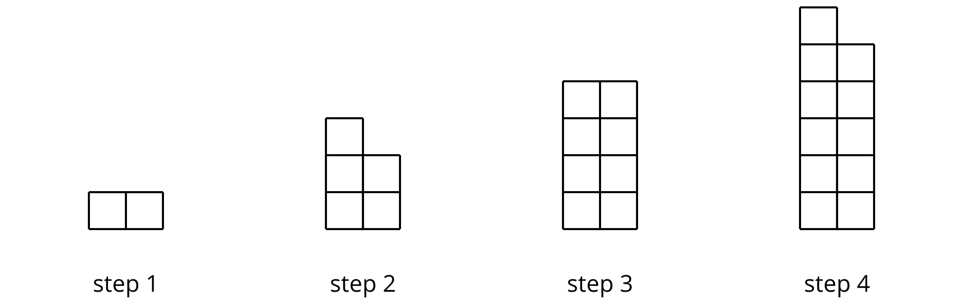
C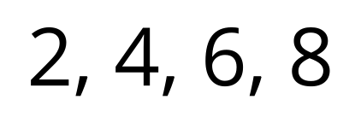
D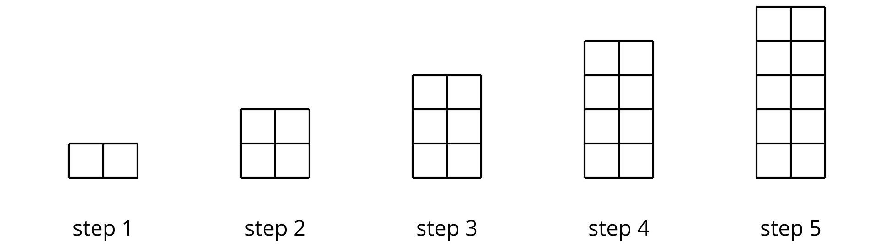

4.1: Count by 10 and by 9
Andre’s class is choral counting by 10 and then by 9. The left column shows the numbers they say when counting by 10.
- Complete the right column with the first ten numbers the class will say when counting by 9.
- What patterns do you notice about the features of the numerical patterns? Make at least two observations about each list of numbers.
- counting by 10 | - counting by 9
- 10
- 20
- 30
- 40
- 50
- 60
- 70
- 80
- 90
- 100
- For the numbers in the “counting by 10” column, why do you think:
  - the digits in the tens place change the way they do?
  - the digits in the ones place are the way they are?
- For the numbers in the “counting by 9” column, why do you think the digits in the ones place change the way they do? Explain your reasoning.

4.2: Count by 99
Andre’s class did a choral count by 99. Here are the first six numbers they said.
- Study the list of numbers. Make at least 3 observations about features of the pattern.
- counting by 99
- 99
- 198
- 297
- 396
- 495
- 594
- Extend the list with the next four multiples of 99. Be prepared to discuss how you know what numbers to write.
- Why do you think the digits in the numbers change the way they do?
- 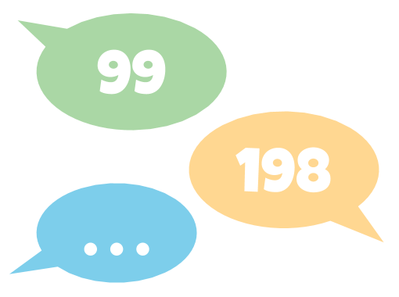

4.3: Count by 15
Elena counted by 15 and recorded the numbers she counted:
15 | 30 | 45 | 60 | 75 | 90

- Write the next four numbers she’d record if she kept going.
- What patterns do you see? Describe as many as you can.
- Choose one pattern that you noticed and explain why you think it happens.
- Could 250 be a number that Elena calls out if she continued to count by 15? Explain or show your reasoning.

Section Summary
Section Summary
In this section, we looked at different patterns of shapes and patterns of numbers. We saw shapes that grew or repeated by certain rules, and we used numbers to help us see how the shapes changed. Here are some examples of the patterns:
- Shapes that grow by a rule: add 1 row of equal-size squares
- Area of the rectangle: 4, 6, 8, 10, . . .
- Shapes that repeat by a rule: triangle, circle, triangle, square, repeat
- 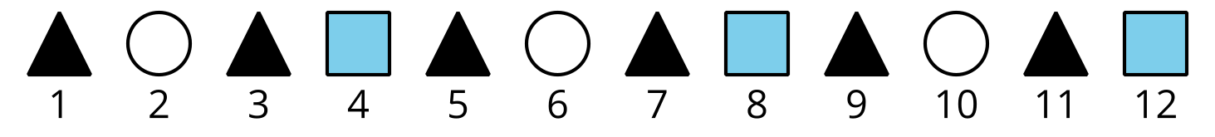
- ▲ : 1, 3, 5, 7, . .
- ◯ : 2, 6, 10, . . .
- ▨ : 4, 8, 12, . . .
- Rectangles that change by a rule: increase the length of the rectangle by 5 inches
- 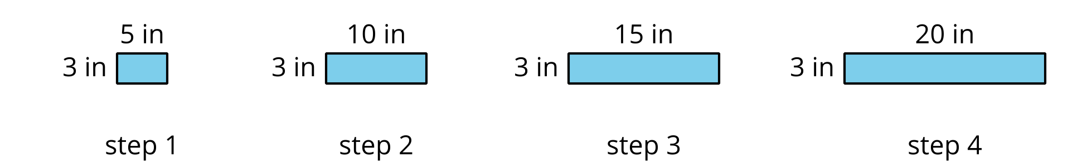
- Side length:
5, 10, 15, 20, . . .
- Area:
15, 30, 45, 60, . . .
- Perimeter:
16, 26, 36, 46, . . .
- Numbers that change by a rule
  - Add 9: 9, 18, 27, 36, 45
  - Add 10: 10, 20, 30, 40, 50
  - Add 99: 99, 198, 297, 396, 495
  - Add 100: 100, 200, 300, 400, 500
We learned to extend the patterns by first finding their rule. Sometimes we can use addition and multiplication to represent a rule and then extend the pattern. Other times we can see how the digits in the numbers change to make predictions.
© CC BY 2021 Illustrative Mathematics®

