Lesson 4: Coordinate Moves

4.1: Translating Coordinates
Select all of the translations that take Triangle T to Triangle U. There may be more than one correct answer.
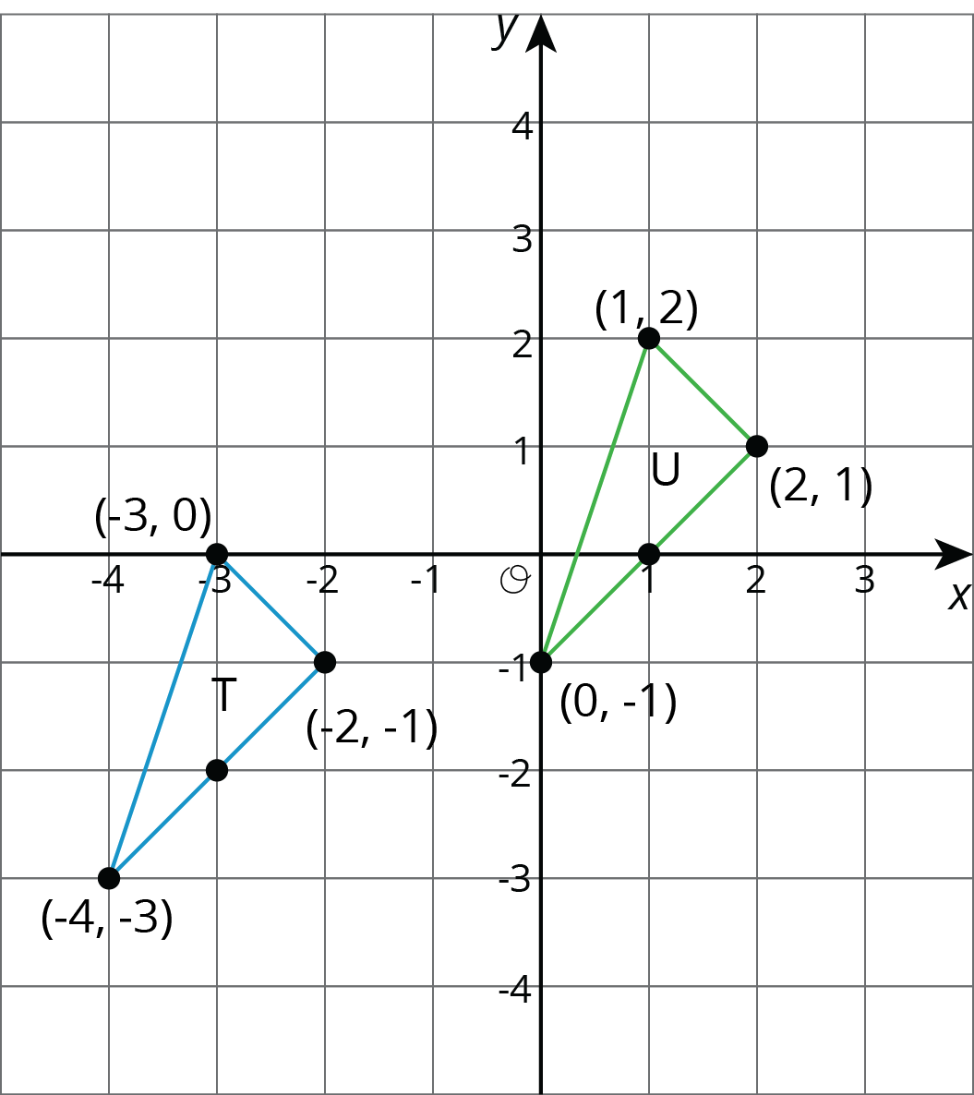
- Translate $(\text{-}3,0)$ to $(1,2)$.
- Translate $(2,1)$ to $(\text{-}2,\text{-}1)$.
- Translate $(\text{-}4,\text{-}3)$ to $(0,\text{-}1)$.
- Translate $(1,2)$ to $(2,1)$.

4.2: Reflecting Points on the Coordinate Plane
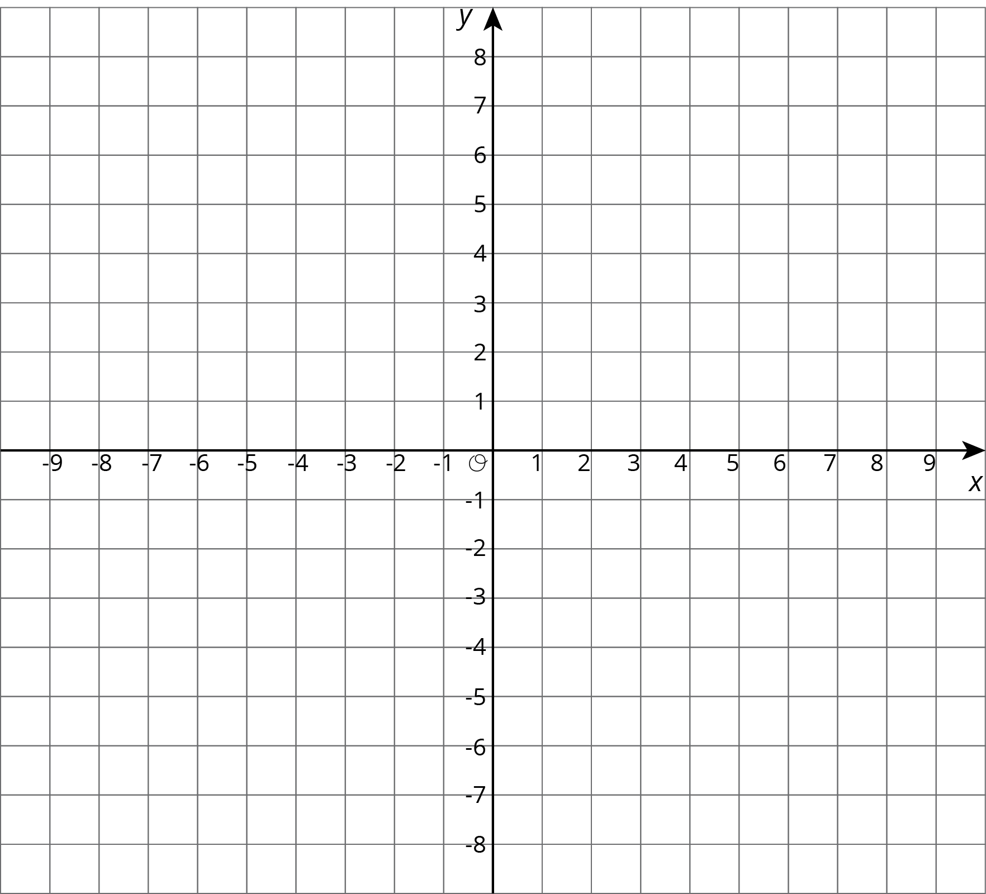
- Here is a list of points $\begin{matrix}A & =(0.5,4) & B & =(\text{-}4,5) & C & =(7,\text{-}2) & D & =(6,0) & E & =(0,\text{-}3) \\ & & & & & & & & & \end{matrix}$ On the coordinate plane:
  - Plot each point and label each with its coordinates.
  - Using the $x$-axis as the line of reflection, plot the image of each point.
  - Label the image of each point with its coordinates.
  - Include a label using a letter. For example, the image of point $A$ should be labeled $A^{′}$.
- If the point $(13,10)$ were reflected using the $x$-axis as the line of reflection, what would be the coordinates of the image? What about $(13,\text{-}20)$? $(13,570)$? Explain how you know.
- The point $R$ has coordinates $(3,2)$.
  - Without graphing, predict the coordinates of the image of point $R$ if point $R$ were reflected using the $y$-axis as the line of reflection.
  - Check your answer by finding the image of $R$ on the graph.
  - 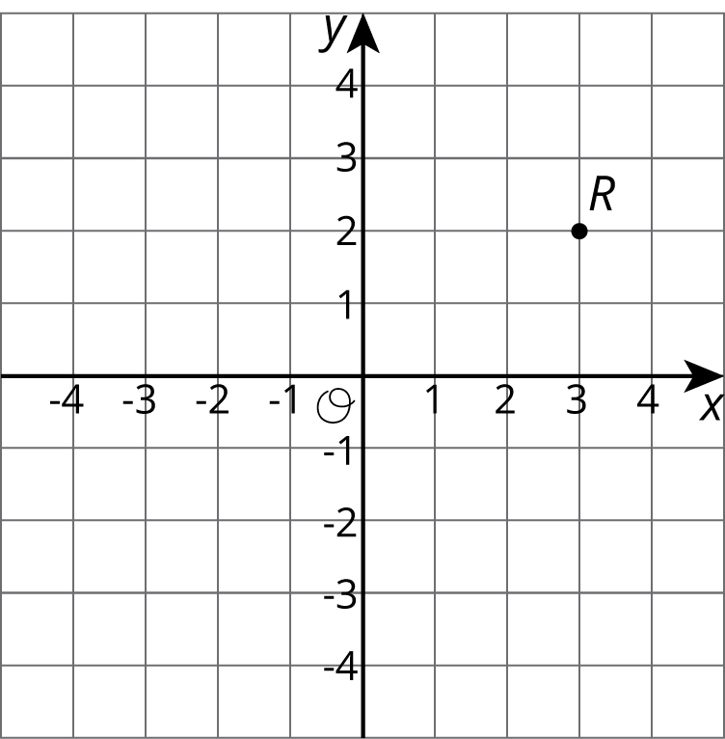
  - Label the image of point $R$ as $R^{′}$.
  - What are the coordinates of $R^{′}$?
- Suppose you reflect a point using the $y$-axis as line of reflection. How would you describe its image?

4.3: Transformations of a Segment
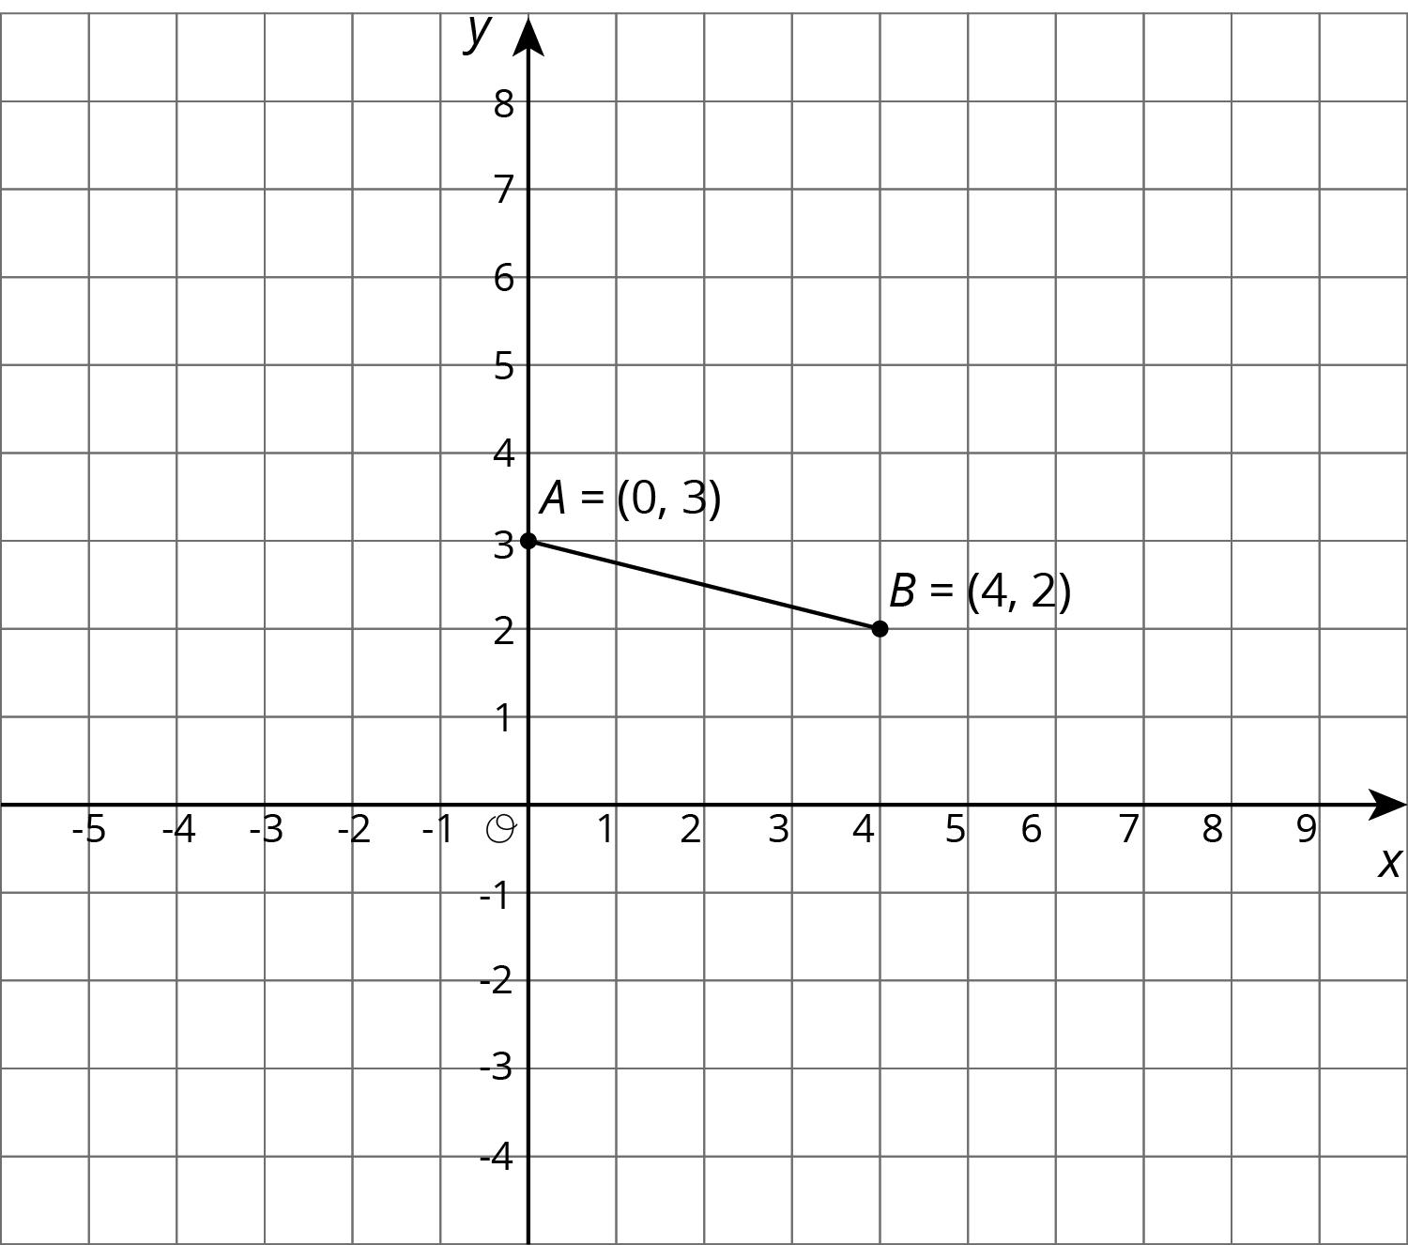
Apply each of the following transformations to segment $AB$.
- Rotate segment $AB$ 90 degrees counterclockwise around center $B$. Label the image of $A$ as $C$. What are the coordinates of $C$?
- Rotate segment $AB$ 90 degrees counterclockwise around center $A$. Label the image of $B$ as $D$. What are the coordinates of $D$?
- Rotate segment $AB$ 90 degrees clockwise around $(0,0)$. Label the image of $A$ as $E$ and the image of $B$ as $F$. What are the coordinates of $E$ and $F$?
- Compare the two 90-degree counterclockwise rotations of segment $AB$. What is the same about the images of these rotations? What is different?

Are you ready for more?
Suppose $EF$ and $GH$ are line segments of the same length. Describe a sequence of transformations that moves $EF$ to $GH$.

Lesson 4 Summary
We can use coordinates to describe points and find patterns in the coordinates of transformed points.
We can describe a translation by expressing it as a sequence of horizontal and vertical translations. For example, segment $AB$ is translated right 3 and down 2.
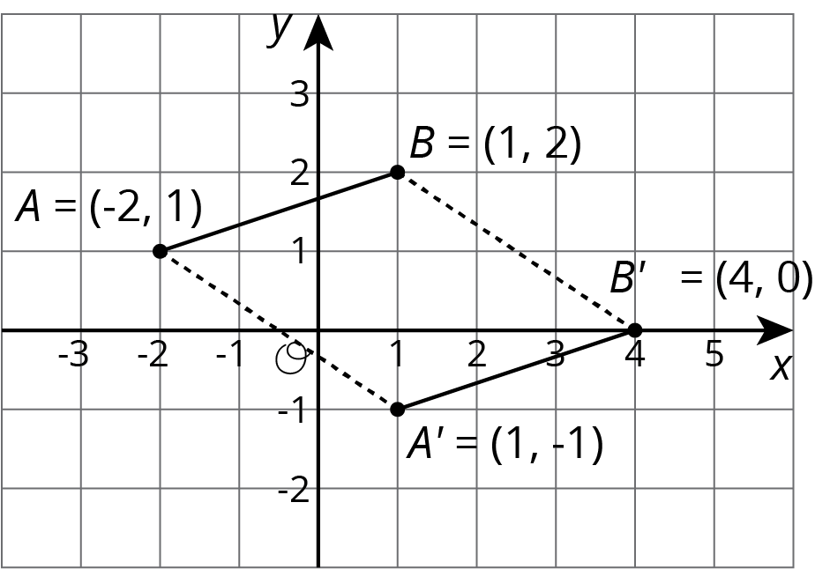
Reflecting a point across an axis changes the sign of one coordinate. For example, reflecting the point $A$ whose coordinates are $(2,\text{-}1)$ across the $x$-axis changes the sign of the $y$-coordinate, making its image the point $A^{′}$ whose coordinates are $(2,1)$. Reflecting the point $A$ across the $y$-axis changes the sign of the $x$-coordinate, making the image the point $A^{″}$ whose coordinates are $(\text{-}2,\text{-}1)$.
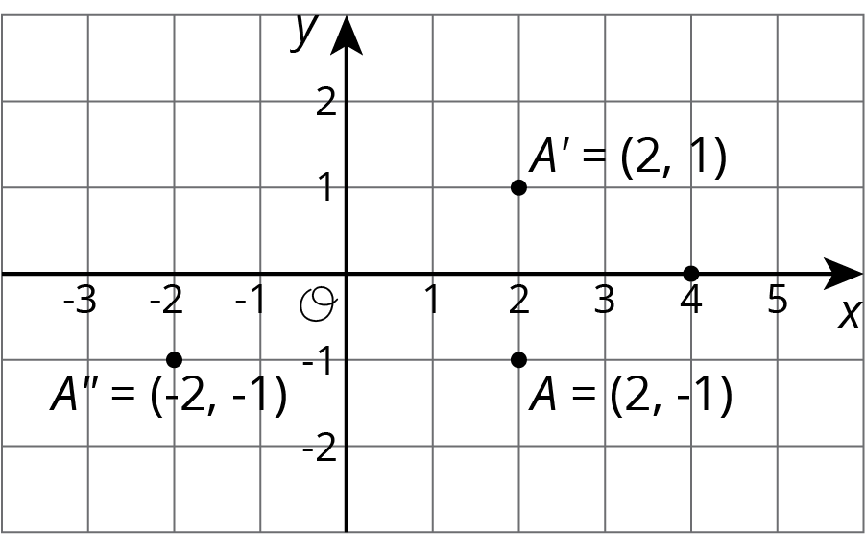
Reflections across other lines are more complex to describe.
We don’t have the tools yet to describe rotations in terms of coordinates in general. Here is an example of a ${90}^{∘}$ rotation with center $(0,0)$ in a counterclockwise direction.
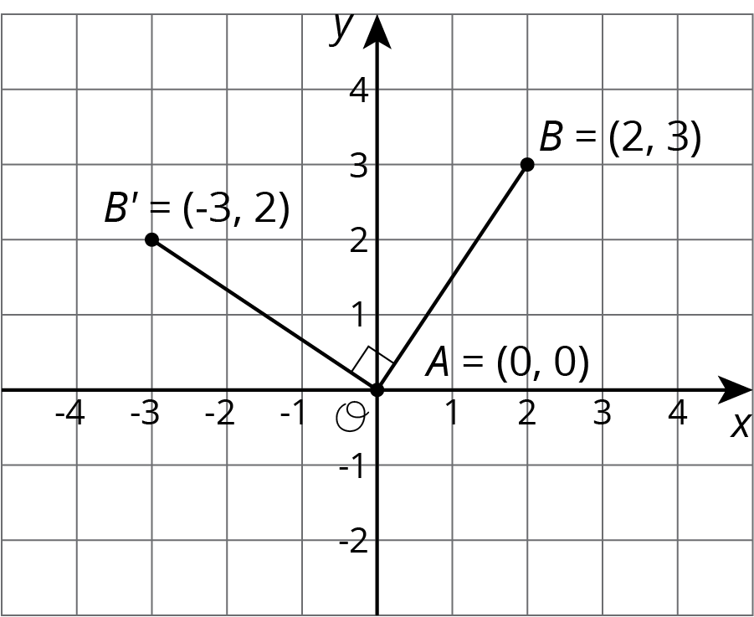
Point $A$ has coordinates $(0,0)$. Segment $AB$ was rotated ${90}^{∘}$ counterclockwise around $A$. Point $B$ with coordinates $(2,3)$ rotates to point $B^{′}$ whose coordinates are $(\text{-}3,2)$.
© CC BY Open Up Resources. Adaptations CC BY IM.

