Unit 8 Lesson 4: Estimating Probabilities Through Repeated Experiments

1 Decimals on the Number Line (Warm up)

Student Task Statement
- Locate and label these numbers on the number line.
  - 0.5
  - 0.75
  - 0.33
  - 0.67
  - 0.25
- Choose one of the numbers from the previous question. Describe a game in which that number represents your probability of winning.

2 In the Long Run

Images for Launch
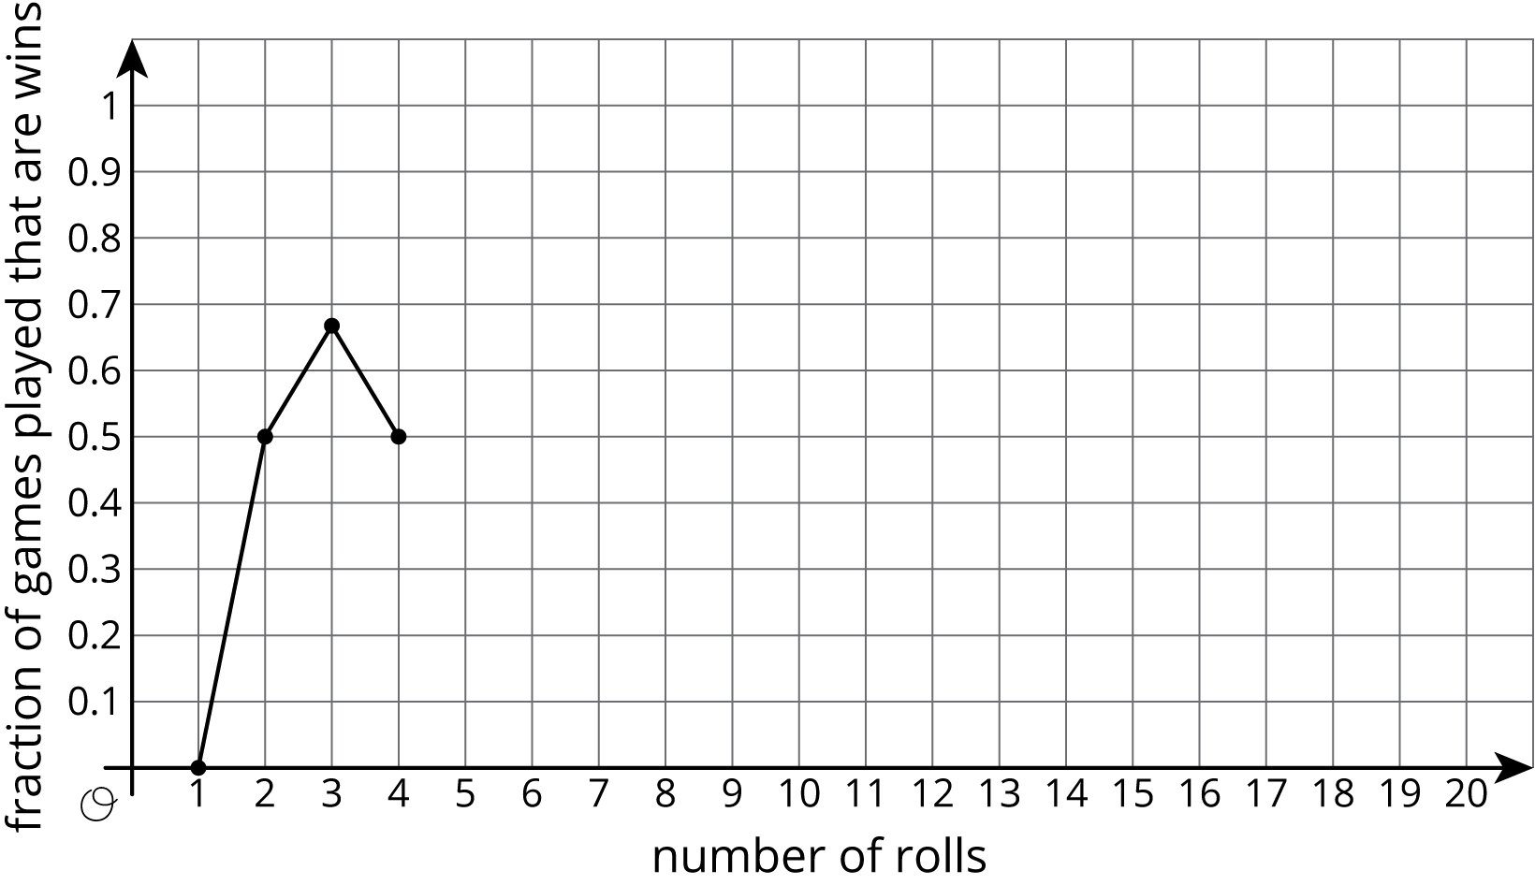

Student Task Statement
Mai plays a game in which she only wins if she rolls a 1 or a 2 with a standard number cube.
- List the outcomes in the sample space for rolling the number cube.
- What is the probability Mai will win the game? Explain your reasoning.
- If Mai is given the option to flip a coin and win if it comes up heads, is that a better option for her to win?
- With your group, follow these instructions 10 times to create the graph.
  - One person rolls the number cube. Everyone records the outcome.
  - Calculate the fraction of rolls that are a win for Mai so far. Approximate the fraction with a decimal value rounded to the hundredths place. Record both the fraction and the decimal in the last column of the table.
  - On the graph, plot the number of rolls and the fraction that were wins.
  - Pass the number cube to the next person in the group.
- roll | - outcome | - total number of  wins for Mai | - fraction of games  played that are wins
- 1
- 2
- 3
- 4
- 5
- 6
- 7
- 8
- 9
- 10
- 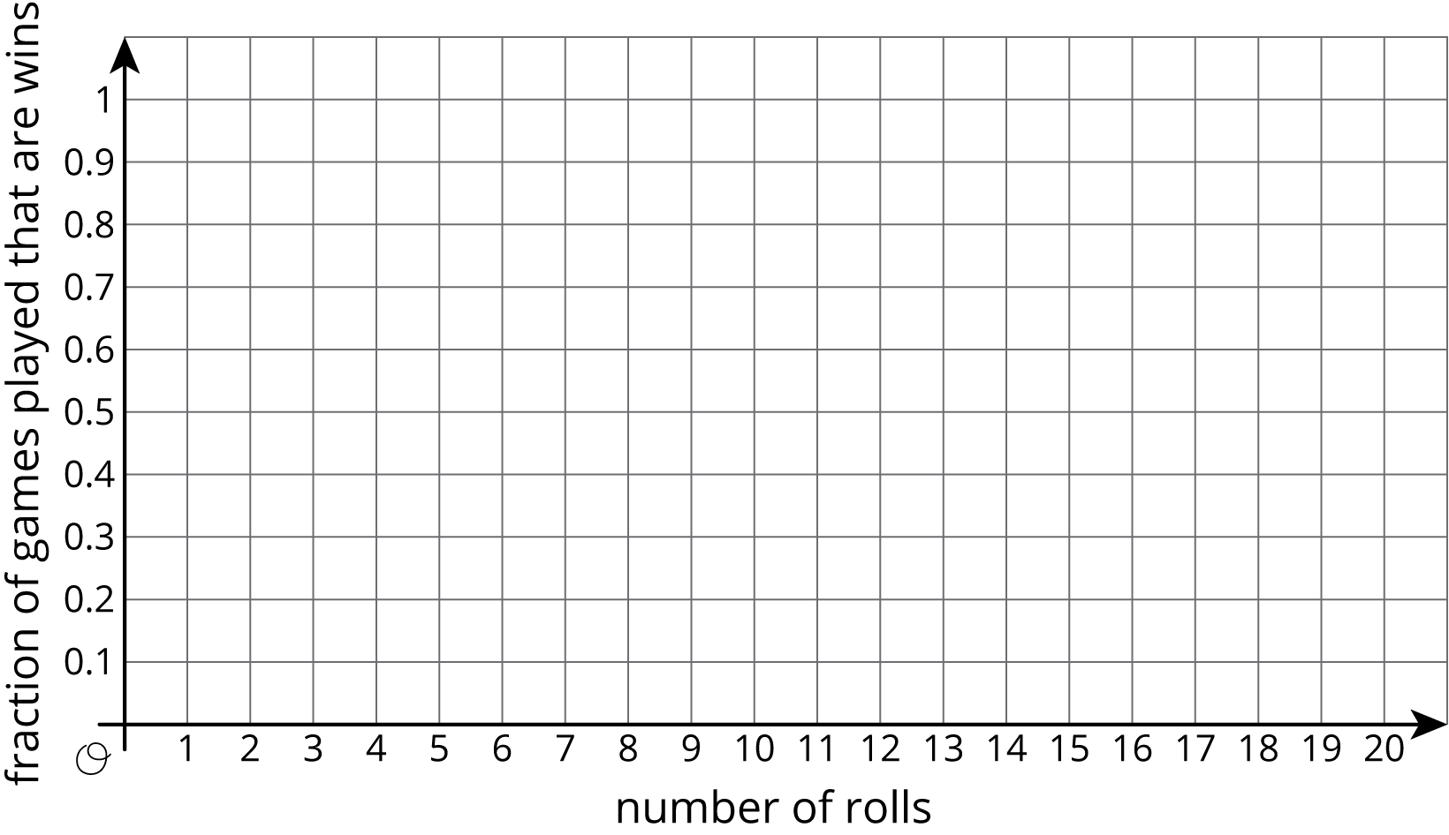
- What appears to be happening with the points on the graph?

  - After 10 rolls, what fraction of the total rolls were a win?
  - How close is this fraction to the probability that Mai will win?
- Roll the number cube 10 more times. Record your results in this table and on the graph from earlier.
- roll | - outcome | - total number of  wins for Mai | - fraction of games  played that are wins
- 11
- 12
- 13
- 14
- 15
- 16
- 17
- 18
- 19
- 20

  - After 20 rolls, what fraction of the total rolls were a win?
  - How close is this fraction to the probability that Mai will win?

3 Due For a Win

Student Task Statement
- For each situation, do you think the result is surprising or not? Is it possible? Be prepared to explain your reasoning.
  - You flip the coin once, and it lands heads up.
  - You flip the coin twice, and it lands heads up both times.
  - You flip the coin 100 times, and it lands heads up all 100 times.
- If you flip the coin 100 times, how many times would you expect the coin to land heads up? Explain your reasoning.
- If you flip the coin 100 times, what are some other results that would not be surprising?
- You’ve flipped the coin 3 times, and it has come up heads once. The cumulative fraction of heads is currently $\frac{1}{3}$. If you flip the coin one more time, will it land heads up to make the cumulative fraction $\frac{2}{4}$?
© CC BY Open Up Resources. Adaptations CC BY IM.

