Lesson 8: Ratios and Rates With Fractions
Let’s calculate some rates with fractions.

8.1: Number Talk: Dividing by Half as Much
Find each quotient mentally.
$743÷10$
$743÷5$
$99÷3$
$99÷\frac{3}{2}$

8.2: Using an Algorithm to Divide Fractions
Calculate each quotient. Show your thinking and be prepared to explain your reasoning.
- $\frac{8}{9}÷4$
- $\frac{3}{4}÷\frac{1}{2}$
- $3\frac{1}{3}÷\frac{2}{9}$
- $\frac{9}{2}÷\frac{3}{8}$
- $6\frac{2}{5}÷3$
- After biking $5\frac{1}{2}$ miles, Jada has traveled $\frac{2}{3}$ of the length of her trip. How long (in miles) is the entire length of her trip? Write an equation to represent the situation, and then find the answer.

Are you ready for more?
Suppose you have a pint of grape juice and a pint of milk. You pour 1 tablespoon of the grape juice into the milk and mix it up. Then you pour 1 tablespoon of this mixture back into the grape juice. Which liquid is more contaminated?

8.3: A Train is Traveling at . . .
A train is traveling at a constant speed and goes 7.5 kilometers in 6 minutes. At that rate:
- How far does the train go in 1 minute?
- How far does the train go in 100 minutes?
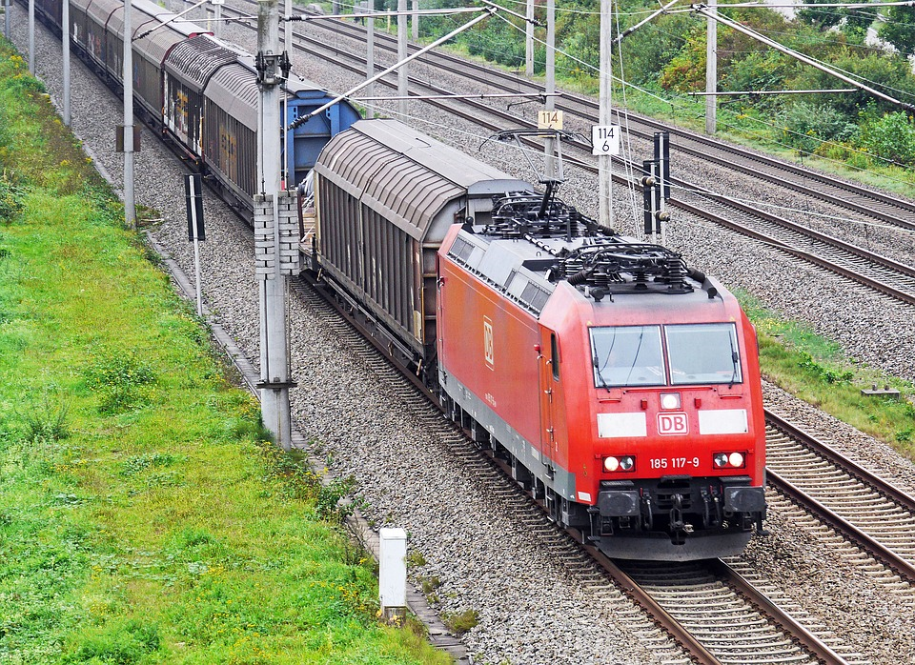

8.4: Comparing Running Speeds
Lin ran $2\frac{3}{4}$ miles in $\frac{2}{5}$ of an hour. Noah ran $8\frac{2}{3}$ miles in $\frac{4}{3}$ of an hour.
- Pick one of the questions that was displayed, but don’t tell anyone which question you picked. Find the answer to the question.
- When you and your partner are both done, share the answer you got (do not share the question) and ask your partner to guess which question you answered. If your partner can’t guess, explain the process you used to answer the question.
- Switch with your partner and take a turn guessing the question that your partner answered.

Are you ready for more?
Nothing can go faster than the speed of light, which is 299,792,458 meters per second. Which of these are possible?
- Traveling a billion meters in 5 seconds.
- Traveling a meter in 2.5 nanoseconds. (A nanosecond is a billionth of a second.)
- Traveling a parsec in a year. (A parsec is about 3.26 light years and a light year is the distance light can travel in a year.)

Lesson 8 Summary
There are 12 inches in a foot, so we can say that for every 1 foot, there are 12 inches, or the ratio of feet to inches is $1:12$. We can find the unit rates by dividing the numbers in the ratio:
$1÷12=\frac{1}{12}$
so there is $\frac{1}{12}$ foot per inch.
$12÷1=12$
so there are 12 inches per foot.
The numbers in a ratio can be fractions, and we calculate the unit rates the same way: by dividing the numbers in the ratio. For example, if someone runs $\frac{3}{4}$ mile in $\frac{11}{2}$ minutes, the ratio of minutes to miles is $\frac{11}{2}:\frac{3}{4}$.
$\frac{11}{2}÷\frac{3}{4}=\frac{22}{3}$, so the person’s
pace is $\frac{22}{3}$ minutes per mile.
$\frac{3}{4}÷\frac{11}{2}=\frac{3}{22}$, so the person’s
speed is $\frac{3}{22}$ miles per minute.
© CC BY Open Up Resources. Adaptations CC BY IM.

