Lesson 6 Practice Problems
- Priya says “I can figure out $5^{0}$ by looking at other powers of 5. $5^{3}$ is 125, $5^{2}$ is 25, then $5^{1}$ is 5.”
  - What pattern do you notice?
  - If this pattern continues, what should be the value of $5^{0}$? Explain how you know.
  - If this pattern continues, what should be the value of $5^{\text{-}1}$? Explain how you know.
- Select all the expressions that are equivalent to $4^{\text{-}3}$.
  - -12
  - $2^{\text{-}6}$
  - $\frac{1}{4^{3}}$
  - $\left(\frac{1}{4}\right)⋅\left(\frac{1}{4}\right)⋅\left(\frac{1}{4}\right)$
  - 12
  - $\left(\text{-}4\right)⋅\left(\text{-}4\right)⋅\left(\text{-}4\right)$
  - $\frac{8^{\text{-}1}}{2^{2}}$
- Write each expression using a single exponent.
  - $\frac{5^{3}}{5^{6}}$
  - ${\left({14}^{3}\right)}^{6}$
  - $8^{3}⋅8^{6}$
  - $\frac{{16}^{6}}{{16}^{3}}$
  - ${\left({21}^{3}\right)}^{\text{-}6}$
- Andre sets up a rain gauge to measure rainfall in his back yard. On Tuesday, it rains off and on all day.
  - He starts at 10 a.m. with an empty gauge when it starts to rain.
  - Two hours later, he checks, and the gauge has 2 cm of water in it.
  - It starts raining even harder, and at 4 p.m., the rain stops, so Andre checks the rain gauge and finds it has 10 cm of water in it.
  - While checking it, he accidentally knocks the rain gauge over and spills most of the water, leaving only 3 cm of water in the rain gauge.
  - When he checks for the last time at 5 p.m., there is no change.
- Graph A
- 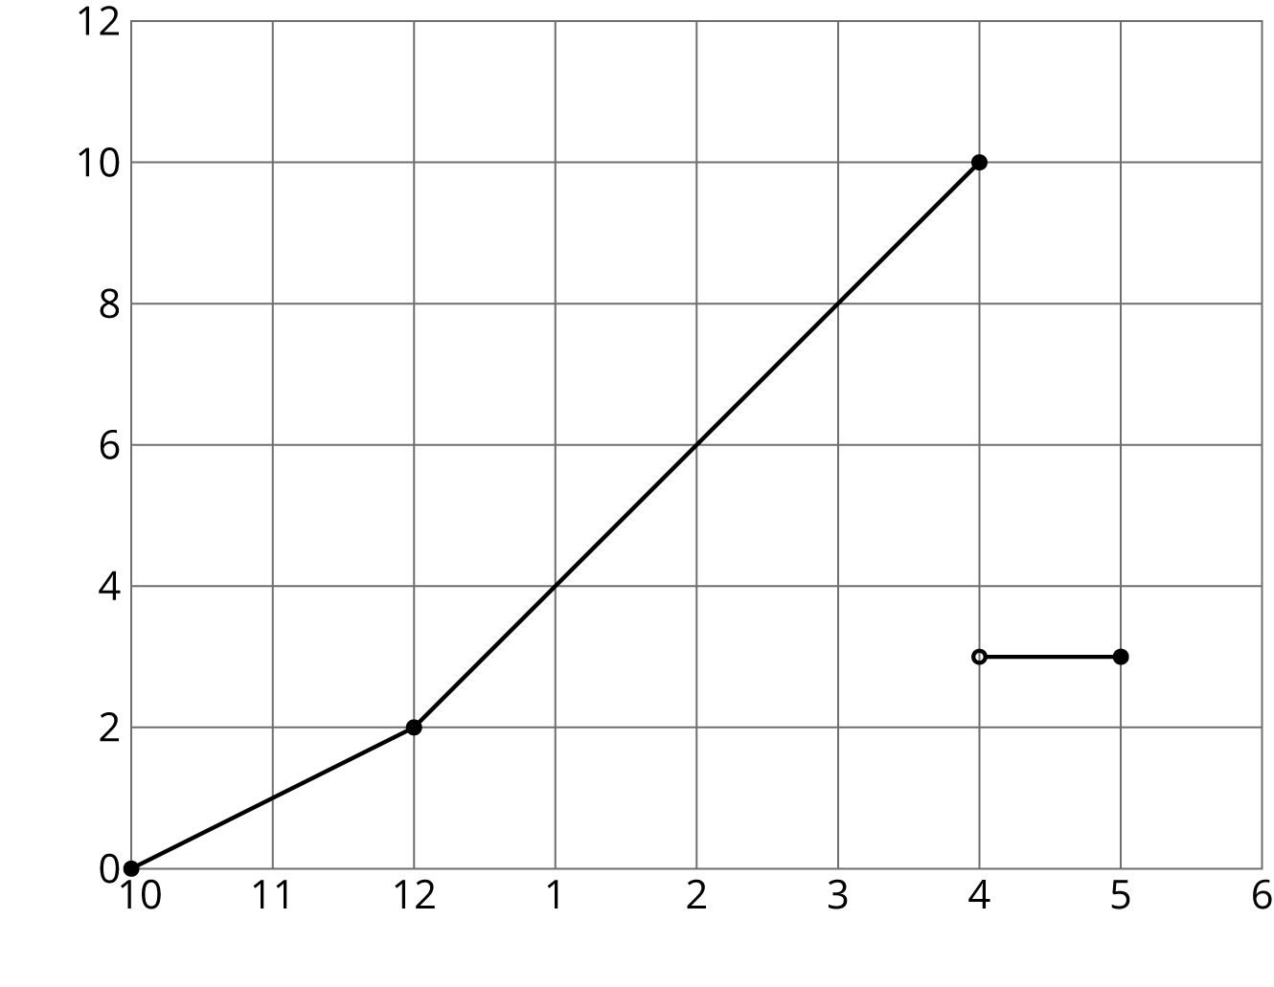
- Graph B
- 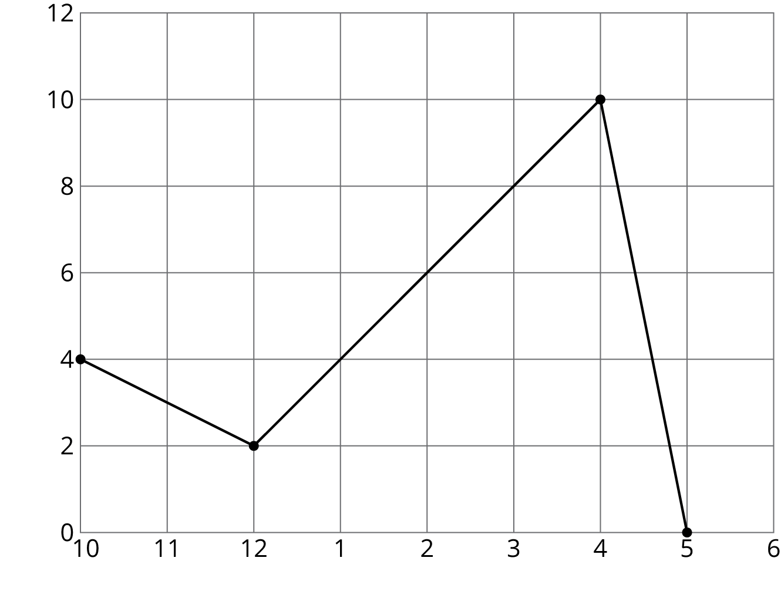
  - Which of the two graphs could represent Andre’s story? Explain your reasoning.
  - Label the axes of the correct graph with appropriate units.
  - Use the graph to determine how much total rain fell on Tuesday.
- (From Unit 6, Lesson 6.)
© CC BY Open Up Resources. Adaptations CC BY IM.

