Unit 1 Lesson 1: Explore Connecting Cubes

WU Notice and Wonder: Connecting Cubes (Warm up)

Student Task Statement
What do you notice?
What do you wonder?
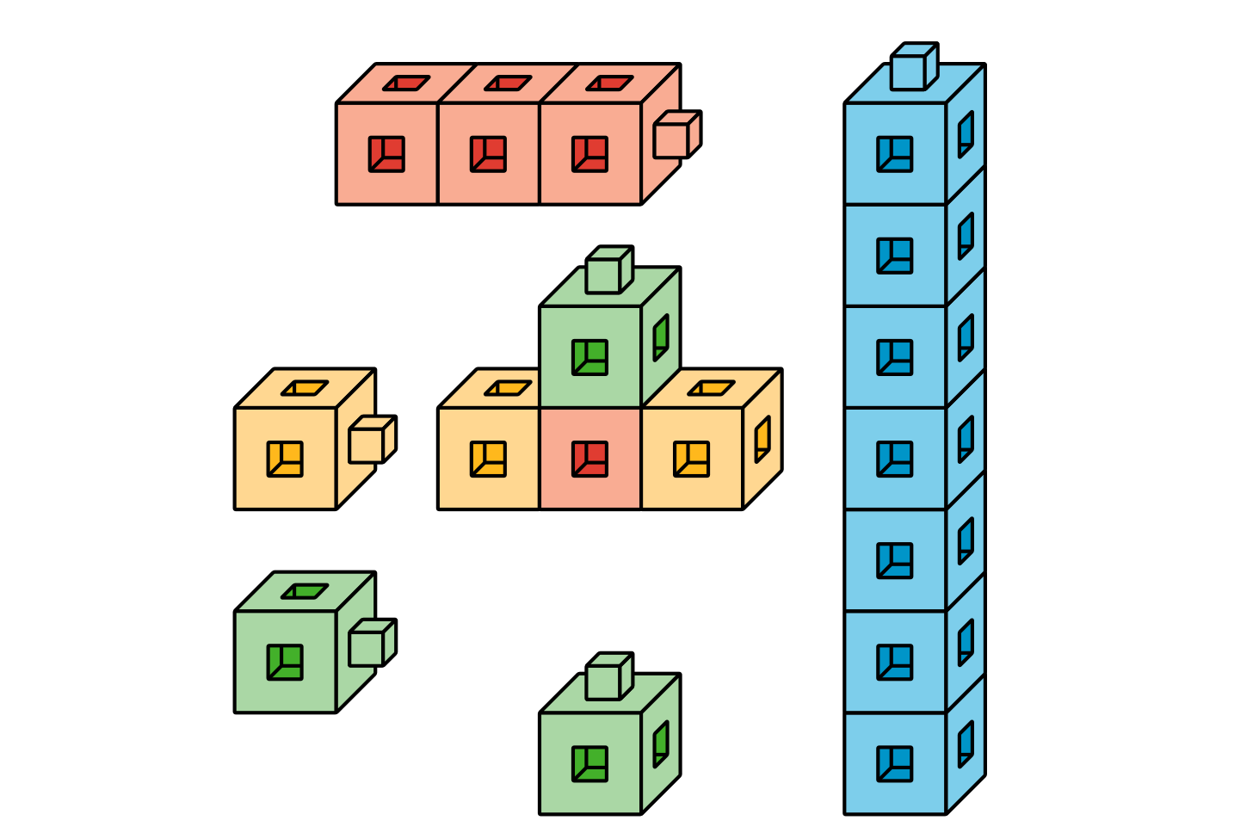

1 Introduce Connecting Cubes, Explore

Student Task Statement

Images for Activity Synthesis
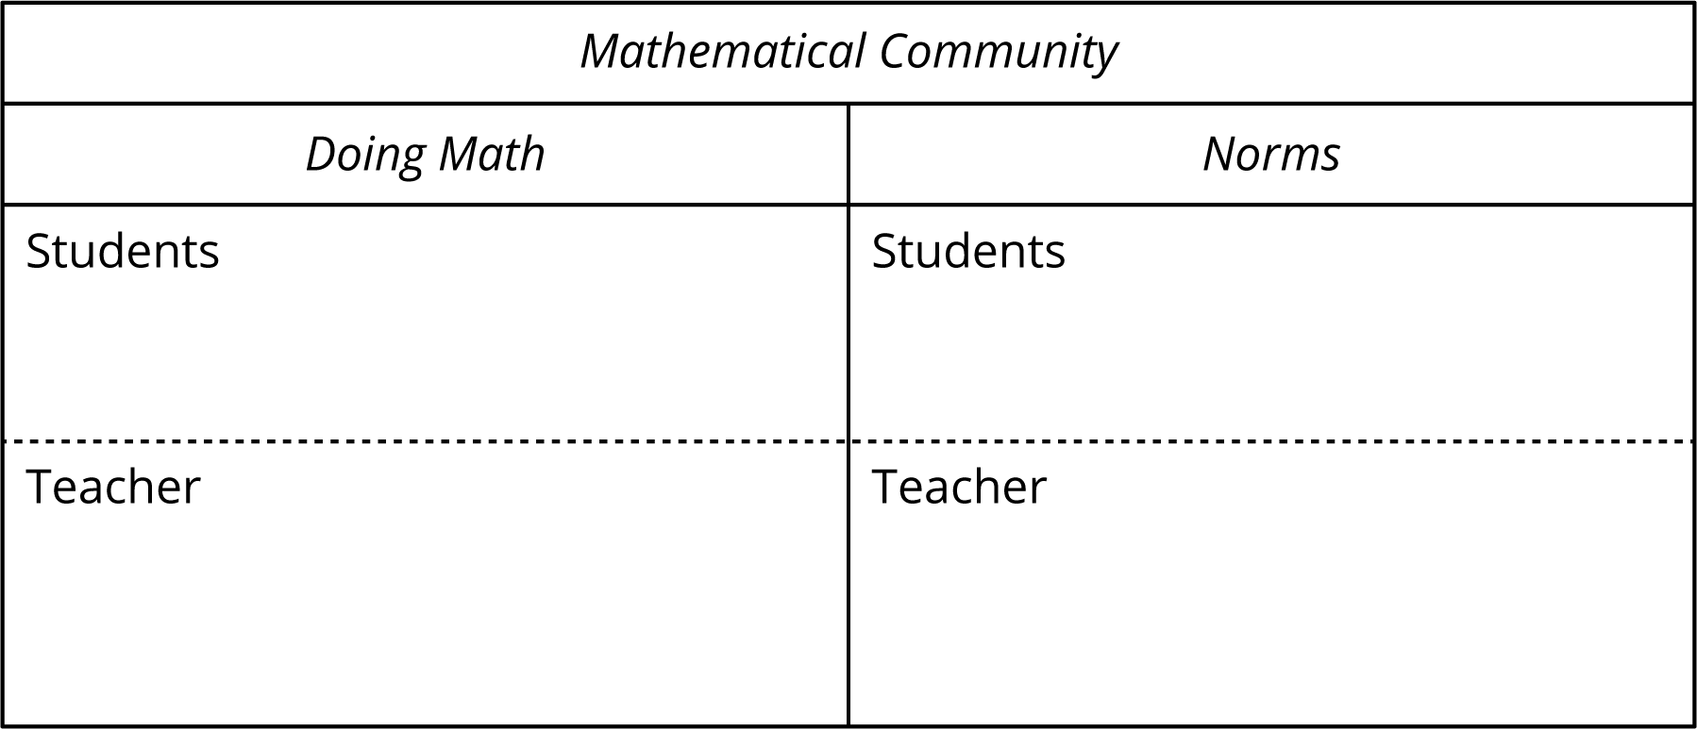
© CC BY 2021 Illustrative Mathematics®

