Lesson 2 Practice Problems
- Large cheese pizzas cost $5 each and large one-topping pizzas cost $6 each.
- Write an equation that represents the total cost, $T$, of $c$ large cheese pizzas and $d$ large one-topping pizzas.
- Jada plans to serve milk and healthy cookies for a book club meeting. She is preparing 12 ounces of milk and 4 cookies per person. Including herself, there are 15 people in the club. A package of cookies contains 24 cookies and costs $4.50.
- A 1-gallon jug of milk contains 128 ounces and costs $3. Let $n$ represent number of people in the club, $m$ represent the ounces of milk, $c$ represent the number of cookies, and $b$ represent Jada's budget in dollars.
- Select all of the equations that could represent the quantities and constraints in this situation.
  - $m=12\left(15\right)$
  - $3m+4.5c=b$
  - $4n=c$
  - $4\left(4.50\right)=c$
  - $b=2\left(3\right)+3\left(4.50\right)$
- A student on the track team runs 45 minutes each day as a part of her training. She begins her workout by running at a constant rate of 8 miles per hour for $a$ minutes, then slows to a constant rate of 7.5 miles per hour for $b$ minutes.
- Which equation describes the relationship between the distance she runs in miles, $D$, and her running speed, in miles per hour?
  - $a+b=45$
  - $8a+7.5b=D$
  - $8\left(\frac{a}{60}\right)+7.5\left(\frac{b}{60}\right)=D$
  - $8\left(45−b\right)+7.5b=D$
- Elena bikes 20 minutes each day for exercise.
- Write an equation to describe the relationship between her distance in miles, $D$, and her biking speed, in miles per hour, when she bikes:
  - at a constant speed of 13 miles per hour for the entire 20 minutes
  - at a constant speed of 15 miles per hour for the first 5 minutes, then at 12 miles per hour for the last 15 minutes
  - at a constant speed of $M$ miles per hour for the first 5 minutes, then at $N$ miles per hour for the last 15 minutes
- The dot plot displays the number of marshmallows added to hot cocoa by several kids. What is the MAD of the data represented in the dot plot?
- 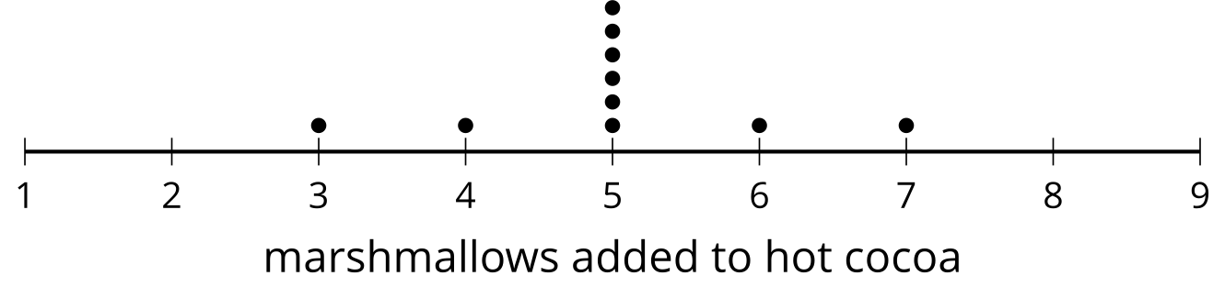
  - 0.6 marshmallows
  - 3 marshmallows
  - 4 marshmallows
  - 5 marshmallows
- (From Unit 1, Lesson 11.)
- Here is a data set:
- 5 | - 10 | - 10 | - 10 | - 15 | - 100

  - After studying the data, the reasearcher realized that the value 100 was meant to be recorded as 15. What happens to the mean and standard deviation of the data set when the 100 is changed to a 15?
  - For the original data set, with the 100, would the median or the mean be a better choice of measure for the center? Explain your reasoning.
- (From Unit 1, Lesson 12.)
- A coach for a little league baseball team is ordering trophies for the team. Players on the team are allowed to choose between 2 types of trophies. The gold baseball trophies cost $5.99 each and the uniform baseball trophies cost $6.49 each. The team orders $g$ gold baseball trophies and $u$ uniform baseball trophies.
- Write an expression that could represent the total cost of all of the trophies.
- (From Unit 2, Lesson 1.)
- The robotics team needs to purchase $350 of new equipment. Each of the $x$ students on the team plans to fundraise and contribute equally to the purchase.
- Which expression represents the amount that each student needs to fundraise?
  - $350−x$
  - $350+x$
  - $\frac{350}{x}$
  - $350⋅x$
- (From Unit 2, Lesson 1.)
- In a trivia contest, players form teams and work together to earn as many points as possible for their team. Each team can have between 3 and 5 players. Each player can score up to 10 points in each round of the game. Elena and four of her friends decided to form a team and play a round.
- Write an expression, an equation, or an inequality for each quantity described here. If you use a variable, specify what it represents.
  - the number of points that Elena’s team earns in one round
  - the number of points Elena’s team earns in one round if every player scores between 6 and 8 points
  - the number of points Elena’s team earns if each player misses one point
  - the number of players in a game if there are 5 teams of 4 players each
  - the number of players in a game if there are at least 3 teams
- (From Unit 2, Lesson 1.)
© CC BY 2019 by Illustrative Mathematics®

