Lesson 8 Practice Problems
- Draw a diagram to show that $\left(2x+5\right)\left(x+3\right)$ is equivalent to $2x^{2}+11x+15$.
- Match each quadratic expression that is written as a product with an equivalent expression that is expanded.
  - $\left(x+2\right)\left(x+6\right)$
  - $\left(2x+8\right)\left(x+2\right)$
  - $\left(x+8\right)\left(x+4\right)$
  - $\left(x+2\right)\left(2x+6\right)$
  - $x^{2}+12x+32$
  - $2x^{2}+10x+12$
  - $2x^{2}+12x+16$
  - $x^{2}+8x+12$
- Select all expressions that are equivalent to $x^{2}+4x$.
  - $x\left(x+4\right)$
  - ${\left(x+2\right)}^{2}$
  - $\left(x+x\right)\left(x+4\right)$
  - ${\left(x+2\right)}^{2}−4$
  - $\left(x+4\right)x$
- Tyler drew a diagram to expand $\left(x+5\right)\left(2x+3\right)$.
  - Explain Tyler’s mistake.
  - What is the correct expanded form of $\left(x+5\right)\left(2x+3\right)$?
- 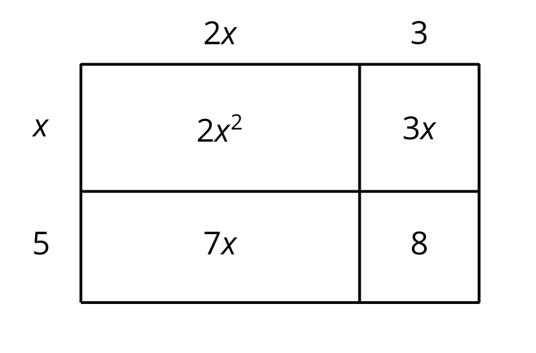
- Explain why the values of the exponential expression $3^{x}$ will eventually overtake the values of the quadratic expression $10x^{2}$.
- (From Unit 6, Lesson 4.)
- A baseball travels $d$ meters $t$ seconds after being dropped from the top of a building. The distance traveled by the baseball can be modeled by the equation $d=5t^{2}$.
- Which graph could represent this situation? Explain how you know.

- Graph A
- 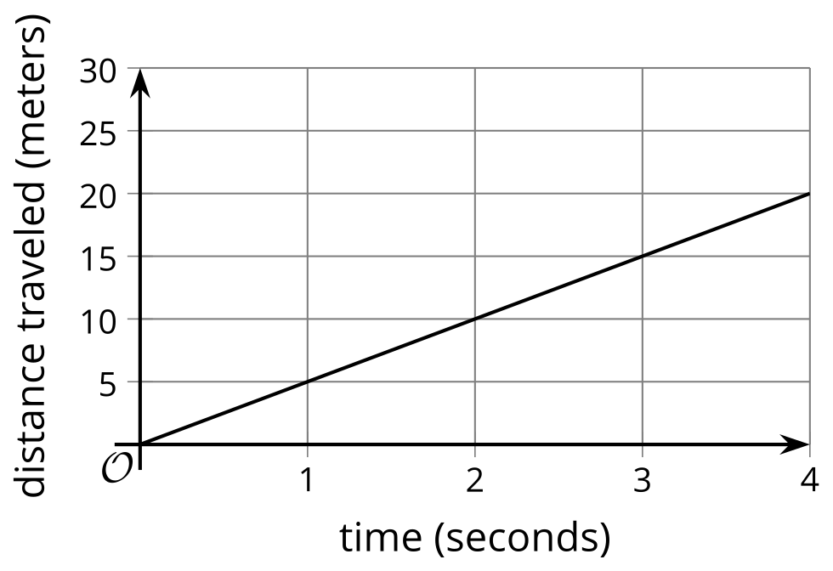

- Graph B
- 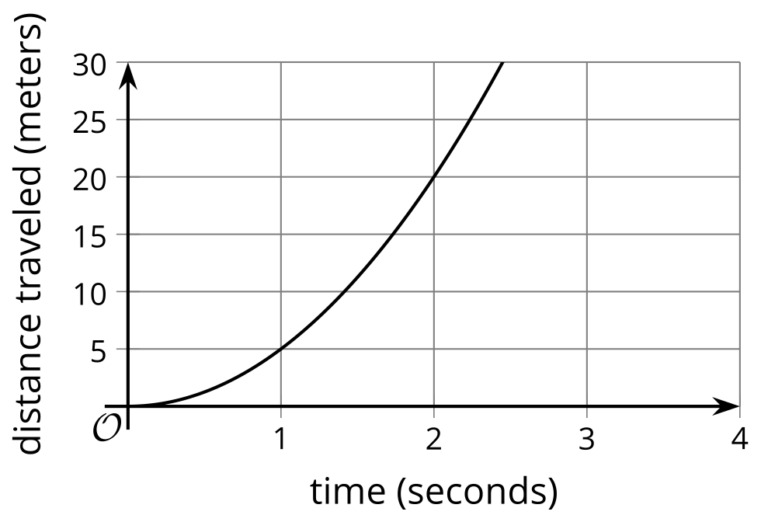

- (From Unit 6, Lesson 5.)
- Consider a function $q$ defined by $q\left(x\right)=x^{2}$. Explain why negative values are not included in the range of $q$.
- (From Unit 4, Lesson 10.)
- Based on past concerts, a band predicts selling $600−10p$ concert tickets when each ticket is sold at $p$ dollars.
  - Complete the table to find out how many concert tickets the band expects to sell and what revenues it expects to receive at the given ticket prices.
- ticket price (dollars) | - number of tickets | - revenue (dollars)
  - 10
  - 15
  - 20
  - 30
  - 35
  - 45
  - 50
  - 60
  - $p$
  - In this model, at what ticket prices will the band earn no revenue at all?
  - At what ticket prices should the band sell the tickets if it must earn at least 8,000 dollars in revenue to break even (to not lose money) on a given concert. Explain how you know.
- (From Unit 6, Lesson 7.)
- A population of bears decreases exponentially. The population was first measured in 2010.
  - What is the annual factor of decrease for the bear population? Explain how you know.
  - Using function notation, represent the relationship between the bear population, $b$, and the number of years since the population was first measured, $t$. That is, find a function, $f$, so that $b=f\left(t\right)$.
- 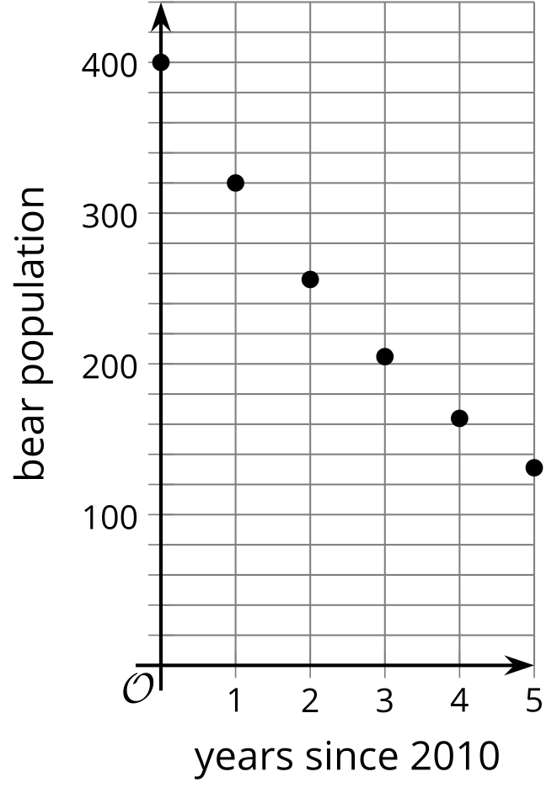
- (From Unit 5, Lesson 8.)
- Equations defining functions $a,b,c,d,$ and $f$ are shown here.
- Select all the equations that represent exponential functions.
  - $a\left(x\right)=2^{3}⋅x$
  - $b\left(t\right)={\left(\frac{2}{3}\right)}^{t}$
  - $c\left(m\right)=\frac{1}{5}⋅2^{m}$
  - $d\left(x\right)=3x^{2}$
  - $f\left(t\right)=3⋅2^{t}$
- (From Unit 5, Lesson 8.)
© CC BY 2019 by Illustrative Mathematics®

