Unit 4 Lesson 12: Piecewise Functions

1 Frozen Yogurt (Warm up)

Student Task Statement
A self-serve frozen yogurt store sells servings up to 12 ounces. It charges $0.50 per ounce for a serving between 0 and 8 ounces, and $4 for any serving greater than 8 ounces and up to 12 ounces.
Choose the graph that represents the price as a function of the weight of a serving of yogurt. Be prepared to explain how you know.

A

B

C

D

2 Postage Stamps

Student Task Statement
The relationship between the postage rate and the weight of a letter can be defined by a piecewise function.
The graph shows the 2018 postage rates for using regular service to mail a letter.
- What is the price of a letter that has the following weight?
  - 1 ounce
  - 1.1 ounces
  - 0.9 ounce
- A letter costs $0.92 to mail. How much did the letter weigh?
- Kiran and Mai wrote some rules to represent the postage function, but each of them made some errors.
- $K(w)=\left\{\begin{matrix}0.50, & 0≤w≤1 \\ 0.71, & 1≤w≤2 \\ 0.92, & 2≤w≤3 \\ 1.13, & 3≤w≤3.5\end{matrix}\right.$
- $M(w)=\left\{\begin{matrix}0.50, & 0<w<1 \\ 0.71, & 1<w<2 \\ 0.92, & 2<w<3 \\ 1.13, & 3<w<3.5\end{matrix}\right.$
- Identify the error in each person’s work and write a corrected set of rules.

3 Bike Sharing

Student Task Statement
Function $C$ represents the dollar cost of renting a bike from a bike-sharing service for $t$ minutes. Here are the rules describing the function:
$C(t)=\left\{\begin{matrix}\begin{matrix} & 2.50, & & 0<t≤30 \\ & 5.00, & & 30<t≤60 \\ & 7.50, & & 60<t≤90 \\ & 10.00, & & 90<t≤120 \\ & 12.50, & & 120<t≤150 \\ & 15.00, & & 150<t≤720\end{matrix}\end{matrix}\right.$​​​​​​
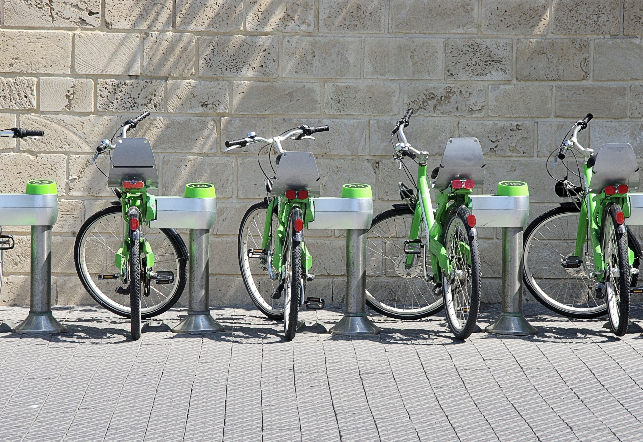
- Complete the table with the costs for the given lengths of rental.
- $t$ (minutes) | - $C$ (dollars)
- 0
- 10
- 25
- 60
- 75
- 130
- 180
- Sketch a graph of the function for all values of $t$ that are at least 0 minutes and at most 240 minutes.
- ​​​​​​
- Describe in words the pricing rules for renting a bike from this bike sharing service.
- Determine the domain and range of this function.

4 Piecing It Together (Optional)

Student Task Statement
Your teacher will give your group strips of paper with parts of a graph of a function. Gridlines are 1 unit apart.
Arrange the strips of paper to create a graph for each of the following functions.
$f(x)=\left\{\begin{matrix}\begin{matrix}\text{-}5, & \text{-}10<x<\text{-}5 \\ x, & \text{-}5≤x<0 \\ 1, & 0≤x<3 \\ x−2, & 3≤x<8 \\ 6, & 8≤x<10 \end{matrix}\end{matrix}\right.$
$g(x)=\left\{\begin{matrix}\begin{matrix}5.5, & \text{-}10<x≤\text{-}8 \\ 4, & \text{-}8<x≤\text{-}3 \\ \text{-}x, & \text{-}3<x≤2 \\ \text{-}3.5, & 2<x≤5 \\ x−5, & 5<x≤10\end{matrix}\end{matrix}\right.$
To accurately represent each function, be sure to include a scale on each axis and add open and closed circles on the graph where appropriate.

Images for Activity Synthesis
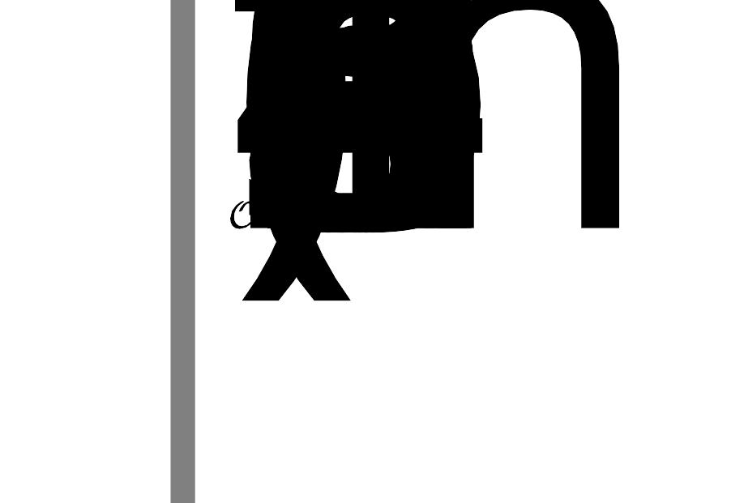
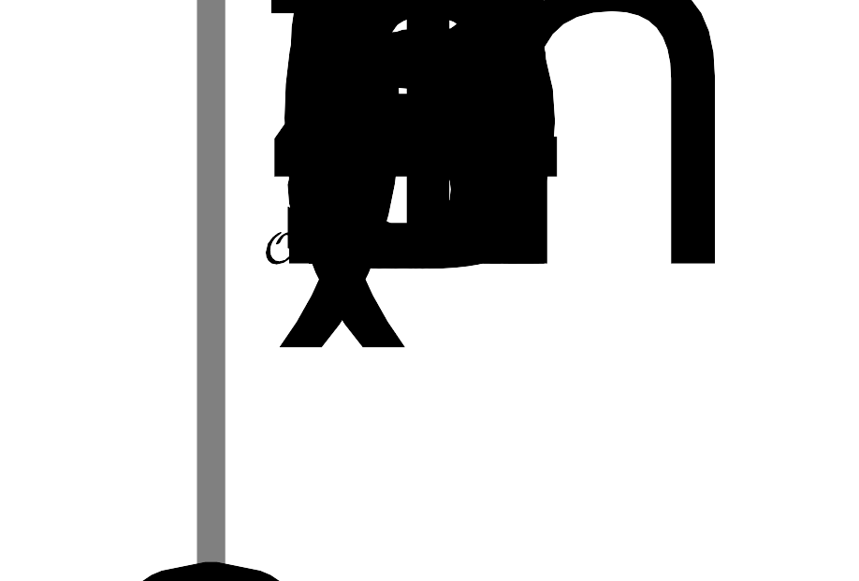
© CC BY 2019 by Illustrative Mathematics®

