Unit 1 Lesson 6: Representing Sequences

1 Reading Representations (Warm up)

Student Task Statement
For each sequence shown, find either the growth factor or rate of change. Be prepared to explain your reasoning.
- 5, 15, 25, 35, 45, . . .
- Starting at 10, each new term is $\frac{5}{2}$ less than the previous term.

- 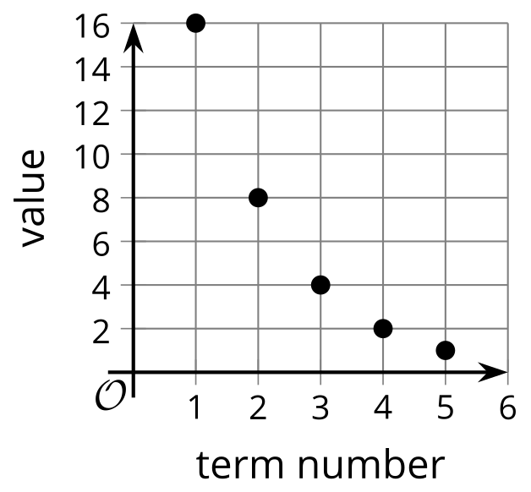
- $g\left(1\right)=\text{-}5,g\left(n\right)=g\left(n−1\right)⋅\text{-}2$ for $n≥2$
- $n$ | - $f\left(n\right)$
- 1 | - 0
- 2 | - 0.1
- 3 | - 0.2
- 4 | - 0.3
- 5 | - 0.4

2 Matching Recursive Definitions (Optional)

Student Task Statement
Take turns with your partner to match a sequence with a recursive definition. It may help to first figure out if the sequence is arithmetic or geometric.
- For each match that you find, explain to your partner how you know it’s a match.
- For each match that your partner finds, listen carefully to their explanation. If you disagree, discuss your thinking and work to reach an agreement.
There is one sequence and one definition that do not have matches. Create their corresponding match.
Sequences:
- 3, 6, 12, 24
- 18, 36, 72, 144
- 3, 8, 13, 18
- 18, 13, 8, 3
- 18, 9, 4.5, 2.25
- 18, 20, 22, 24
Definitions:
- $G\left(1\right)=18,G\left(n\right)=\frac{1}{2}⋅G\left(n−1\right),n≥2$
- $H\left(1\right)=3,H\left(n\right)=5⋅H\left(n−1\right),n≥2$
- $J\left(1\right)=3,J\left(n\right)=J\left(n−1\right)+5,n≥2$
- $K\left(1\right)=18,K\left(n\right)=K\left(n−1\right)−5,n≥2$
- $L\left(1\right)=18,L\left(n\right)=2⋅L\left(n−1\right),n≥2$
- $M\left(1\right)=3,M\left(n\right)=2⋅M\left(n−1\right),n≥2$

3 Squares of Squares (Optional)

Student Task Statement
Here is a pattern where the number of small squares increases with each new step.
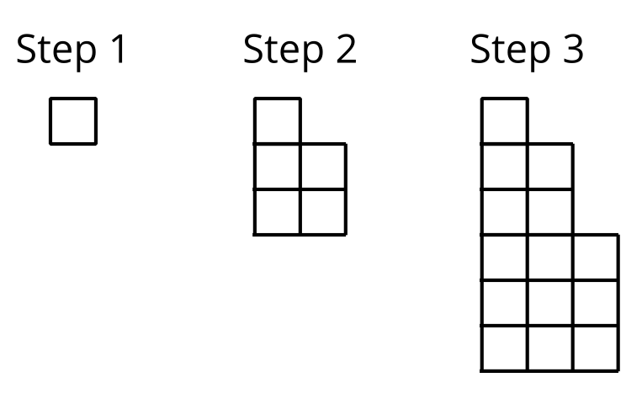
- Write a recursive definition for the total number of small squares $S\left(n\right)$ in Step $n$.
- Sketch a graph of $S$ that shows Steps 1 to 7.
- Is this sequence geometric, arithmetic, or neither? Be prepared to explain how you know.
© CC BY 2019 by Illustrative Mathematics®

