Lesson 12: Rectangles with the Same Area
- Let’s explore rectangles with the same area.

Warm-up: Number Talk: Divide in Parts
Find the value of each expression mentally.
- $40÷4$
- $60÷4$
- $80÷4$
- $96÷4$

12.1: Area of 24
- Draw as many different rectangles as you can with an area of 24 square units.
- Find the perimeter of each rectangle you draw. Explain or show your reasoning.

12.2: Same Area, Different Perimeter
Your teacher will give you some paper for drawing rectangles.
- For each of the following areas, draw 2 rectangles with that area but different perimeters.
  - 12 square units
  - 20 square units
  - 42 square units
  - 48 square units
  - Choose your own area.
- Cut out the rectangles you want to share and place them on the appropriate poster. Try to look for rectangles that are different from what other groups have already placed.
- Gallery Walk: As you visit the posters, discuss something you notice and something you wonder.

Section Summary
Section Summary
In this section, we drew rectangles with the same perimeter and different areas. We also drew rectangles with the same area and different perimeters.
rectangles with a perimeter of 16 units
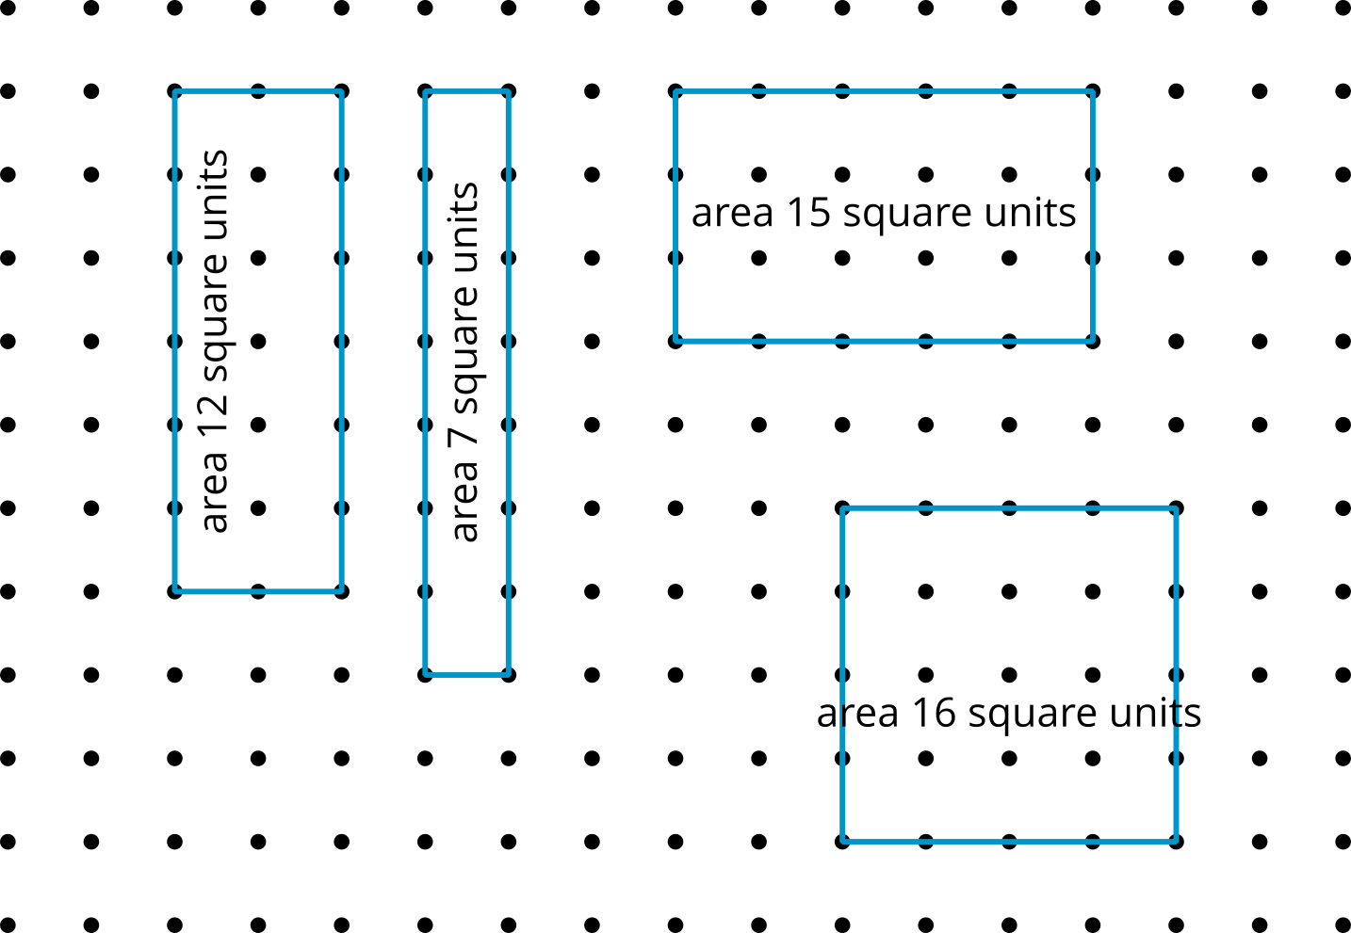
rectangles with an area of 24 square units
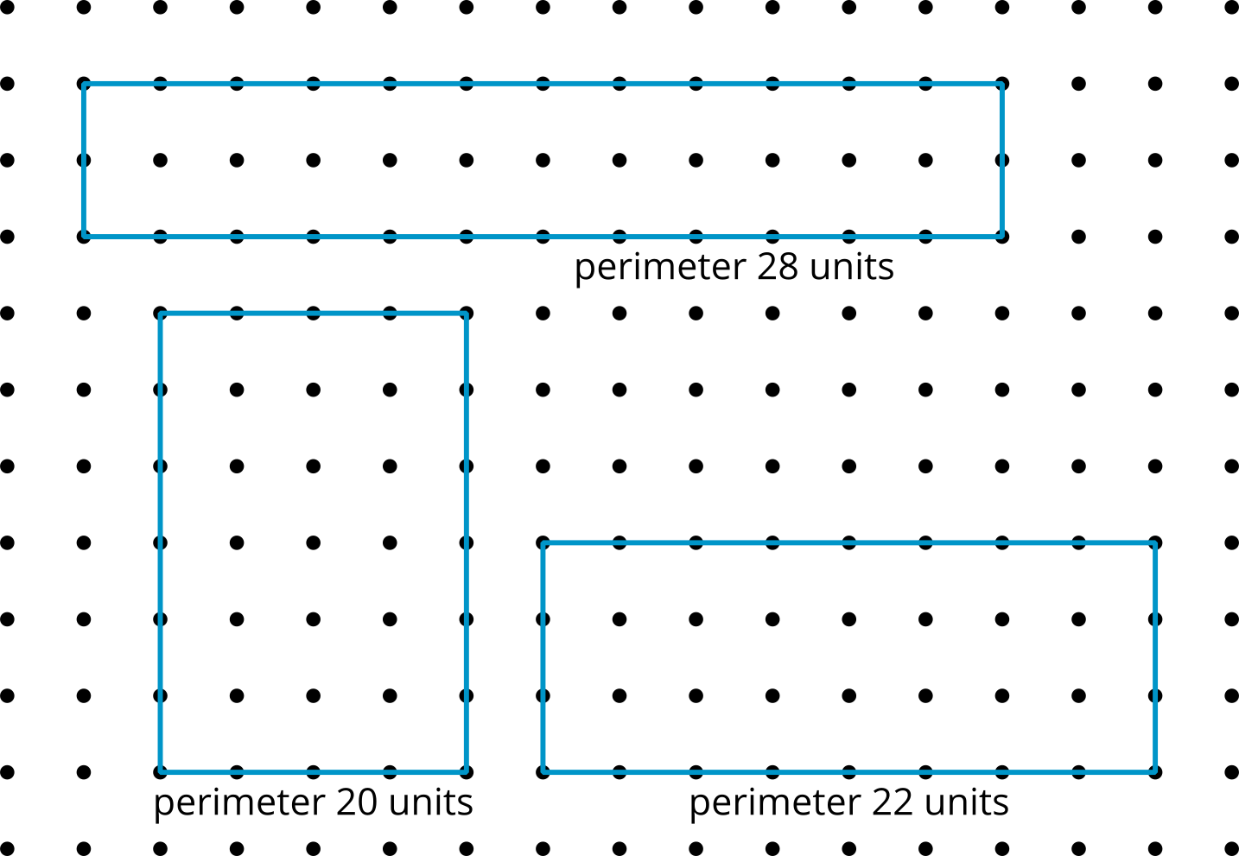
© CC BY 2021 Illustrative Mathematics®

