Lesson 1: Compare, Count on, and Count Back
- Let’s compare numbers and add or subtract.

Warm-up: Number Talk: Count Back
Find the value of each expression mentally.
- $586−6$
- $586−8$
- $434−5$
- $352−4$

1.1: Notice the Difference
Tyler and Elena were asked to find the value of $81−79$.
Their work is shown.
Tyler
$\begin{matrix}81−70 & =11 \\ 11−9 & =2\end{matrix}$
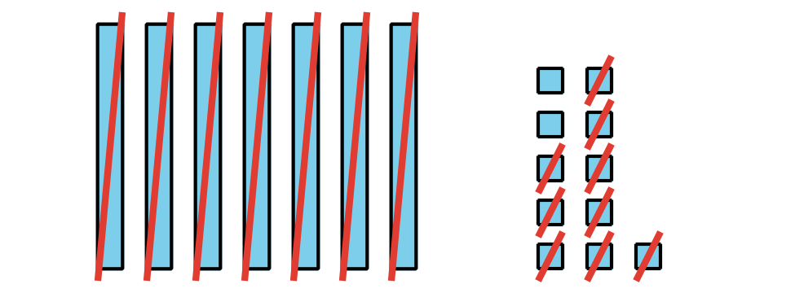
Elena
$81−79=2$
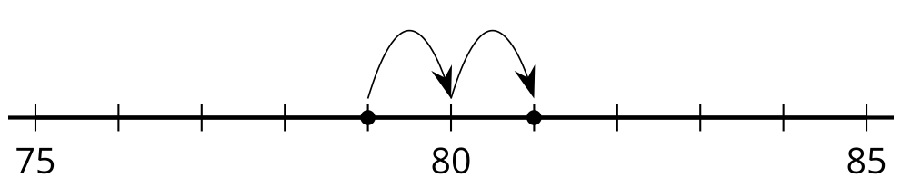
What do you notice? What do you wonder?
- Locate and label 203 and 198 on the number line.
- Compare using >, <, or =.
- _ 00 _
- Find the value of $203−198$. Show your thinking.
- Locate and label 673 and 680 on the number line.
- Compare using >, <, or =.
- _ 00 _
- Find the value of $680−673$. Show your thinking.
- Locate and label 501 and 499 on the number line.
- Find the value of $501−499$. Show your thinking.
- Find the value of $400−396$. Show your thinking.

1.2: What’s the Big Difference?
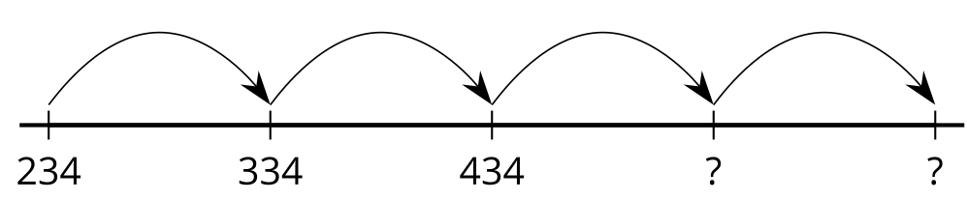
- Fill in the missing numbers.
- 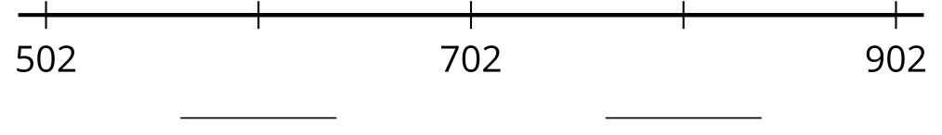
- Does this number line show counting on by 10 or counting on by 100?
- Fill in the missing numbers.
- 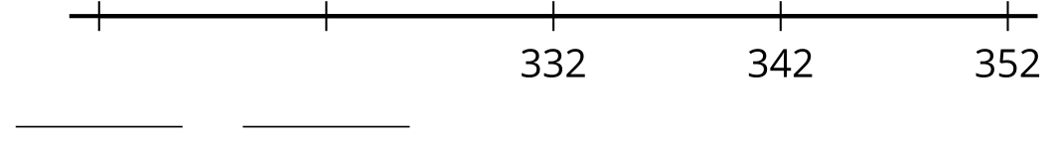
- Does this number line show counting on by 10 or counting on by 100?
- Fill in the missing numbers.
- 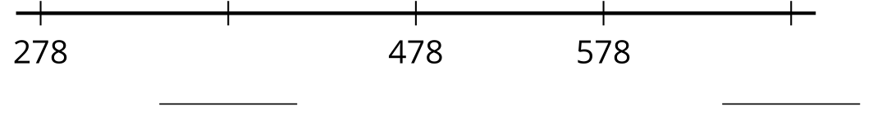
- Does this number line show counting on by 10 or counting on by 100?
- Fill in the missing numbers to show counting on by 10.
- 739, 749, __________, 769, __________
- Explain how you can tell your numbers show counting on by 10 and not counting on by 100.
© CC BY 2021 Illustrative Mathematics®

