Unit 9 Lesson 11: All About Tape Diagrams

WU Number Talk: Addition and Subtraction (Warm up)

Student Task Statement
Find the value of each expression mentally.
- $7+13$
- $27+13$
- $40−13$
- $40−27$

1 Represent Story Problems

Student Task Statement
Match the stories, diagrams, and equations.

Activity Synthesis
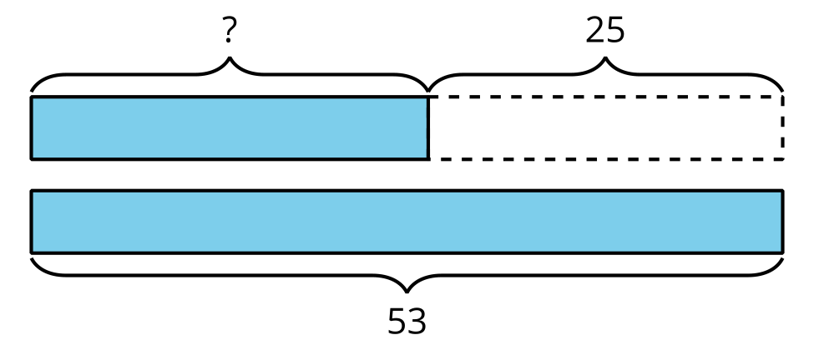
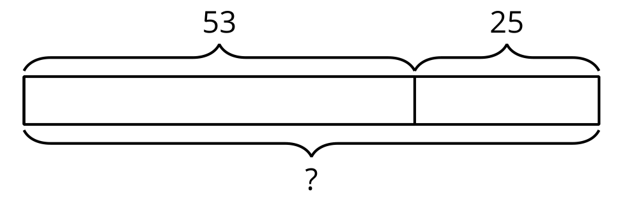

2 Write Stories

Student Task Statement
Choose one of the diagrams. Write and solve a story problem that the diagram could represent.

- 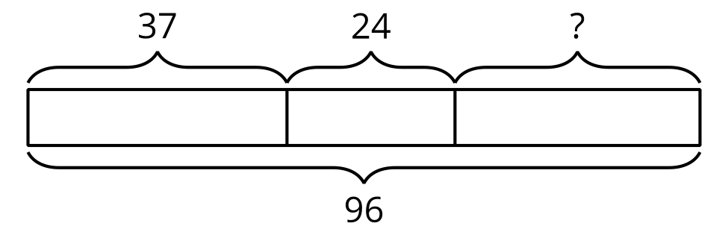

- 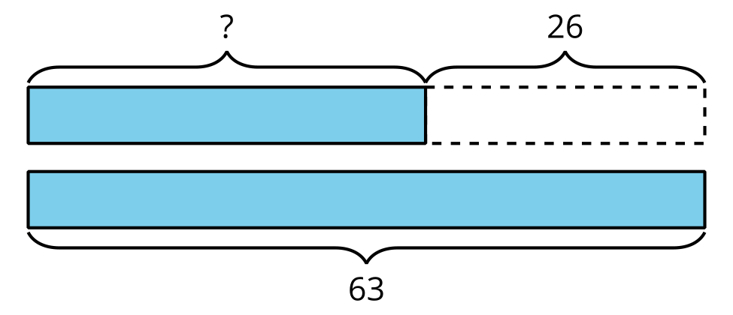

- 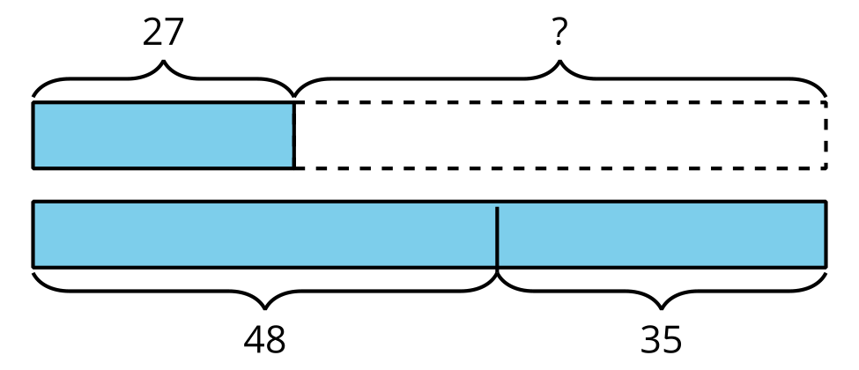
Problem ______
© CC BY 2021 Illustrative Mathematics®

