Lesson 1: Multiples of a Number

Standards Alignments
Building On | 3.MD.C, 3.MD.C.7.a
Addressing | 4.OA.B.4
Building Towards | 4.OA.B.4

Teacher-facing Learning Goals
- Find areas of different rectangles with a given a side length.
- Understand that the area of a rectangle is a multiple of each of its side lengths.

Student-facing Learning Goals
- Let’s build some rectangles.

Lesson Purpose
The purpose of this lesson is for students to apply their understanding of area to explore multiples.
In grade 3, students learned how to find the area of a rectangle by tiling and found that multiplying the side lengths yields the same result.
The purpose of this lesson is for students to apply their understanding of area and multiplication to build rectangles and find their area. As students consider the areas of rectangles with a given side length, they explore the idea of multiples. Students learn that a multiple of a number is the result of multiplying that whole number by another.
While students are introduced to the term multiple in this lesson, they work more with it in upcoming lessons. They do not need to have a formal understanding of the term in this lesson. In upcoming lessons, students also explore and learn the terms factor and factor pair. In this lesson, they refer to them as side lengths within the context of area.
Math Community
Prepare a space, such as a piece of poster paper, titled “Mathematical Community”​ ​and a T-chart with the headers “Doing Math”​ ​and “Norms” as shown here.
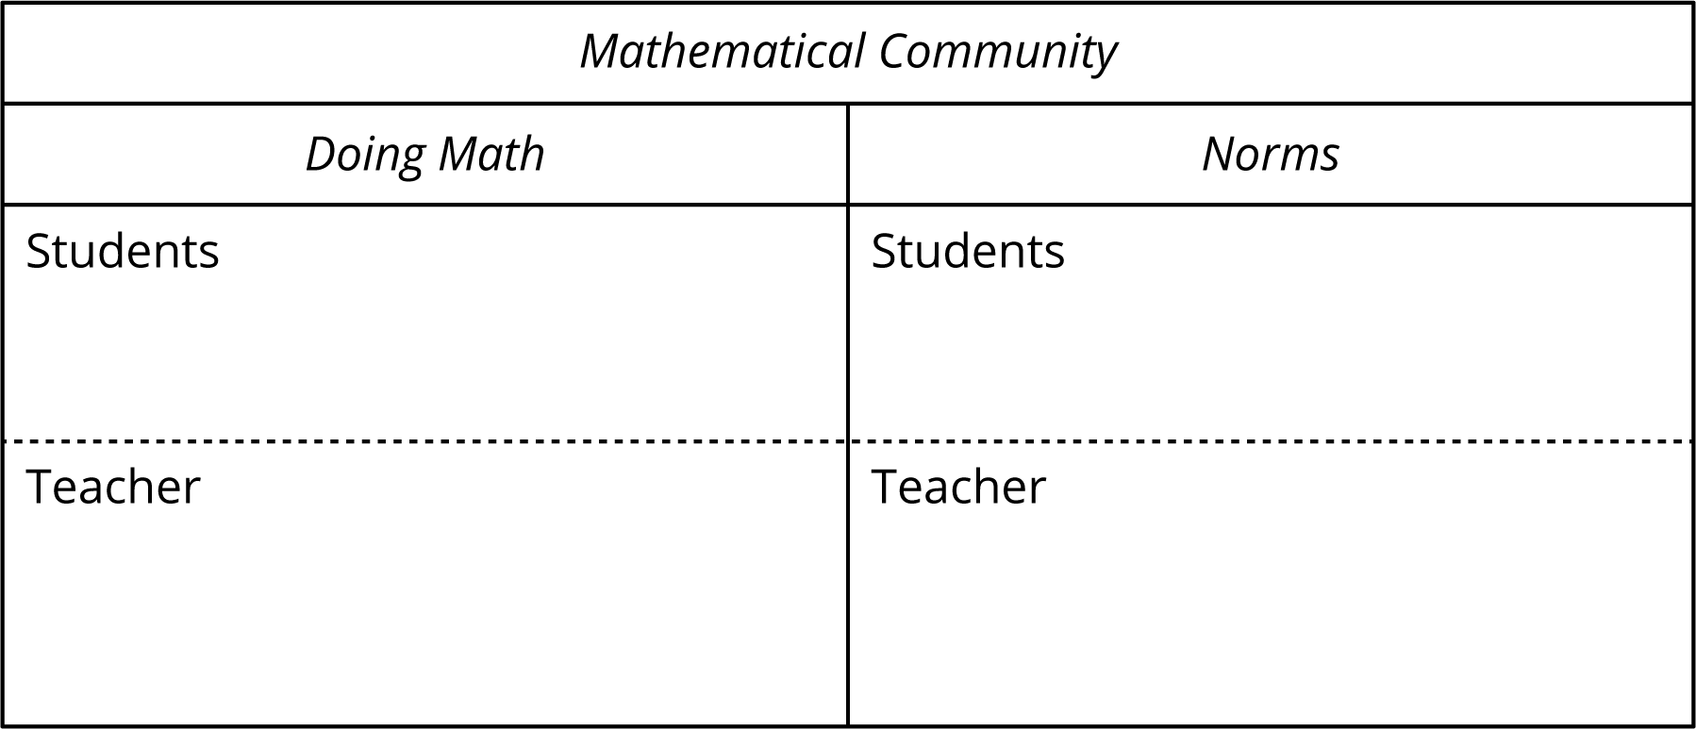
The two sections encourage the students and teacher to be mindful that both respective parties are responsible for the way math is done in the classroom.

Access for:

Students with Disabilities
- Representation (Activity 2)

English Learners
- MLR2 (Activity 1)

Instructional Routines
Which One Doesn’t Belong? (Warm-up)

Materials to Gather
- Inch tiles: Activity 1, Activity 2

Materials to Copy
- Centimeter Grid Paper - Standard (groups of 2): Activity 2

Lesson Timeline
Warm-up | 10 min
Activity 1 | 20 min
Activity 2 | 15 min
Lesson Synthesis | 10 min
Cool-down | 5 min

Teacher Reflection Question
In grade 3, students fluently multiplied and divided within 100 and related area to multiplication and addition. How is that prior knowledge supporting students in understanding multiples in this lesson?

Cool-down
(to be completed at the end of the lesson) 5min
Area and Multiples

Standards Alignments
Addressing | 4.OA.B.4

Student-facing Task Statement
If a rectangle is 6 tiles wide, what could be its area? Name three possibilities. Explain or show your reasoning.

Student Responses
Sample response: 12, 18, and 24, because $6×2=12$, $6×3=18$, and $6×4=24$.

