Lesson 6: Multiply Two-digit Numbers and One-digit Numbers
- Let’s multiply two-digit and one-digit numbers.

Warm-up: Notice and Wonder: With and Without a Grid
What do you notice? What do you wonder?
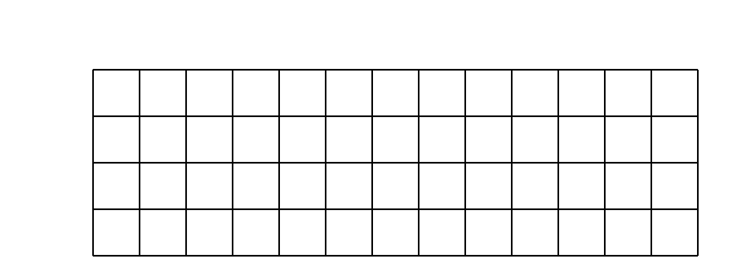
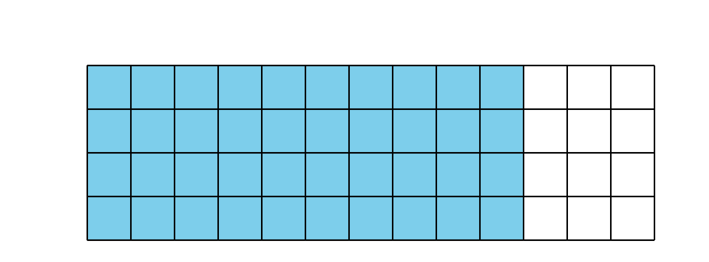
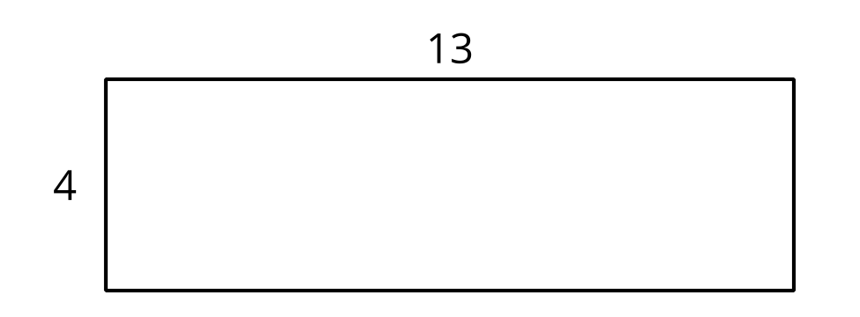

6.1: Tyler's Diagrams
- To find the value of $4×36$, Tyler uses a base-ten diagram, as shown here.
- 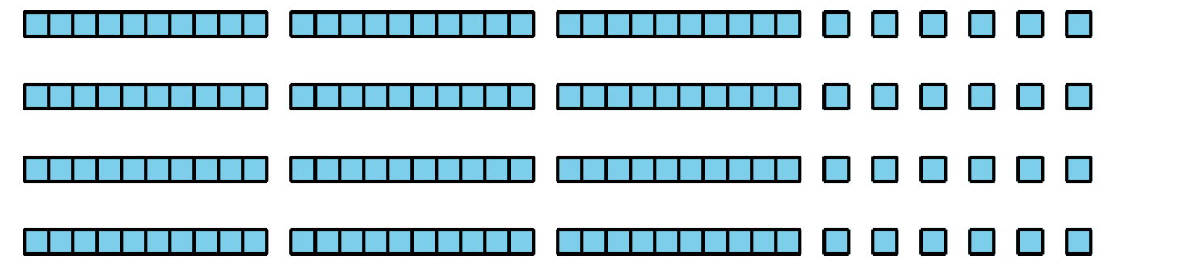
  - Where is the 36 in Tyler's diagram?
  - Where is the 4 in Tyler’s diagram?
  - What is the value of $4×36$?
- Here is a diagram Tyler made to find the value of $9×18$.
- Explain or show how his diagram helps him find the value of $9×18$.
- 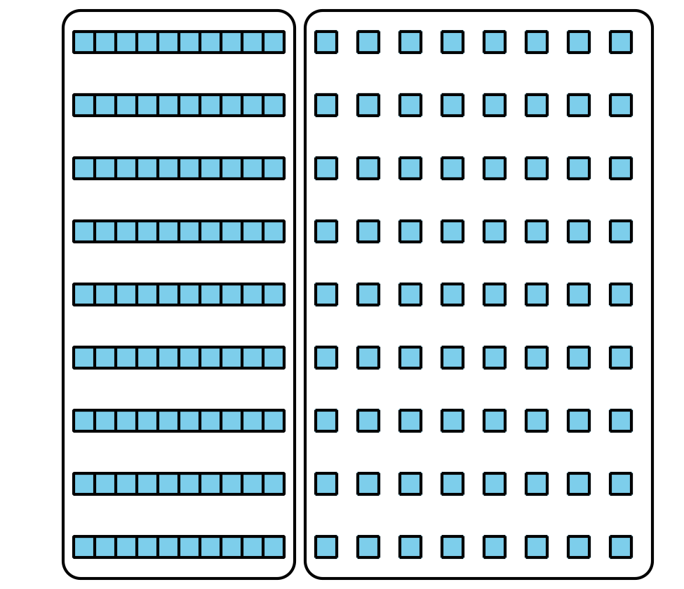

6.2: Two Kinds of Diagrams
- Priya drew a base-ten diagram to multiply $6×53$. She said it shows that the product can be found by adding 300 and 18.
- 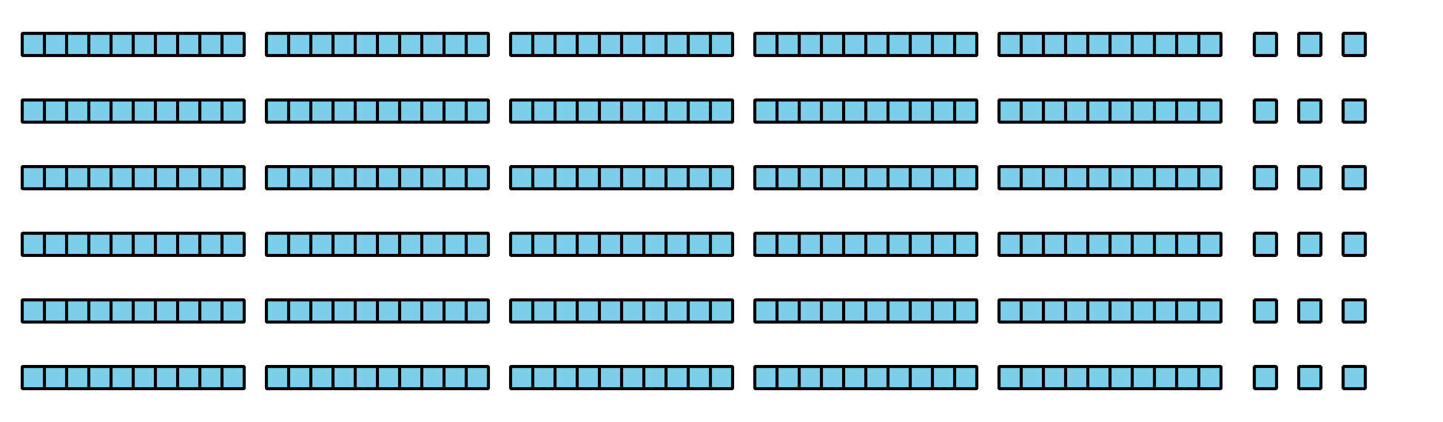
  - Where do you see 6 and 53 in her diagram?
  - Where do you see 300 and 18 in Priya’s diagram? What do they represent?
- Han drew this diagram to multiply $6×53$:
- 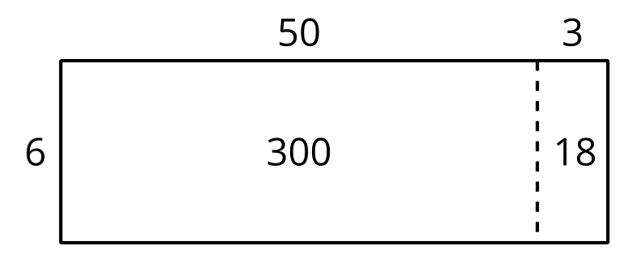
- Where do you see 300 and 18 in his diagram? What do they represent?
- Which diagram do you prefer for multiplying $6×53$: Han’s way or Priya’s way? Explain your reasoning.
- Find the value of $6×53$.
- Draw a diagram to represent each multiplication expression. Then, find the value of each product.
  - $6×48$
  - $9×67$
© CC BY 2021 Illustrative Mathematics®

