Unit 7 Lesson 2 Cumulative Practice Problems
- Write each expression with a single exponent:
  - ${10}^{3}⋅{10}^{9}$
  - $10⋅{10}^{4}$
  - ${10}^{10}⋅{10}^{7}$
  - ${10}^{3}⋅{10}^{3}$
  - ${10}^{5}⋅{10}^{12}$
  - ${10}^{6}⋅{10}^{6}⋅{10}^{6}$

- A large rectangular swimming pool is 1,000 feet long, 100 feet wide, and 10 feet deep. The pool is filled to the top with water.
  - What is the area of the surface of the water in the pool?
  - How much water does the pool hold?
  - Express your answers to the previous two questions as powers of 10.
- Here is triangle $ABC$. Triangle $DEF$ is similar to triangle $ABC$, and the length of $EF$ is 5 cm. What are the lengths of sides $DE$ and $DF$, in centimeters?
- 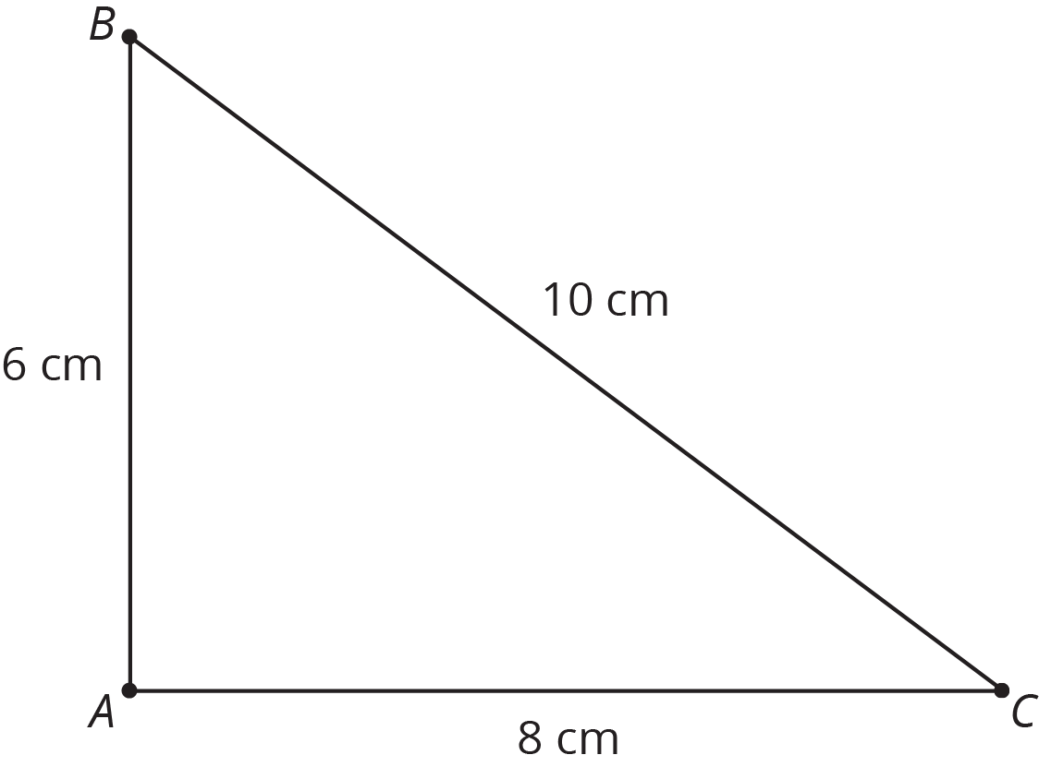
- (From Unit 2, Lesson 12.)
- Elena and Jada distribute flyers for different advertising companies. Elena gets paid 65 cents for every 10 flyers she distributes, and Jada gets paid 75 cents for every 12 flyers she distributes.
- Draw graphs on the coordinate plane representing the total amount each of them earned, $y$, after distributing $x$ flyers. Use the graph to decide who got paid more after distributing 14 flyers.
- (From Unit 5, Lesson 2.)
- Noah drew a scaled copy of Polygon P and labeled it Polygon Q.
- 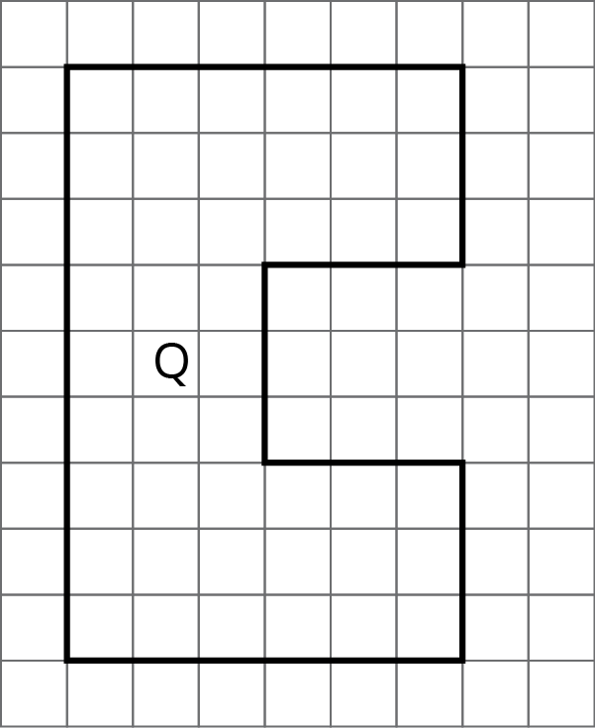
- If the area of Polygon P is 5 square units, what scale factor did Noah apply to Polygon P to create Polygon Q? Explain or show how you know.
- (From Unit 2, Lesson 4.)
- A cylinder has a volume of $36π$ cm³ and height $h$. Complete this table for the volume of other cylinders with the same radius but different heights.
- height (cm) | - volume (cm³)
- $h$ | - $36π$
- $2h$
- $5h$
- $\frac{h}{2}$
- $\frac{h}{5}$
- (From Unit 6, Lesson 21.)
© CC BY Open Up Resources. Adaptations CC BY IM.

