Lesson 9: Fractional Lengths
Let’s solve problems about fractional lengths.

9.1: Number Talk: Multiplication Strategies
Find the product mentally.
$19⋅14$

9.2: Info Gap: How Many Would It Take?
Your teacher will give you either a problem card or a data card. Do not show or read your card to your partner.
If your teacher gives you the problem card:
- Silently read your card and think about what information you need to be able to answer the question.
- Ask your partner for the specific information that you need.
- Explain how you are using the information to solve the problem.
- Continue to ask questions until you have enough information to solve the problem.
- Share the problem card and solve the problem independently.
- Read the data card and discuss your reasoning.
If your teacher gives you the data card:
- Silently read your card.
- Ask your partner “What specific information do you need?” and wait for them to ask for information.
- If your partner asks for information that is not on the card, do not do the calculations for them. Tell them you don’t have that information.
- Before sharing the information, ask “Why do you need that information?” Listen to your partner’s reasoning and ask clarifying questions.
- Read the problem card and solve the problem independently.
- Share the data card and discuss your reasoning.

Are you ready for more?
Lin has a work of art that is $14$ inches by $20$ inches. She wants to frame it with large paper clips laid end to end.
- If each paper clip is $1\frac{3}{4}$ inch long, how many paper clips would she need? Show your reasoning and be sure to think about potential gaps and overlaps. Consider making a sketch that shows how the paper clips could be arranged.
- How many paper clips are needed if the paper clips are spaced $\frac{1}{4}$ inch apart? Describe the arrangement of the paper clips at the corners of the frame.

9.3: How Many Times as Tall or as Far?
- A second-grade student is 4 feet tall. Her teacher is $5\frac{2}{3}$ feet tall.
  - How many times as tall as the student is the teacher?
  - What fraction of the teacher’s height is the student’s height?
- Find each quotient. Show your reasoning and check your answer.
  - $9÷\frac{3}{5}$
  - $1\frac{7}{8}÷\frac{3}{4}$
- Write a division equation that can help answer each of these questions. Then find the answer. If you get stuck, consider drawing a diagram.
  - A runner ran $1\frac{4}{5}$ miles on Monday and $6\frac{3}{10}$ miles on Tuesday. How many times her Monday’s distance was her Tuesday’s distance?
  - A cyclist planned to ride $9\frac{1}{2}$ miles but only managed to travel $3\frac{7}{8}$ miles. What fraction of his planned trip did he travel?

9.4: Comparing Paper Rolls
The photo shows a situation that involves fractions.
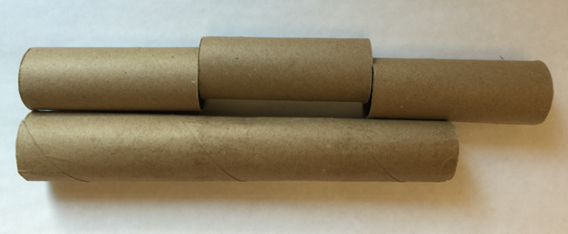
- Complete the sentences. Be prepared to explain your reasoning.
  - The length of the long tube is about ______ times the length of a short tube.
  - The length of a short tube is about ______ times the length of the long tube.
- If the length of the long paper roll is $11\frac{1}{4}$ inches, what is the length of each short paper roll?

Lesson 9 Summary
Division can help us solve comparison problems in which we find out how many times as large or as small one number is compared to another. For example, a student is playing two songs for a music recital. The first song is $1\frac{1}{2}$ minutes long. The second song is $3\frac{3}{4}$ minutes long.
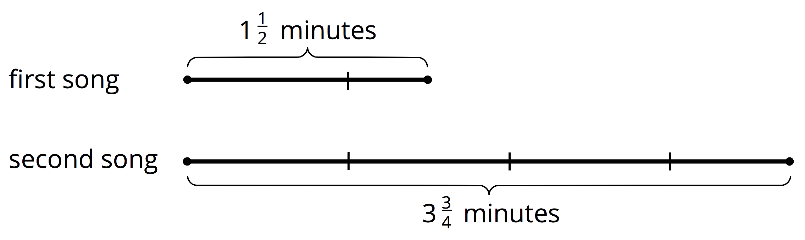
We can ask two different comparison questions and write different multiplication and division equations to represent each question.
- How many times as long as the first song is the second song?
$?⋅1\frac{1}{2}=3\frac{3}{4}$
$3\frac{3}{4}÷1\frac{1}{2}=?$
- What fraction of the second song is the first song?
$?⋅3\frac{3}{4}=1\frac{1}{2}$
$1\frac{1}{2}÷3\frac{3}{4}=?$
We can use the algorithm we learned to calculate the quotients.
$\begin{matrix} & =\frac{15}{4}÷\frac{3}{2} \\ & =\frac{15}{4}⋅\frac{2}{3} \\ & =\frac{30}{12} \\ & =\frac{5}{2}\end{matrix}$
This means the second song is $2\frac{1}{2}$ times as long as the first song.
$\begin{matrix} & =\frac{3}{2}÷\frac{15}{4} \\ & =\frac{3}{2}⋅\frac{4}{15} \\ & =\frac{12}{30} \\ & =\frac{2}{5}\end{matrix}$
This means the first song is $\frac{2}{5}$ as long as the second song.
© CC BY Open Up Resources. Adaptations CC BY IM.

