Lesson 6 Practice Problems
- Match the graph to the following situations (you can use a graph multiple times). For each match, name possible independent and dependent variables and how you would label the axes.
- 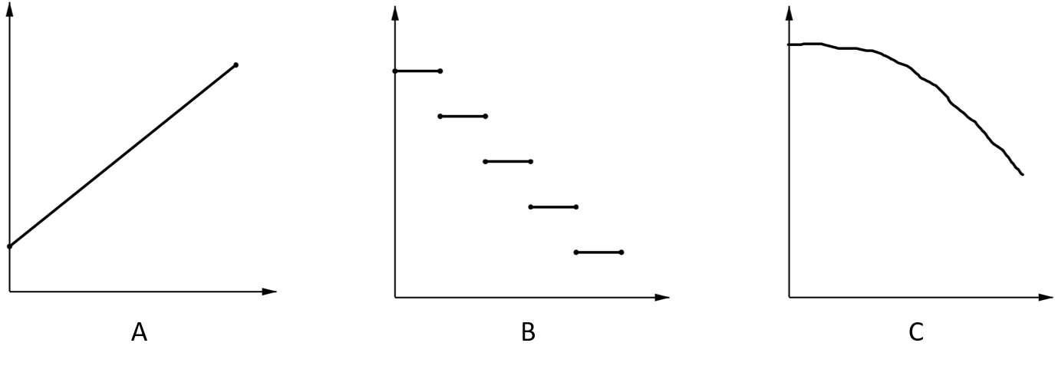
  - Tyler pours the same amount of milk from a bottle every morning.
  - A plant grows the same amount every week.
  - The day started very warm but then it got colder.
  - A carnival has an entry fee of $5 and tickets for rides cost $1 each.
- Jada fills her aquarium with water.
- The graph shows the height of the water, in cm, in the aquarium as a function of time in minutes. Invent a story of how Jada fills the aquarium that fits the graph.
- 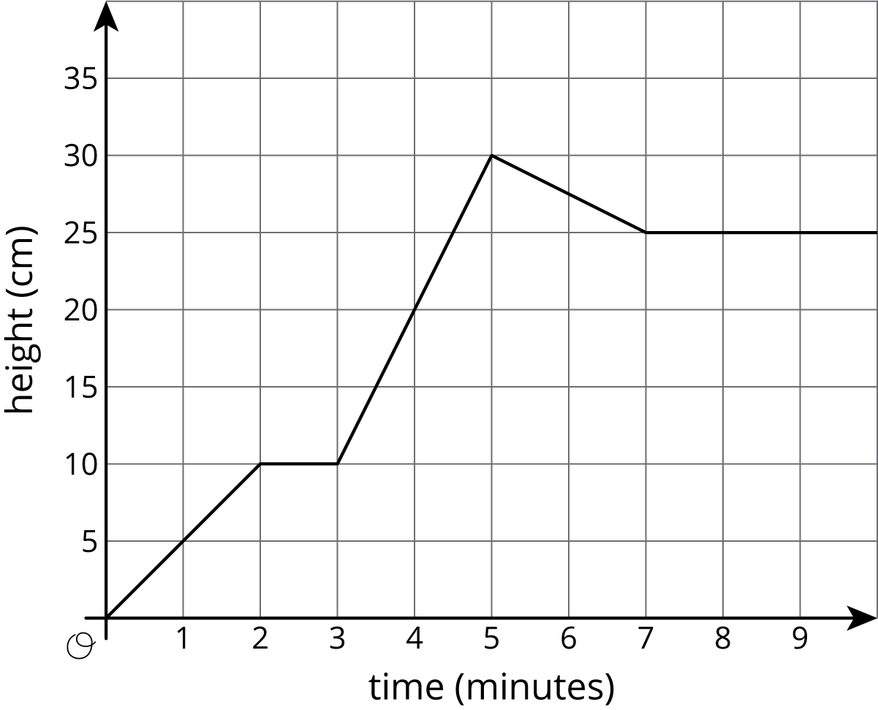
- Recall the formula for area of a circle.
  - Write an equation relating a circle’s radius, $r$, and area, $A$.
  - Is area a function of the radius? Is radius a function of the area?
  - Fill in the missing parts of the table.
- $r$ | - 3 |  | - $\frac{1}{2}$
- $A$ |  | - $16π$ |  | - $100π$
- (From Unit 6, Lesson 4.)
- The points with coordinates $\left(4,8\right)$, $\left(2,10\right)$, and $\left(5,7\right)$ all lie on the line $2x+2y=24$.
  - Create a graph, plot the points, and sketch the line.
  - What is the slope of the line you graphed?
  - What does this slope tell you about the relationship between lengths and widths of rectangles with perimeter 24?
- (From Unit 5, Lesson 9.)
© CC BY Open Up Resources. Adaptations CC BY IM.

