Lesson 7 Practice Problems
- Write with a single exponent:
  - $\frac{7^{6}}{7^{2}}$
  - ${\left({11}^{4}\right)}^{5}$
  - $4^{2}⋅4^{6}$
  - $6⋅6^{8}$
  - ${\left({12}^{2}\right)}^{7}$
  - $\frac{3^{10}}{3}$
  - ${\left(0.173\right)}^{9}⋅{\left(0.173\right)}^{2}$
  - $\frac{{0.87}^{5}}{{0.87}^{3}}$
  - $\frac{{\left(\frac{5}{2}\right)}^{8}}{{\left(\frac{5}{2}\right)}^{6}}$
- Noah says that $2^{4}⋅3^{2}=6^{6}$. Tyler says that $2^{4}⋅4^{2}={16}^{2}$.
  - Do you agree with Noah? Explain or show your reasoning.
  - Do you agree with Tyler? Explain or show your reasoning.
- Make a sketch of a linear relationship with a slope of 4 and a negative $y$-intercept. Show how you know the slope is 4 and write an equation for the line.
- (From Unit 5, Lesson 7.)
- Using the data in the scatter plot, what can you tell about the slope of a good model?
- 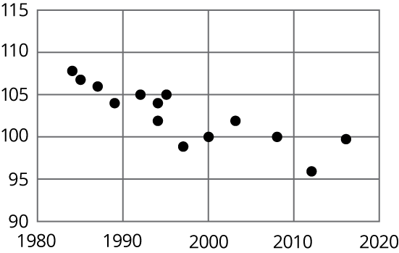
  - The slope is positive.
  - The slope is zero.
  - The slope is negative.
  - There is no association.
- (From Unit 5, Lesson 21.)
© CC BY Open Up Resources. Adaptations CC BY IM.

