Unit 1 Lesson 2: Explore Pattern Blocks

WU Notice and Wonder: Pattern Blocks (Warm up)

Student Task Statement
What do you notice?
What do you wonder?
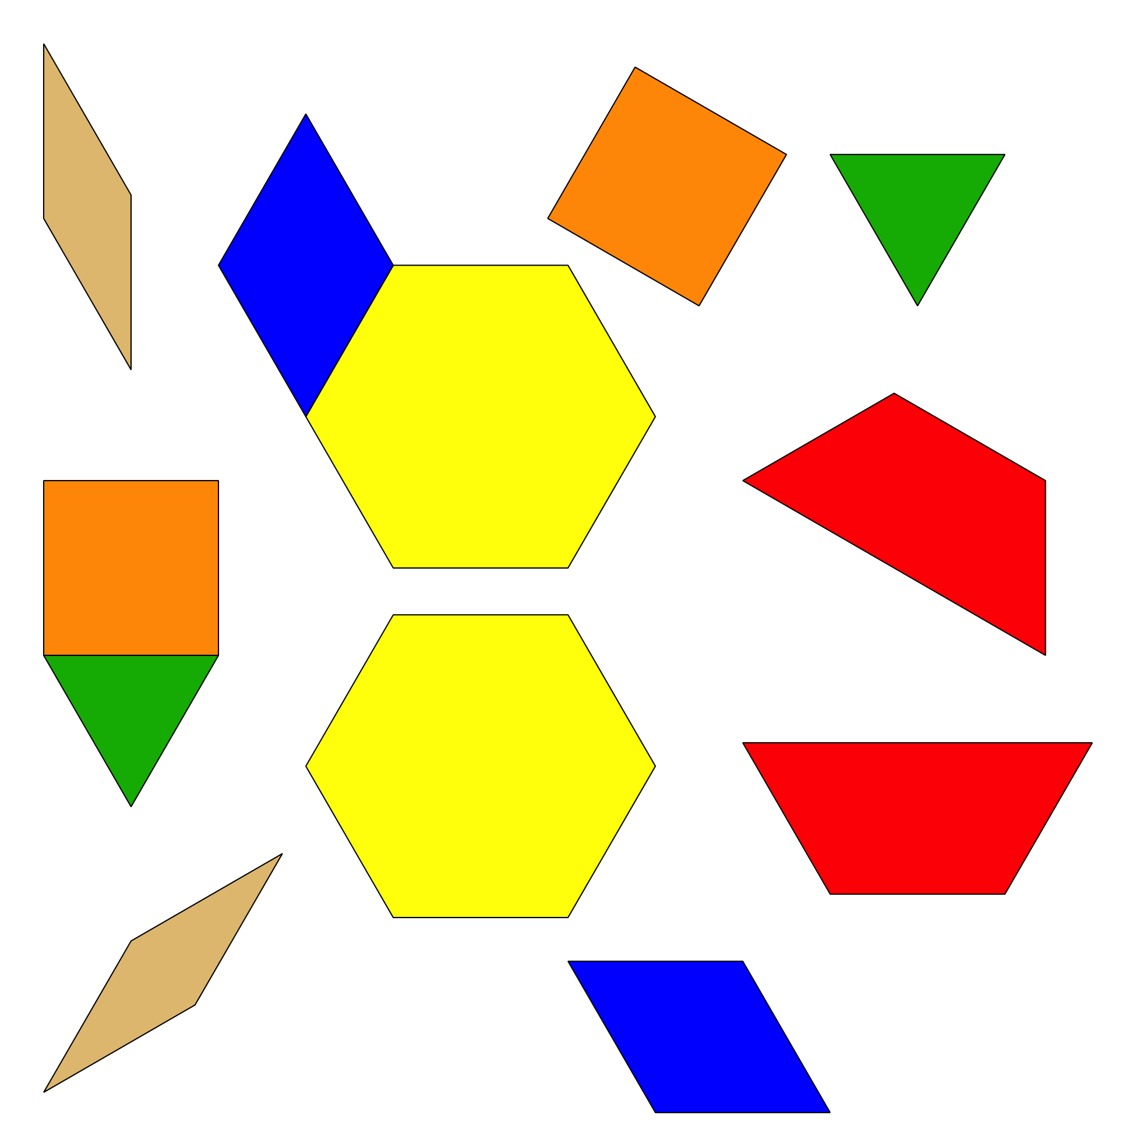

1 Introduce Pattern Blocks, Explore

Student Task Statement
© CC BY 2021 Illustrative Mathematics®

