Lesson 5: Order Numbers 1-20
- Let’s think about the order of numbers 1-20.

5.1: Order Numbers
Write the numbers in order.
_________
_________
_________
_________
_________
_________
_________
_________
_________
_________
_________
_________
_________
_________
_________
_________
_________
_________
_________
_________

5.3: Centers: Choice Time
Choose a center.
Less, Same, More
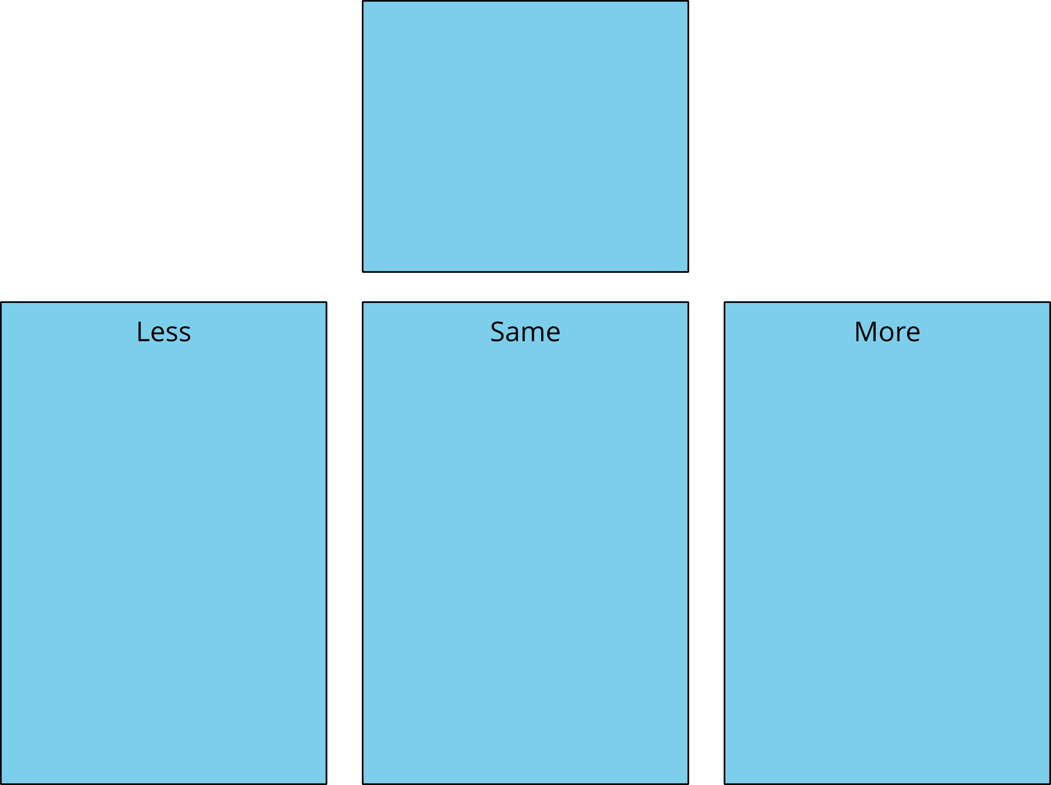
Math Fingers
Tower Build
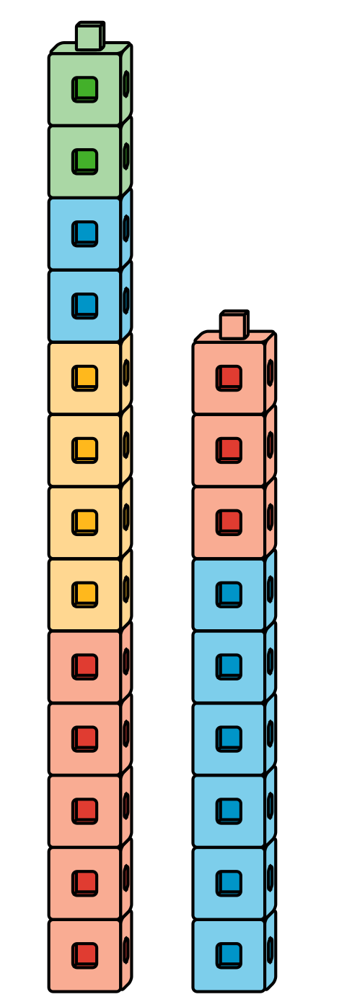
Math Stories
Which One

Section Summary
Section Summary
In this section, we counted and compared groups of objects.
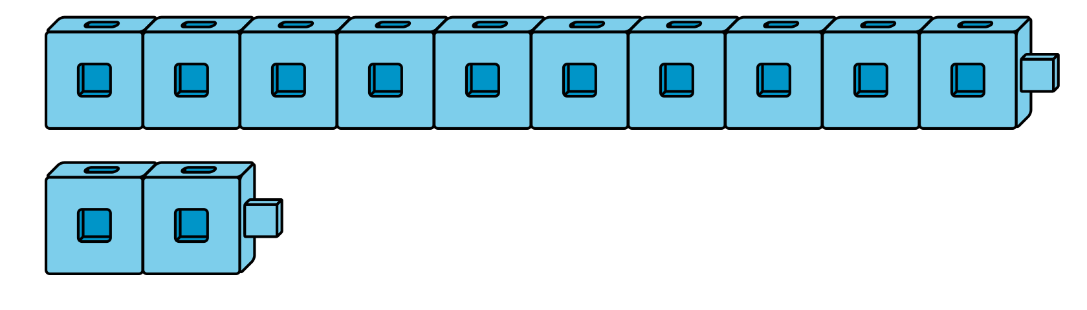
There are 14 counters and 12 cubes. There are fewer cubes.
We also used what we know about counting to help us figure out 1 more and 1 less.
1, 2, 3, 4, 5, 6, 7, 8
8 is 1 more than 7.
There were 10 people on the bus.
Then 1 person got off the bus.
How many people are on the bus now?
1, 2, 3, 4, 5, 6, 7, 8, 9, 10
9 comes before 10 when we count, so 9 is 1 less than 10.
© CC BY 2021 Illustrative Mathematics®

