Lesson 5 Practice Problems
A rocket is launched in the air and its height, in feet, is modeled by the function $h$. Here is a graph representing $h$.
Select all true statements about the situation.
- The rocket is launched from a height less than 20 feet above the ground.
- The rocket is launched from about 20 feet above the ground.
- The rocket reaches its maximum height after about 3 seconds.
- The rocket reaches its maximum height after about 160 seconds.
- The maximum height of the rocket is about 160 feet.
A baseball travels $d$ meters $t$ seconds after being dropped from the top of a building. The distance traveled by the baseball can be modeled by the equation $d=5t^{2}$.
- Complete the table and plot the data on the coordinate plane.
- $t$ (seconds)
- Is the baseball traveling at a constant speed? Explain how you know.
A rock is dropped from a bridge over a river. Which table could represent the distance in feet fallen as a function of time in seconds?
Table A
time (seconds) | distance fallen (feet)
1 | 0
2 | 48
3 | 96
4 | 144
Table B
time (seconds)
distance fallen (feet)
1
0
2
16
3
64
4
144
Table C
time (seconds)
distance fallen (feet)
1
180
2
132
3
84
4
36
Table D
time (seconds)
distance fallen (feet)
1
180
2
164
3
116
4
36
- Table A
- Table B
- Table C
- Table D
Determine whether $5n^{2}$ or $3^{n}$ will have the greater value when:
- $n=1$
- $n=3$
- $n=5$
(From Unit 6, Lesson 4.)
Select all of the expressions that give the number of small squares in Step $n$.
- $2n$
- $n^{2}$
- $n+1$
- $n^{2}+1$
- $n(n+1)$
- $n^{2}+n$
- $n+n+1$
(From Unit 6, Lesson 3.)
A small ball is dropped from a tall building. Which equation could represent the ball’s height, $h$, in feet, relative to the ground, as a function of time, $t$, in seconds?
- $h=100−16t$
- $h=100−16t^{2}$
- $h=100−{16}^{t}$
- $h=100−\frac{16}{t}$
Use the rule for function $f$ to draw its graph.
$f(x)=\left\{\begin{matrix}2, & \text{-}5≤x<\text{-}2 \\ 6, & \text{-}2≤x<4 \\ x, & 4≤x<8\end{matrix}\right.$
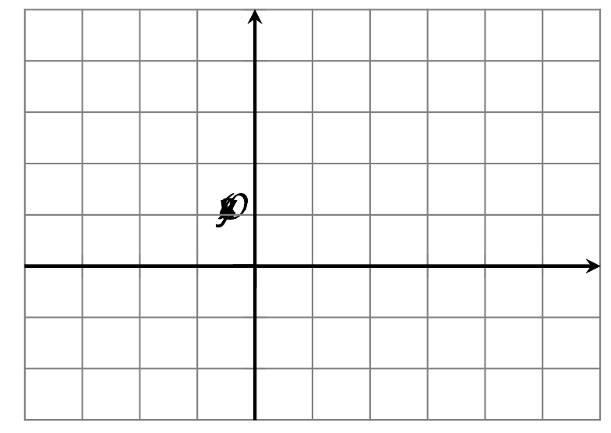
(From Unit 4, Lesson 12.)
Diego claimed that $10+x^{2}$ is always greater than $2^{x}$ and used this table as evidence.
Do you agree with Diego?
$x$ | $10+x^{2}$ | $2^{x}$
1 | 11 | 2
2 | 14 | 4
3 | 19 | 8
4 | 26 | 16
(From Unit 6, Lesson 4.)
The table shows the height, in centimeters, of the water in a swimming pool at different times since the pool started to be filled.
- Does the height of the water increase by the same amount each minute? Explain how you know.
- Does the height of the water increase by the same factor each minute? Explain how you know.
minutes | height
0 | 150
1 | 150.5
2 | 151
3 | 151.5
(From Unit 5, Lesson 2.)
© CC BY 2019 by Illustrative Mathematics®

