Unit 4 Lesson 8: Represent and Solve Story Problems

WU Act It Out: Birds in a Fountain (Warm up)

Student Task Statement
8 birds were splashing in the fountain.
3 of the birds flew away.
How can you act out this story?
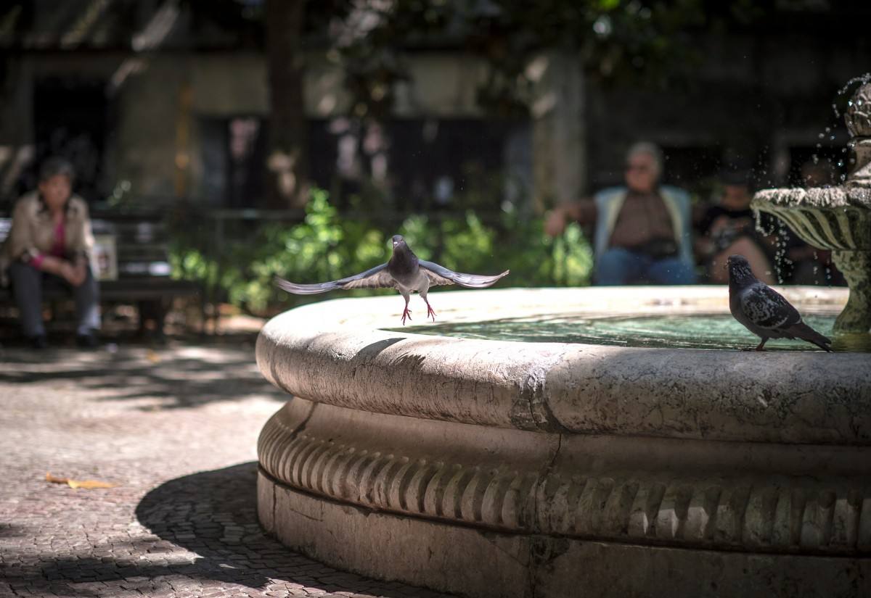

1 Questionless Story Problems

Student Task Statement
- 8 birds were splashing in the fountain.
- 3 of the birds flew away.
- Priya planted 6 flowers in the neighborhood garden at the park.
- Diego planted 3 more flowers in the garden.

2 From a Story to a Story Problem

Student Task Statement
Noah had 5 crayons.
Jada gave Noah 4 more crayons.
How many crayons does Noah have now?

3 Centers: Choice Time

Student Task Statement
Choose a center.
Math Stories
Subtraction Towers
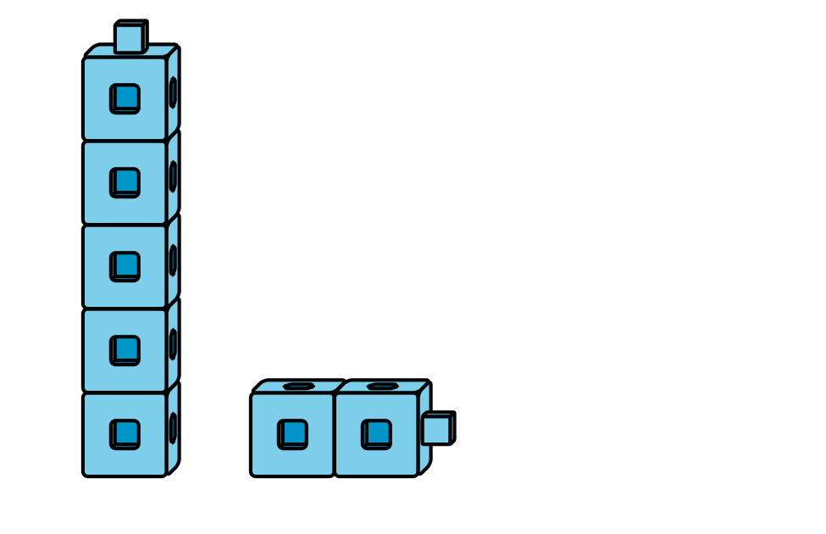
5-frames
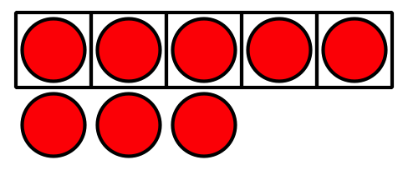
Build Shapes
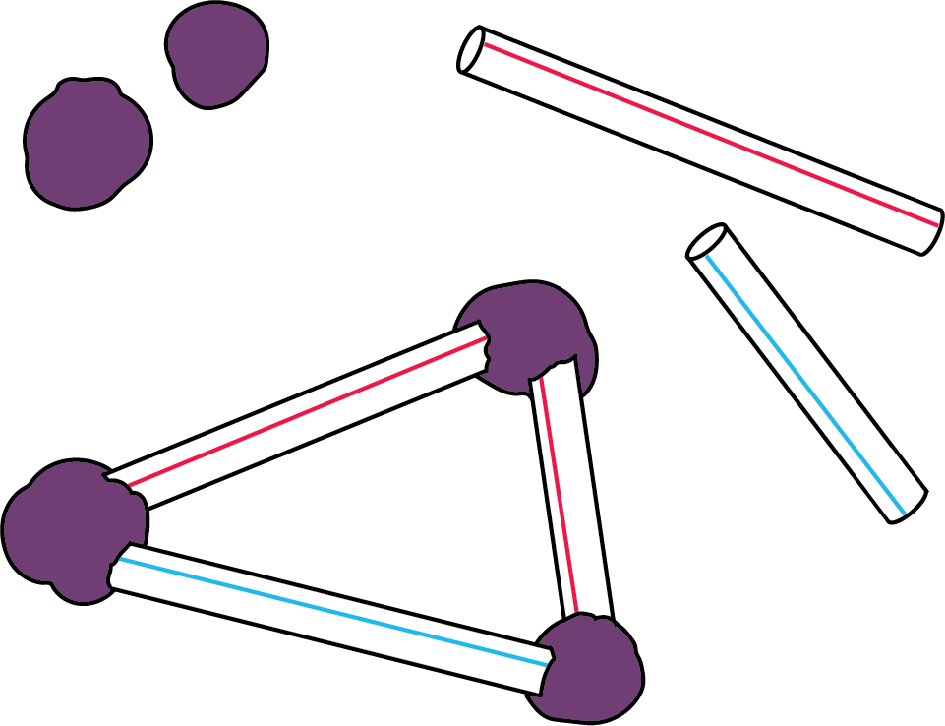
Counting Collections
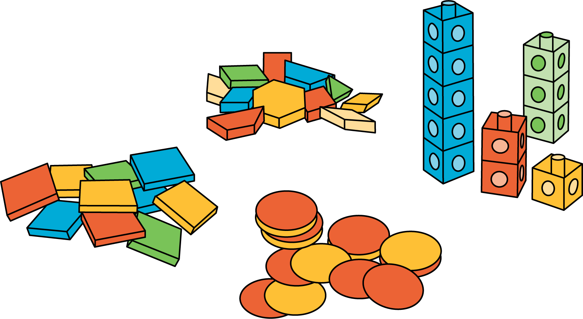
© CC BY 2021 Illustrative Mathematics®

