Lesson 7: Multiply Three- and Four-digit Numbers by One-digit Numbers
- Let’s multiply three- and four-digit numbers by one-digit numbers.

Warm-up: Estimation Exploration: Mysterious Area
What is the area of the rectangle?
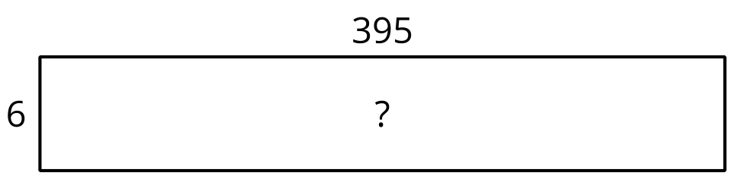
Record an estimate that is:
too low | about right | too high

7.1: Larger Numbers to Multiply
- Clare drew this diagram.
- 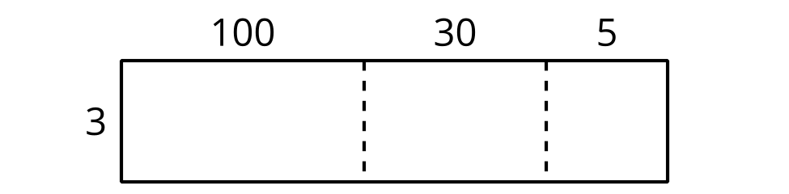
  - What multiplication expression can be represented by the diagram?
  - Find the value of the expression. Show your reasoning.
- Consider the expression $6×252$.
  - Draw a diagram to represent the expression.
  - Find the value of the expression. Show your reasoning.
- Lin drew a diagram to represent $3×2,​135$.
- 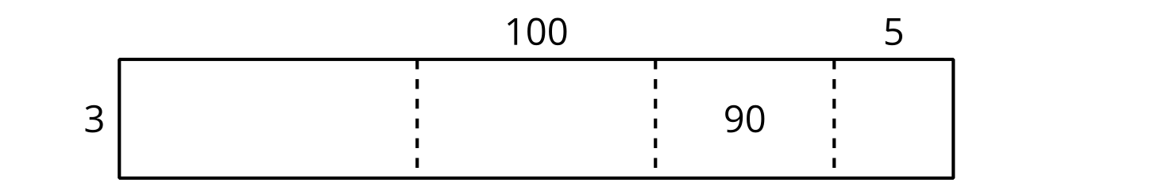
  - Complete Lin’s diagram.
  - Write an expression to represent the value of each part of the diagram.
  - Find the value of $3×2,​135$. Show your reasoning.

7.2: Jada’s Errors
- Jada used a diagram to multiply $3×6,​489$ and made a few errors.
- 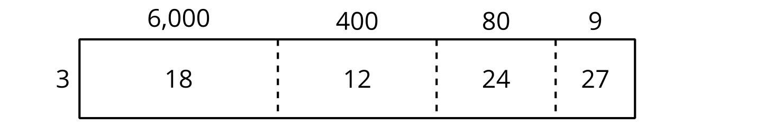
  - Explain the errors Jada made.
  - Find the value of $3×6,​489$. Show your reasoning.
- Find the value of $5×699$. Show your reasoning.
- Find the value of $8×4,​973$. Show your reasoning.
© CC BY 2021 Illustrative Mathematics®

