Lesson 7: Rotation Patterns

7.1: Building a Quadrilateral
Here is a right isosceles triangle:
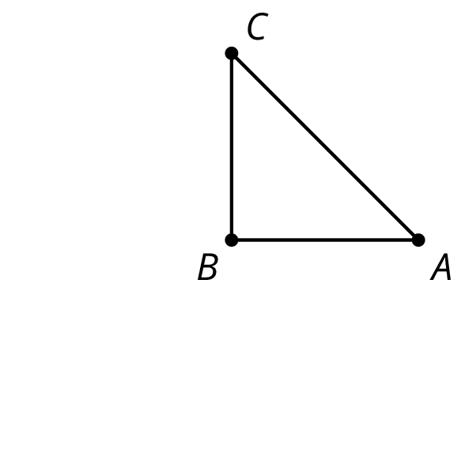

- Rotate triangle $ABC$ 90 degrees clockwise around $B$.
- Rotate triangle $ABC$ 180 degrees clockwise round $B$.
- Rotate triangle $ABC$ 270 degrees clockwise around $B$.
- What would it look like when you rotate the four triangles 90 degrees clockwise around $B$? 180 degrees? 270 degrees clockwise?

7.2: Rotating a Segment
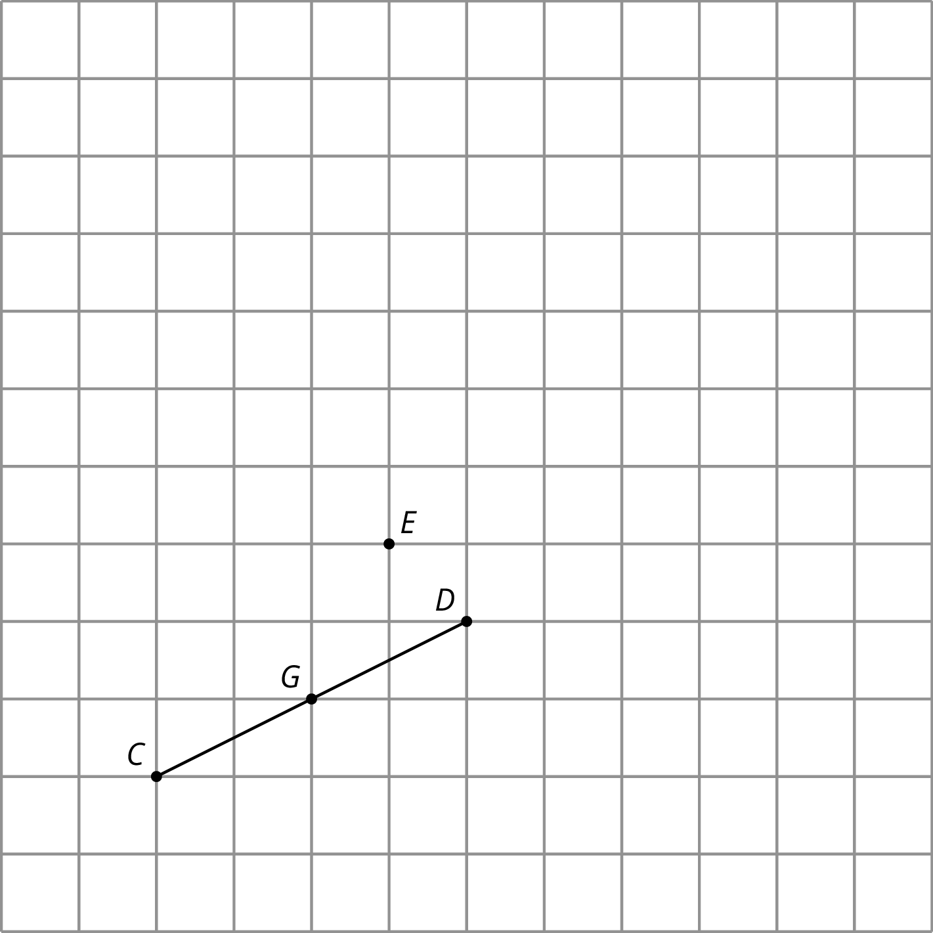
- Rotate segment $CD$ 180 degrees around point $D$. Draw its image and label the image of $C$ as $A.$
- Rotate segment $CD$ 180 degrees around point $E$. Draw its image and label the image of $C$ as $B$ and the image of $D$ as $F$.
- Rotate segment $CD$ 180 degrees around its midpoint, $G.$ What is the image of $C$?
- What happens when you rotate a segment 180 degrees around a point?

Are you ready for more?
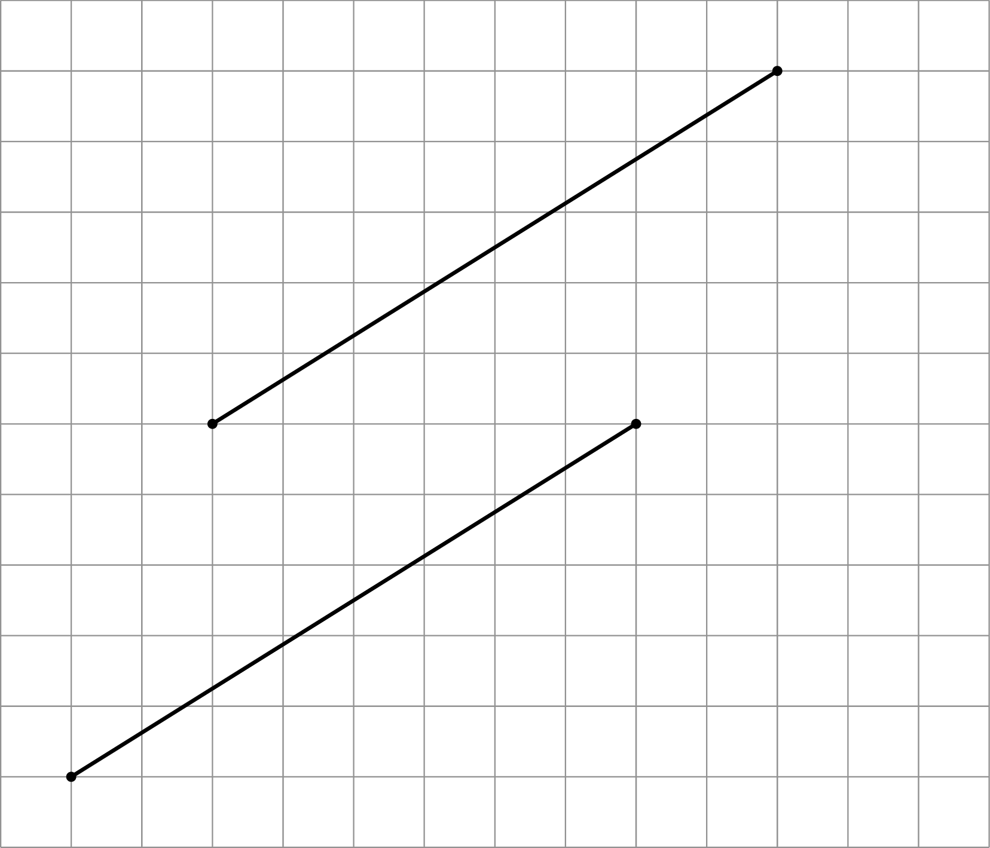
Here are two line segments. Is it possible to rotate one line segment to the other? If so, find the center of such a rotation. If not, explain why not.

7.3: A Pattern of Four Triangles
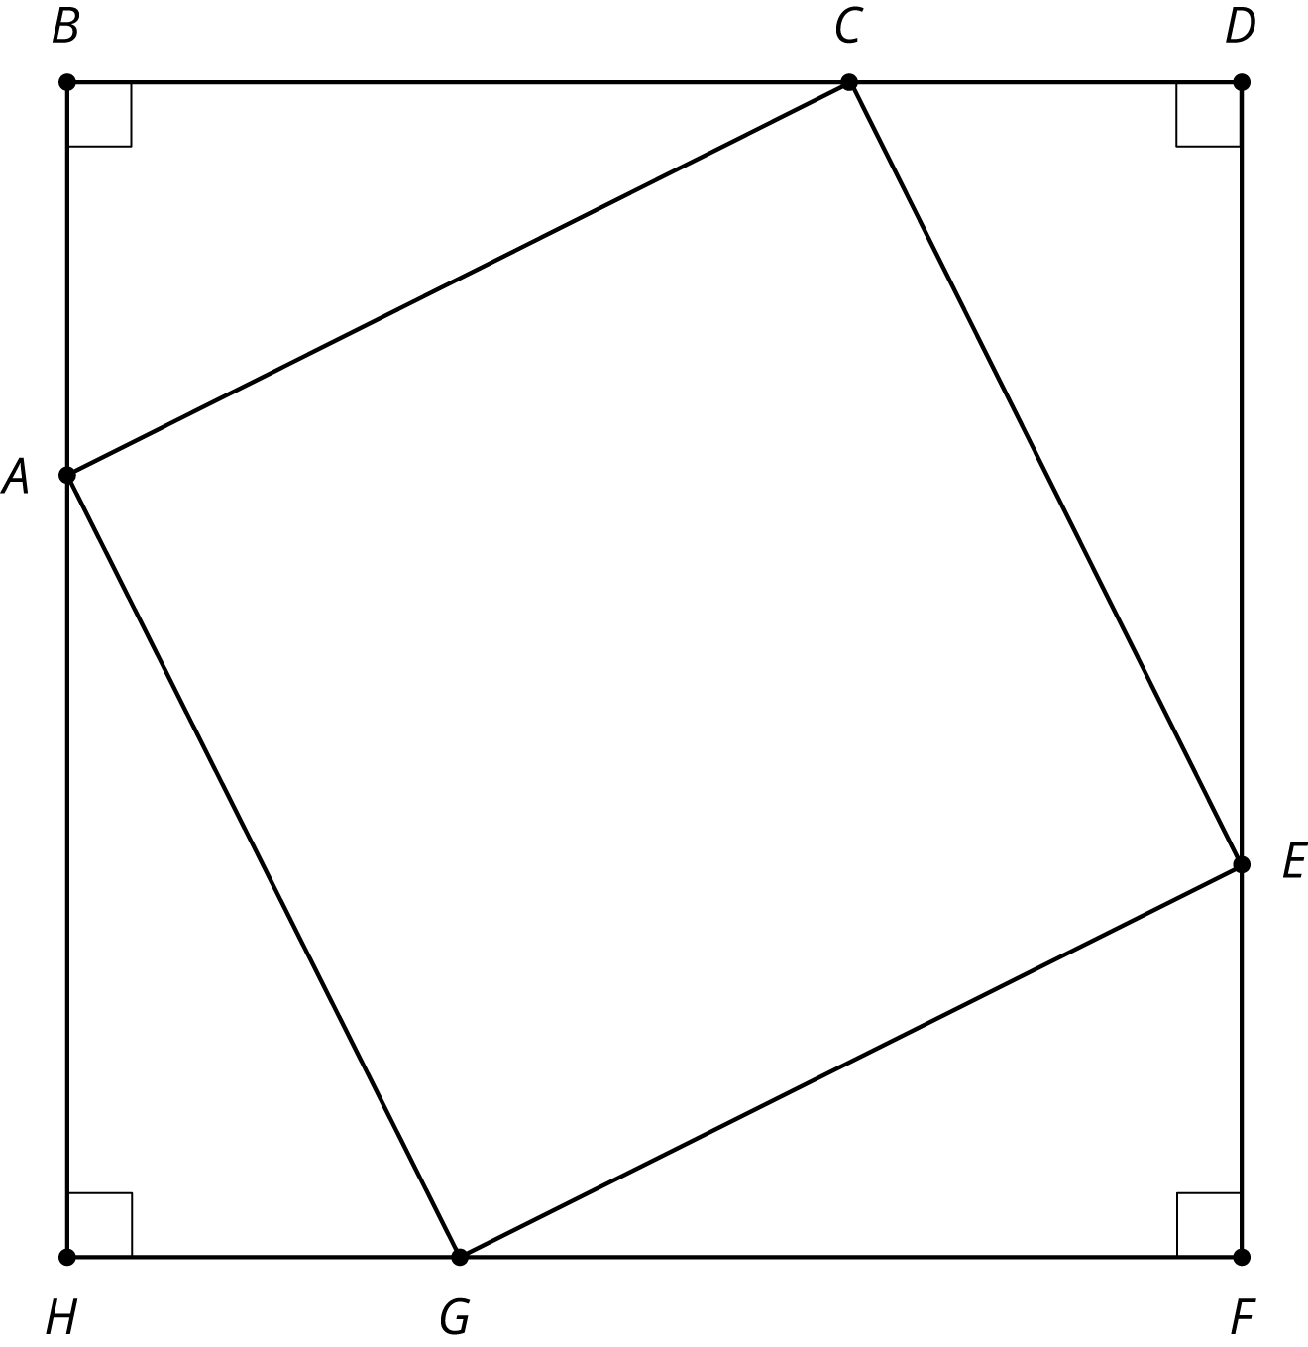
You can use rigid transformations of a figure to make patterns. Here is a diagram built with three different transformations of triangle $ABC$.
- Describe a rigid transformation that takes triangle $ABC$ to triangle $CDE$.
- Describe a rigid transformation that takes triangle $ABC$ to triangle $EFG$.
- Describe a rigid transformation that takes triangle $ABC$ to triangle $GHA$.
- Do segments $AC$, $CE$, $EG$, and $GA$ all have the same length? Explain your reasoning.

Lesson 7 Summary
When we apply a 180-degree rotation to a line segment, there are several possible outcomes:
- The segment maps to itself (if the center of rotation is the midpoint of the segment).
- The image of the segment overlaps with the segment and lies on the same line (if the center of rotation is a point on the segment).
- The image of the segment does not overlap with the segment (if the center of rotation is not on the segment).
We can also build patterns by rotating a shape. For example, triangle $ABC$ shown here has $m(∠A)=60$. If we rotate triangle $ABC$ 60 degrees, 120 degrees, 180 degrees, 240 degrees, and 300 degrees clockwise, we can build a hexagon.
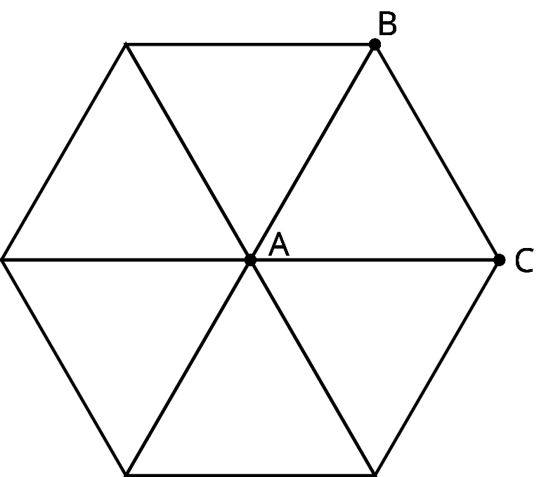
© CC BY Open Up Resources. Adaptations CC BY IM.

