Unit 1 Lesson 3: Explore Two-color Counters and 5-frames

WU Notice and Wonder: Counters and 5-frames (Warm up)

Student Task Statement
What do you notice?
What do you wonder?
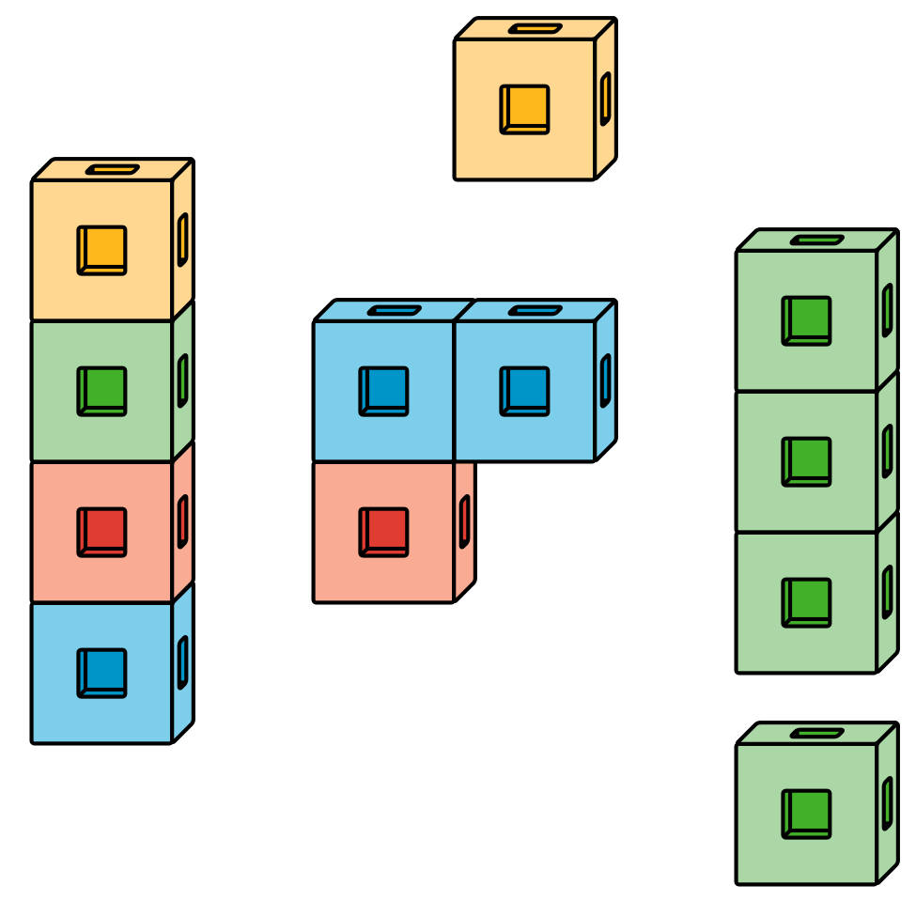
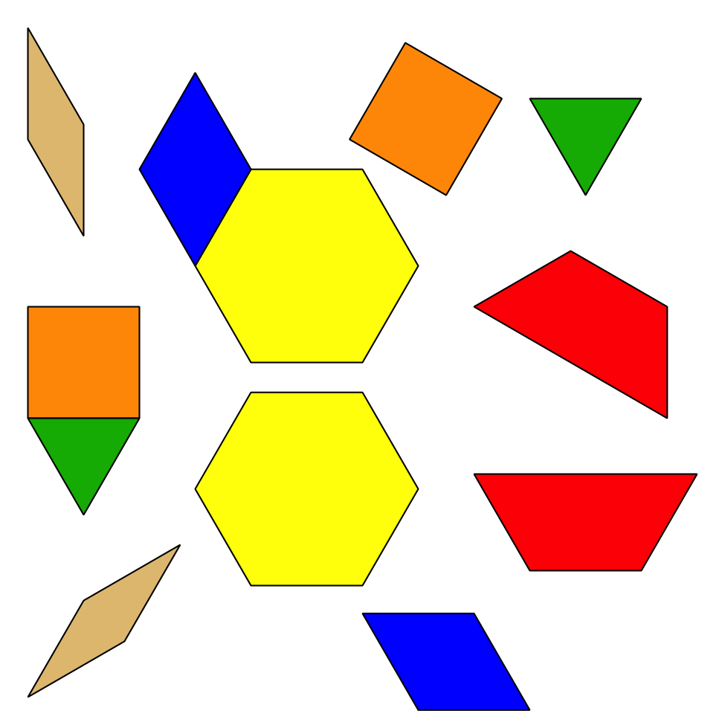

1 Explore Counters and 5-frames

Student Task Statement
Let’s explore two-color counters and 5-frames.
© CC BY 2021 Illustrative Mathematics®

