Lesson 1: Count Larger Collections of Objects
- Let’s figure out how many objects are in our collections.

1.3: Introduce Number Race, 11–20
Choose a center.
Number Race
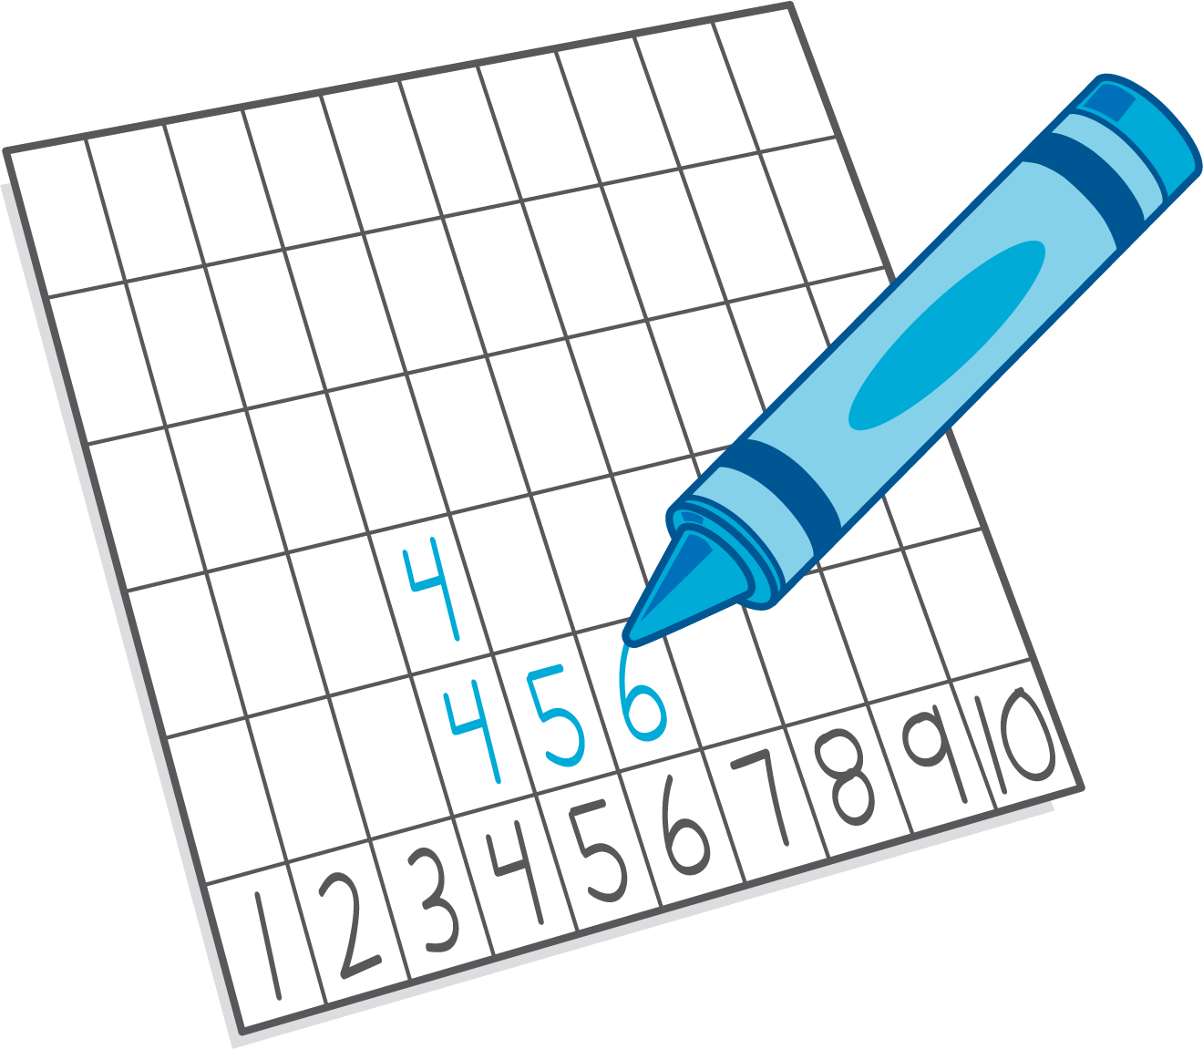
Subtraction Towers
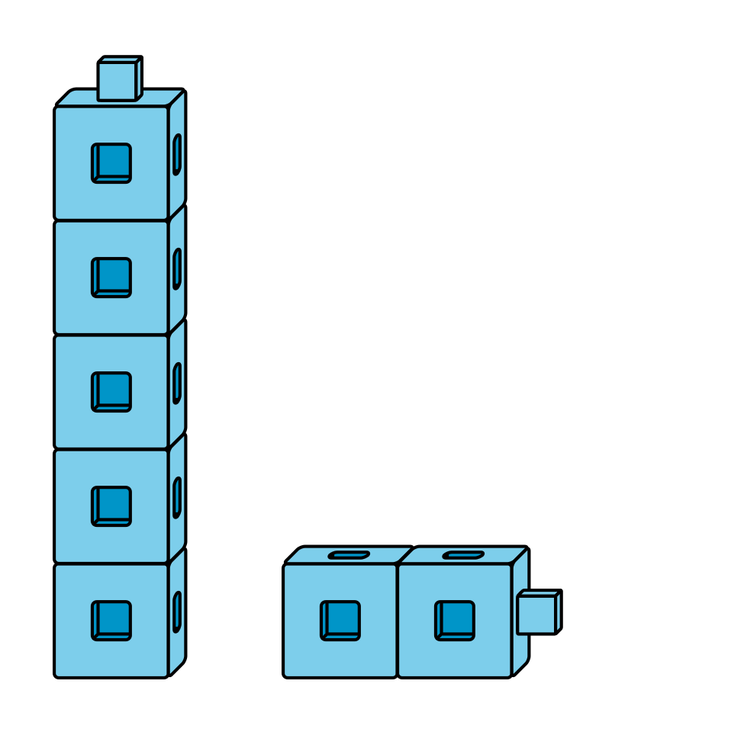
5-frames
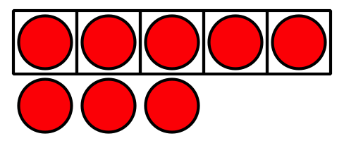
© CC BY 2021 Illustrative Mathematics®

