Lesson 4 Practice Problems
- An artist is selling children's crafts. Necklaces cost $2.25 each, and bracelets cost $1.50 per each.
- Select all the combinations of necklaces and bracelets that the artist could sell for exactly $12.00.
  - 5 necklaces and 1 bracelet
  - 2 necklaces and 5 bracelets
  - 3 necklaces and 3 bracelet
  - 4 necklaces and 2 bracelets
  - 3 necklaces and 5 bracelets
  - 6 necklaces and no bracelets
  - No necklaces and 8 bracelets
- Diego is collecting dimes and nickels in a jar. He has collected $22.25 so far. The relationship between the numbers of dimes and nickels, and the amount of money in dollars is represented by the equation $0.10d+0.05n=22.25$.
- Select all the values $\left(d,n\right)$ that could be solutions to the equation.
  - $\left(0,445\right)$
  - $\left(0.50,435\right)$
  - $\left(233,21\right)$
  - $\left(118,209\right)$
  - $\left(172,101\right)$
- Volunteer drivers are needed to bring 80 students to the championship baseball game. Drivers either have cars, which can seat 4 students, or vans, which can seat 6 students. The equation $4c+6v=80$ describes the relationship between the number of cars, $c$, and number of vans, $v$, that can transport exactly 80 students.
- Select all statements that are true about the situation.
  - If 12 cars go, then 2 vans are needed.
  - The pair $c=14$ and $v=4$ is a solution to the equation.
  - If 6 cars go and 11 vans go, there will be extra space.
  - 10 cars and 8 vans isn’t enough to transport all the students.
  - If 20 cars go, no vans are needed.
  - 8 vans and 8 cars are numbers that meet the constraints in this situation.
- The drama club is printing t-shirts for its members. The printing company charges a certain amount for each shirt plus a setup fee of $40. There are 21 students in the drama club.
  - If there are 21 students in the club and the t-shirt order costs a total of $187, how much does each t-shirt cost? Show your reasoning.
  - The equation $201.50=f+6.50\left(21\right)$ represents the cost of printing the shirts at a second printing company. Find the solution to the equation and state what it represents in this situation.
- The box plot represents the distribution of the number of children in 30 different familes.
- 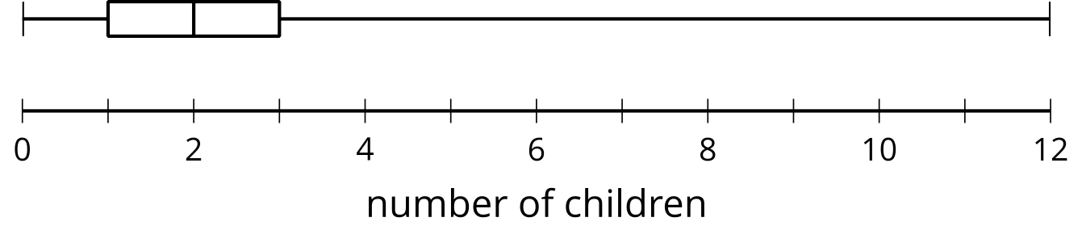

- After further examination, the value of 12 is removed for having been recorded in error. The box plot represents the distribution of the same data set, but with the maximum, 12, removed.
- 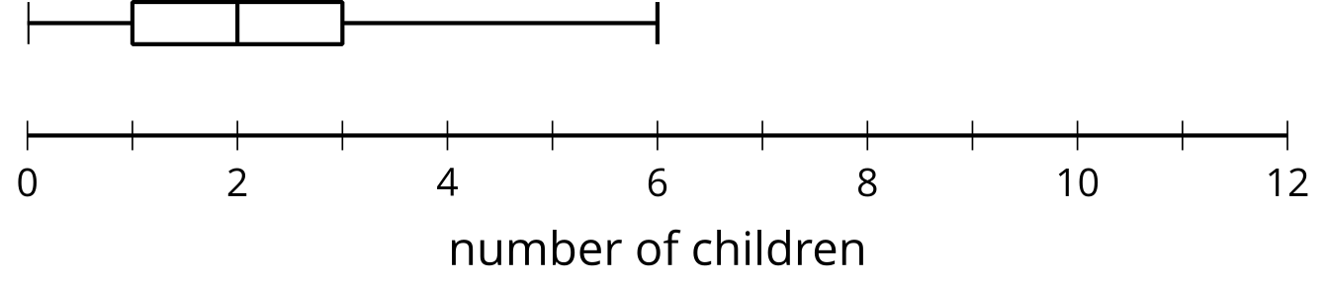

- The median is 2 children for both plots.
  - Explain why the median remains the same when 12 was removed from the data set.
  - When 12 is removed from the data set, does mean remain the same? Explain your reasoning.
- (From Unit 1, Lesson 10.)
- The number of points Jada's basketball team scored in their games have a mean of about 44 and a standard deviation of about 15.7 points.
- Interpret the mean and standard deviation in the context of Jada's basketball team.
- (From Unit 1, Lesson 13.)
- Kiran’s family is having people over to watch a football game. They plan to serve sparkling water and pretzels. They are preparing 12 ounces of sparkling water and 3 ounces of pretzels per person. Including Kiran’s family, there will be 10 people at the gathering.
- A bottle of sparkling water contains 22 ounces and costs $1.50. A package of pretzels contains 16 ounces and costs $2.99. Let $n$ represent number of people watching the football game, $s$ represent the ounces of sparkling water, $p$ represent the ounces of pretzels, and $b$ represent Kiran’s budget in dollars. Which equation best represents Kiran’s budget?
  - $12s+3p=b$
  - $12⋅10+3⋅10=b$
  - $1.50s+2.99p=b$
  - $1.50⋅6+2.99⋅2=b$
- (From Unit 2, Lesson 2.)
- The speed of an object can be found by taking the distance it travels and dividing it by the time it takes to travel that distance. An object travels 100 feet in 2.5 seconds. Let the speed, $S$, be measured in feet per second.
- Write an equation to represent the relationship between the three quantities (speed, distance, and time).
- (From Unit 2, Lesson 2.)
- A donut shop made 12 dozen donuts to give to a school’s math club.
- Which expression represents how many donuts each student would get if the donuts were equally distributed and there were $x$ students in math club?
  - $\frac{x}{12}$
  - $12⋅\frac{12}{x}$
  - $\left(12⋅12\right)⋅x$
  - $12⋅12$
- (From Unit 2, Lesson 1.)
© CC BY 2019 by Illustrative Mathematics®

