Lesson 6 Practice Problems
- The height of a diver above the water, is given by $h(t)=\text{-}5t^{2}+10t+3$, where $t$ is time measured in seconds and $h(t)$ is measured in meters. Select all statements that are true about the situation.
  - The diver begins 5 meters above the water.
  - The diver begins 3 meters above the water.
  - The function has 1 zero that makes sense in this situation.
  - The function has 2 zeros that make sense in this situation.
  - The graph that represents $h$ starts at the origin and curves upward.
  - The diver begins at the same height as the water level.
- The height of a baseball, in feet, is modeled by the function $h$ given by the equation $h(t)=3+60t−16t^{2}$. The graph of the function is shown.
  - About when does the baseball reach its maximum height?
  - About how high is the maximum height of the baseball?
  - About when does the ball hit the ground?
- ​​​​
- Technology required. Two rocks are launched straight up in the air. The height of Rock A is given by the function $f$, where $f(t)=4+30t−16t^{2}$. The height of Rock B is given by $g$, where $g(t)=5+20t−16t^{2}$. In both functions, $t$ is time measured in seconds and height is measured in feet.
- Use graphing technology to graph both equations. Determine which rock hits the ground first and explain how you know.
- Each expression represents an object’s distance from the ground in meters as a function of time, $t$, in seconds.
- Object A: $−5t^{2}+25t+50$
- Object B: $−5t^{2}+50t+25$
  - Which object was launched with the greatest vertical speed?
  - Which object was launched from the greatest height?
- Tyler is building a pen for his rabbit on the side of the garage. He needs to fence in three sides and wants to use 24 ft of fencing.
- 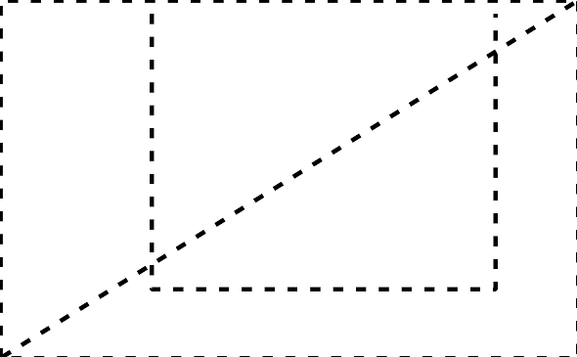
  - The table show some possible lengths and widths. Complete each area.
  - Which length and width combination should Tyler choose to give his rabbit the most room?
- length (ft) | - width (ft) | - area (sq ft)
- 8 | - 8
- 10 | - 7
- 12 | - 6
- 14 | - 5
- 16 | - 4
- (From Unit 6, Lesson 1.)
- Here is a pattern of dots.
  - Complete the table.
  - How many dots will there be in Step 10?
  - How many dots will there be in Step $n$?
- step | - total number  of dots
- 0
- 1
- 2
- 3
- (From Unit 6, Lesson 2.)
- The function $f$ is defined by $f(x)=2^{x}$ and the function $g$ is defined by $g(x)=x^{2}+16$.
  - Find the values of $f$ and $g$ when $x$ is 4, 5, and 6.
  - Will the values of $f$ always be greater than the values of $g$? Explain how you know.
- (From Unit 6, Lesson 4.)
- Han accidentally drops his water bottle from the balcony of his apartment building. The equation $d=32−5t^{2}$ gives the distance from the ground, $d$, in meters after $t$ seconds.
  - Complete the table and plot the data on the coordinate plane.
- $t$ (seconds) | - $d$ (meters)
  - 0
  - 0.5
  - 1
  - 1.5
  - 2
  - ​​​​​​
  - Is the water bottle falling at a constant speed? Explain how you know.
- (From Unit 6, Lesson 5.)
- The graph shows how much insulin, in micrograms (mcg), is in a patient's body after receiving an injection.
  - Write an equation giving the number of mcg of insulin, $m$, in the patient's body $h$ hours after receiving the injection.
  - After 3 hours, will the patient still have at least 10 mcg of insulin in their body? Explain how you know.
- (From Unit 5, Lesson 6.)
© CC BY 2019 by Illustrative Mathematics®

