Teacher Presentation Materials

Unit 5 Lesson 4: Reflecting Functions

1 Notice and Wonder: Reflections (Warm up)

Student Task Statement
What do you notice? What do you wonder?
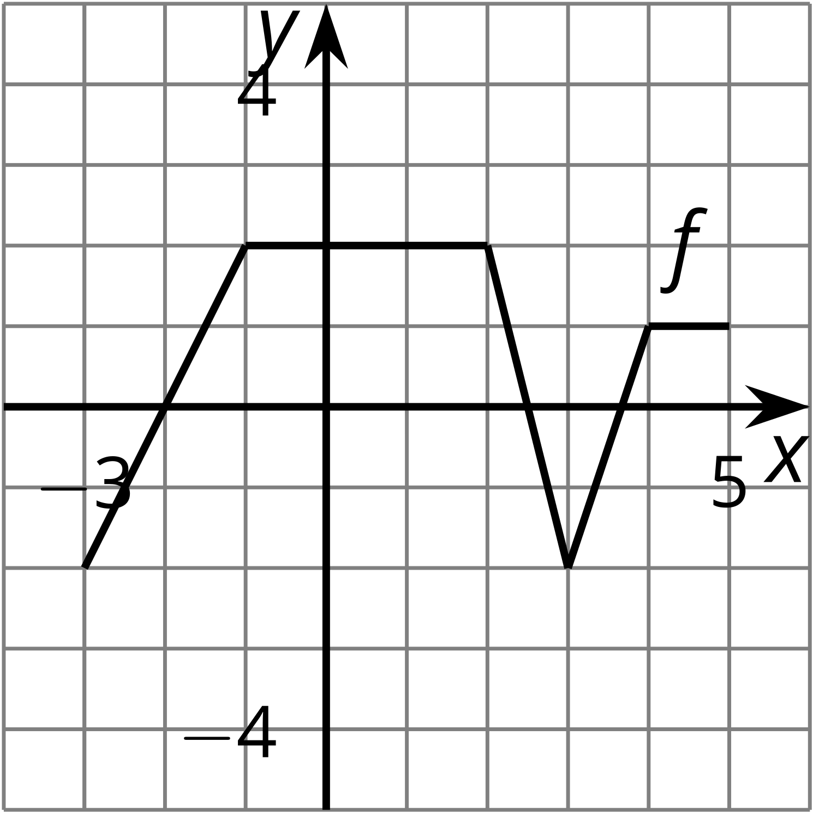
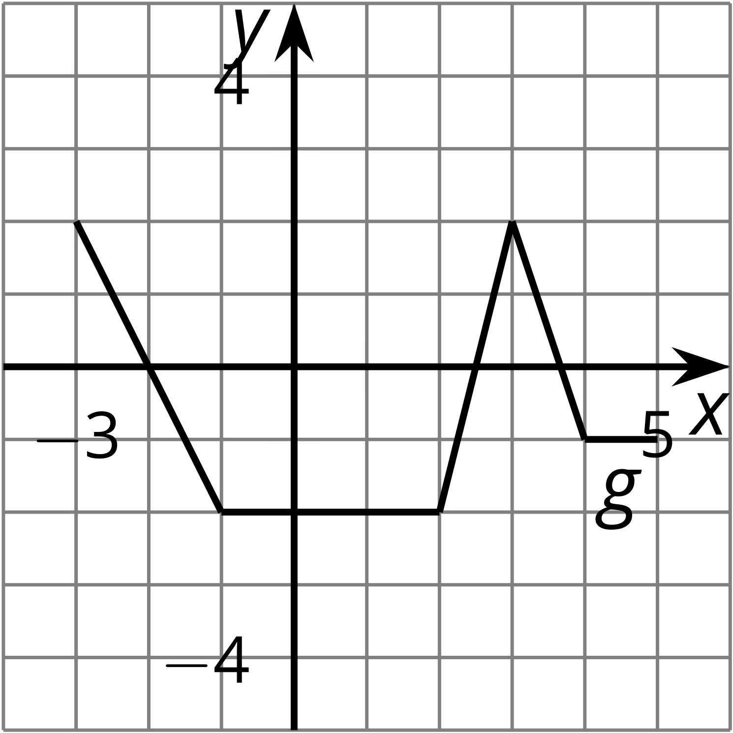
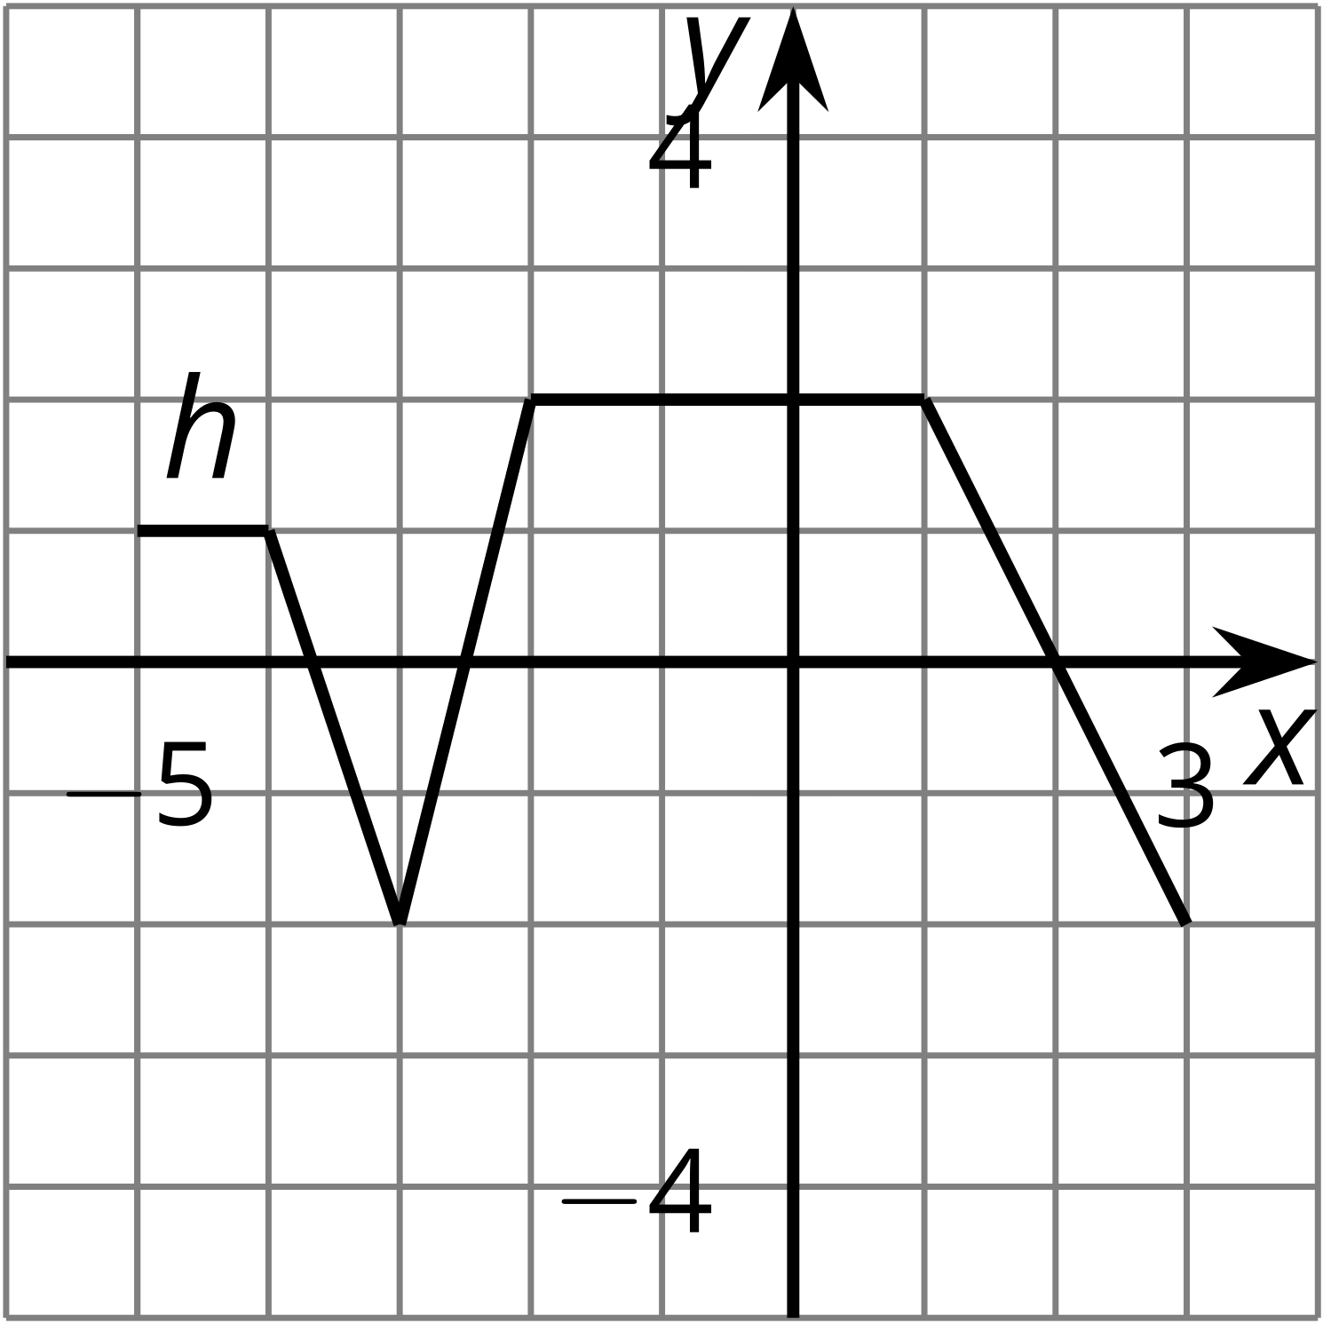

2 Reflecting Across

Student Task Statement
Here is the graph of function $f$ and a table of values.
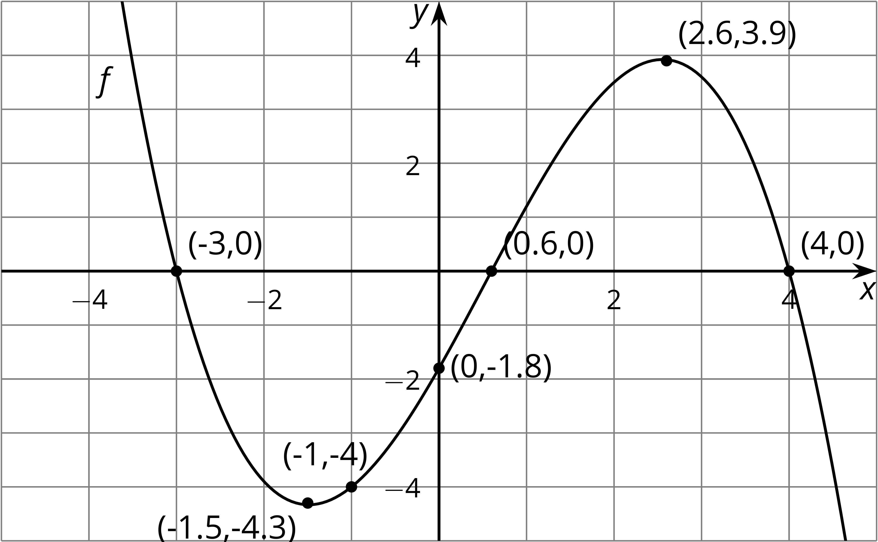
$x$ | $f(x)$ | $g(x)=\text{-}f(x)$
-3 | 0
-1.5 | -4.3
-1 | -4
0 | -1.8
0.6 | 0
2.6 | 3.9
4 | 0
- Let $g$ be the function defined by $g(x)=\text{-}f(x)$. Complete the table.
- Sketch the graph of $g$ on the same axes as the graph of $f$ but in a different color.
- Describe how to transform the graph of $f$ into the graph of $g$. Explain how the equation produces this transformation.

3 Reflecting Across a Different Way

Student Task Statement
Here is another copy of the graph of $f$ from the earlier activity. This time, let $h$ be the function defined by $h(x)=f(\text{-}x)$.
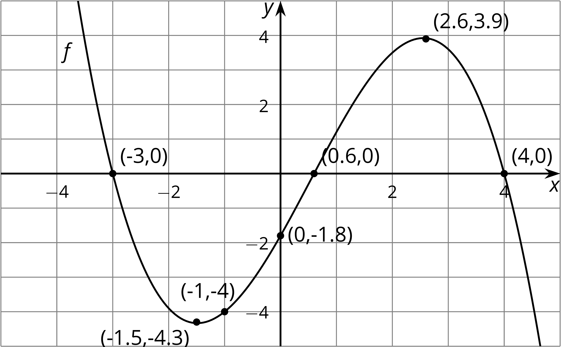
- Use the definition of $h$ to find $h(0)$. Does your answer agree with your prediction?
- What does your prediction tell you about $h(\text{-}0.6)$? Does your answer agree with the definition of $h$?
- Complete the tables. The values for $x$ will not be the same for the two tables.
- $x$ | - $f(x)$
- -3 | - 0
- -1.5 | - -4.3
- -1 | - -4
- 0 | - -1.8
- 0.6 | - 0
- 2.6 | - 3.9
- 4 | - 0
- $x$ | - $h(x)=f(\text{-}x)$
- Sketch the graph of $h$ on the same axes as the graph of $f$ but in a different color.
- Describe what happened to the graph of $f$ to transform it into the graph of $h$. Explain how the equation produces this transformation.

Images for Activity Synthesis
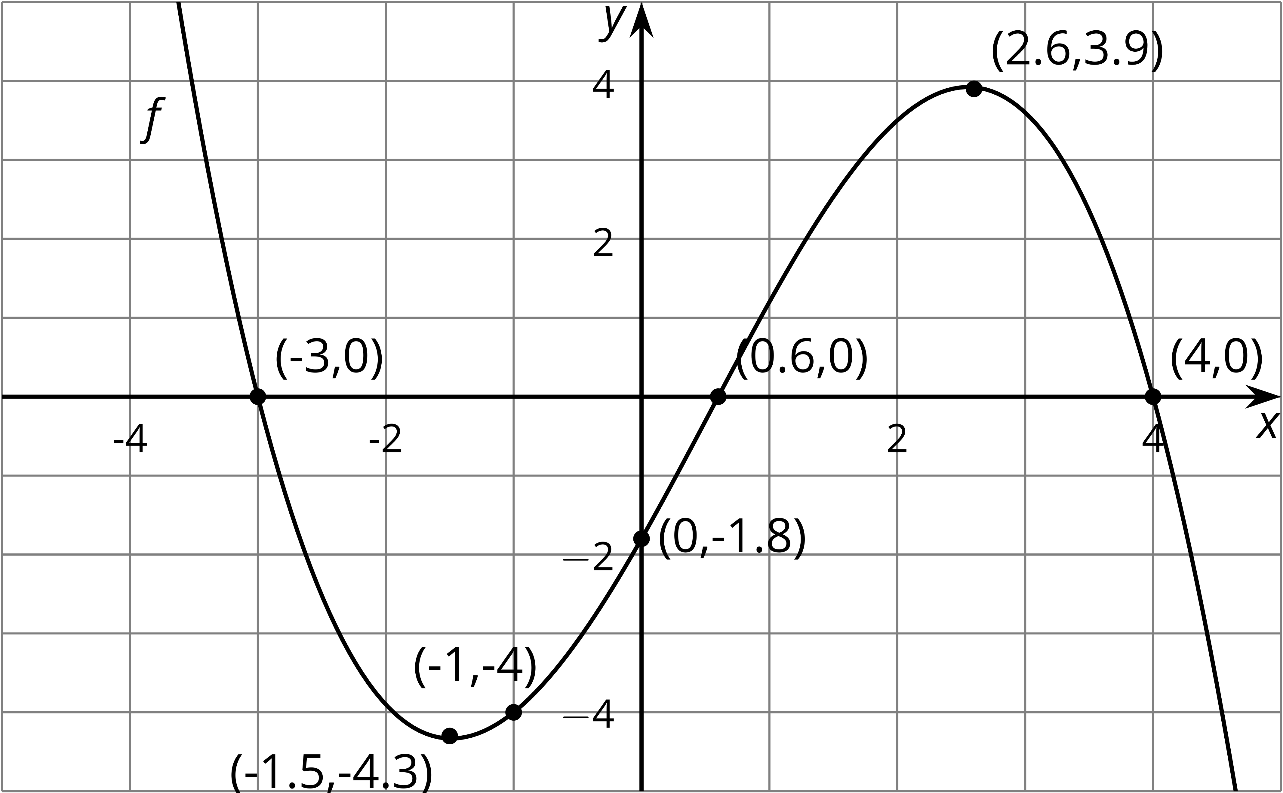
© CC BY 2019 by Illustrative Mathematics

