Lesson 10 Practice Problems
- A quadratic function $f$ is defined by $f\left(x\right)=\left(x−7\right)\left(x+3\right)$.
  - Without graphing, identify the $x$-intercepts of the graph of $f$. Explain how you know.
  - Expand $\left(x−7\right)\left(x+3\right)$ and use the expanded form to identify the $y$-intercept of the graph of $f$.
- What are the $x$-intercepts of the graph of the function defined by $\left(x−2\right)\left(2x+1\right)$?
  - $\left(2,0\right)$ and $\left(\text{-}1,0\right)$
  - $\left(2,0\right)$ and $\left(\text{-}\frac{1}{2},0\right)$
  - $\left(\text{-}2,0\right)$ and $\left(1,0\right)$
  - $\left(\text{-}2,0\right)$ and $\left(\frac{1}{2},0\right)$
- Here is a graph that represents a quadratic function.
- Which expression could define this function?
- 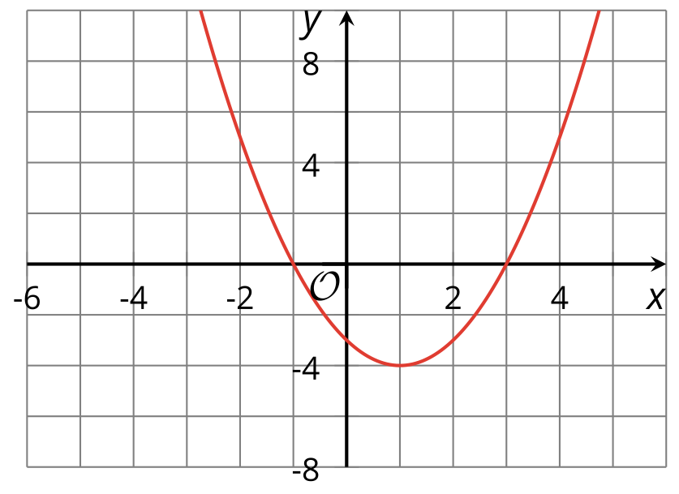
  - $\left(x+3\right)\left(x+1\right)$
  - $\left(x+3\right)\left(x−1\right)$
  - $\left(x−3\right)\left(x+1\right)$
  - $\left(x−3\right)\left(x−1\right)$

  - What is the $y$-intercept of the graph of the equation $y=x^{2}−5x+4$?
  - An equivalent way to write this equation is $y=\left(x−4\right)\left(x−1\right)$. What are the $x$-intercepts of this equation’s graph?
- Noah said that if we graph $y=\left(x−1\right)\left(x+6\right)$, the $x$-intercepts will be at $\left(1,0\right)$ and $\left(\text{-}6,0\right)$. Explain how you can determine, without graphing, whether Noah is correct.
- A company sells a video game. If the price of the game in dollars is $p$ the company estimates that it will sell $20,​000−500p$ games.
- Which expression represents the revenue in dollars from selling games if the game is priced at $p$ dollars?
  - $\left(20,​000−500p\right)+p$
  - $\left(20,​000−500p\right)−p$
  - $\frac{20,000−500p}{p}$
  - $\left(20,​000−500p\right)⋅p$
- (From Unit 6, Lesson 7.)
- Write each quadratic expression in standard form. Draw a diagram if needed.
  - $\left(x−3\right)\left(x−6\right)$
  - ${\left(x−4\right)}^{2}$
  - $\left(2x+3\right)\left(x−4\right)$
  - $\left(4x−1\right)\left(3x−7\right)$
- (From Unit 6, Lesson 9.)
- Consider the expression $\left(5+x\right)\left(6−x\right)$.
  - Is the expression equivalent to $x^{2}+x+30$? Explain how you know.
  - Is the expression $30+x−x^{2}$ in standard form? Explain how you know.
- (From Unit 6, Lesson 9.)
- Here are graphs of the functions $f$ and $g$ given by $f\left(x\right)=100⋅{\left(\frac{3}{5}\right)}^{x}$ and $g\left(x\right)=100⋅{\left(\frac{2}{5}\right)}^{x}$.
- Which graph corresponds to $f$ and which graph corresponds to $g$? Explain how you know.
- 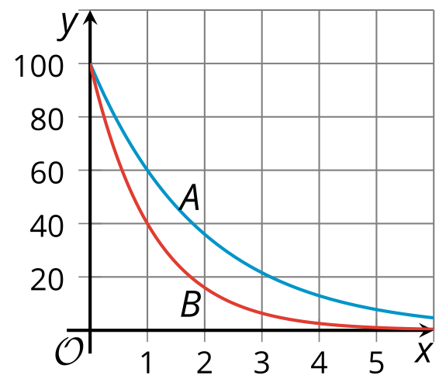
- (From Unit 5, Lesson 12.)
- Here are graphs of two functions $f$ and $g$.
- An equation defining $f$ is $f\left(x\right)=100⋅2^{x}$.
- Which of these could be an equation defining the function $g$?
- 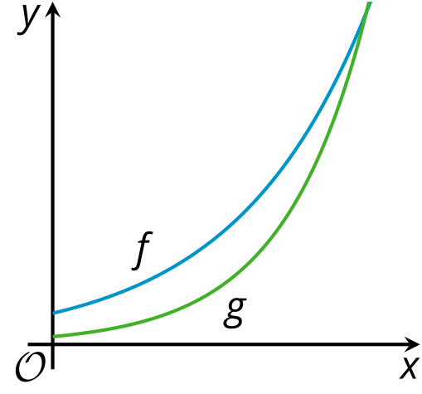
  - $g\left(x\right)=25⋅3^{x}$
  - $g\left(x\right)=50⋅{\left(1.5\right)}^{x}$
  - $g\left(x\right)=100⋅3^{x}$
  - $g\left(x\right)=200⋅{\left(1.5\right)}^{x}$
- (From Unit 5, Lesson 13.)
© CC BY 2019 by Illustrative Mathematics®

