Unit 1 Lesson 13: Questions About Data

WU Number Talk: Plus or Minus 1 or 2 (Warm up)

Student Task Statement
Find the value of each expression mentally.
- $7+1$
- $7+2$
- $9−1$
- $9−2$

1 Can You Answer It?

Student Task Statement
Elena asked her classmates, “What is your favorite subject in school?”
She showed their responses below.
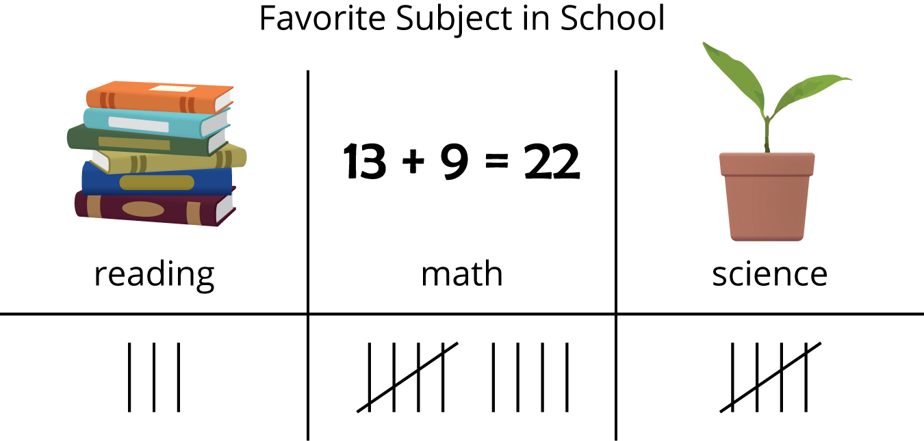
Han wrote questions about Elena's data.
Decide whether each question can be answered using the data representation.
Be ready to explain why.
- How many students said math is their favorite subject?
- How many students said writing is their favorite subject?
- Who said they like reading best?
- How many students chose reading or science?

2 Ask Questions

Student Task Statement
Our favorite __________________________________________________
category 1 | category 2 | category 3

3 Answer Questions

Student Task Statement
© CC BY 2021 Illustrative Mathematics®

