Lesson 8: Multiply 2 Two-digit Numbers
- Let’s multiply 2 two-digit numbers.

Warm-up: Number Talk: Extra Groups
Find the value of each expression mentally.
- $20×60$
- $21×60$
- $20×62$
- $19×60$

8.1: Two by Two
- For each diagram, write a multiplication expression that the diagram can represent. Then, find the value of the expression. Use equations to show or explain your reasoning.
  - 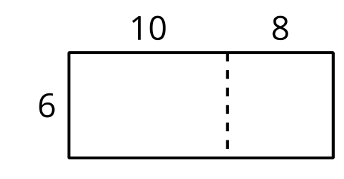
  - 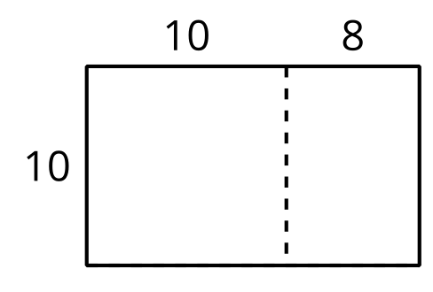
  - 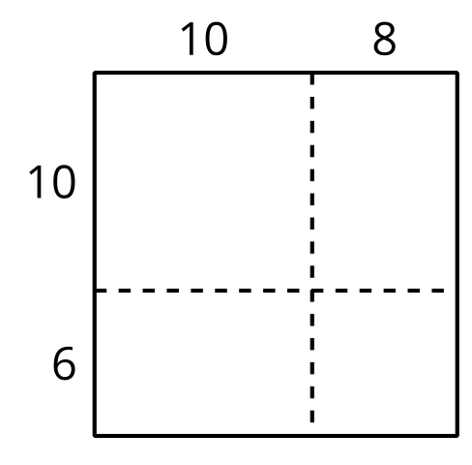
- How are the diagrams alike? How are they different? Discuss with your partner.
- Use a diagram to find each product.
  - $13×21$
  - $25×46$

8.2: Decompose by Place Value
These diagrams could be used to find the value of $49×57$.
Diagram A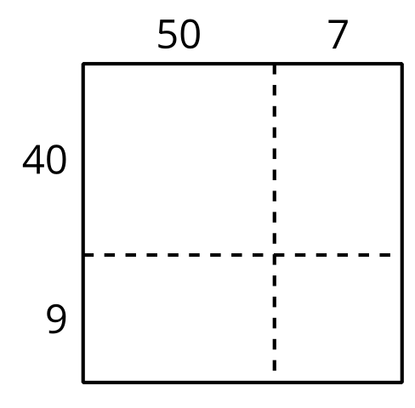
Diagram B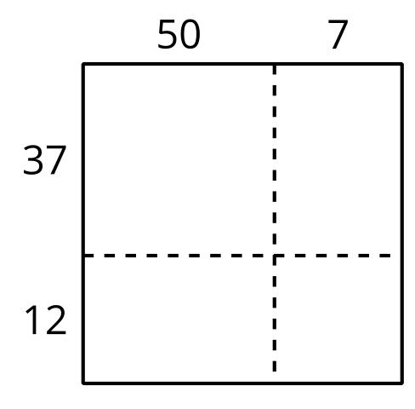
- Which diagram is more helpful when finding the value of $49×57$? Why?
- Use a diagram to find each product.
  - $49×57$
  - $29×55$
© CC BY 2021 Illustrative Mathematics®

