Unit 1 Lesson 9 Cumulative Practice Problems
- Here is the design for the flag of Trinidad and Tobago.
- Describe a sequence of translations, rotations, and reflections that take the lower left triangle to the upper right triangle.
- Here is a picture of an older version of the flag of Great Britain. There is a rigid transformation that takes Triangle 1 to Triangle 2, another that takes Triangle 1 to Triangle 3, and another that takes Triangle 1 to Triangle 4.
- 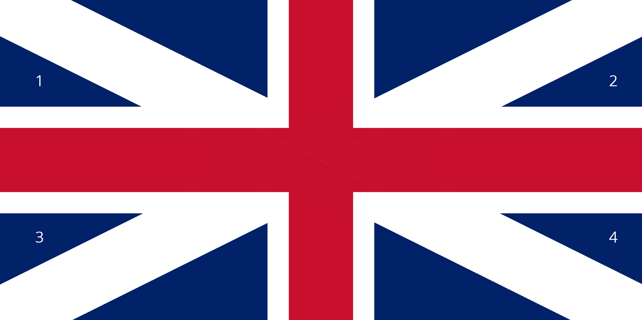
  - Measure the lengths of the sides in Triangles 1 and 2. What do you notice?
  - What are the side lengths of Triangle 3? Explain how you know.
  - Do all eight triangles in the flag have the same area? Explain how you know.
  - Which of the lines in the picture is parallel to line $ℓ$? Explain how you know.
  - 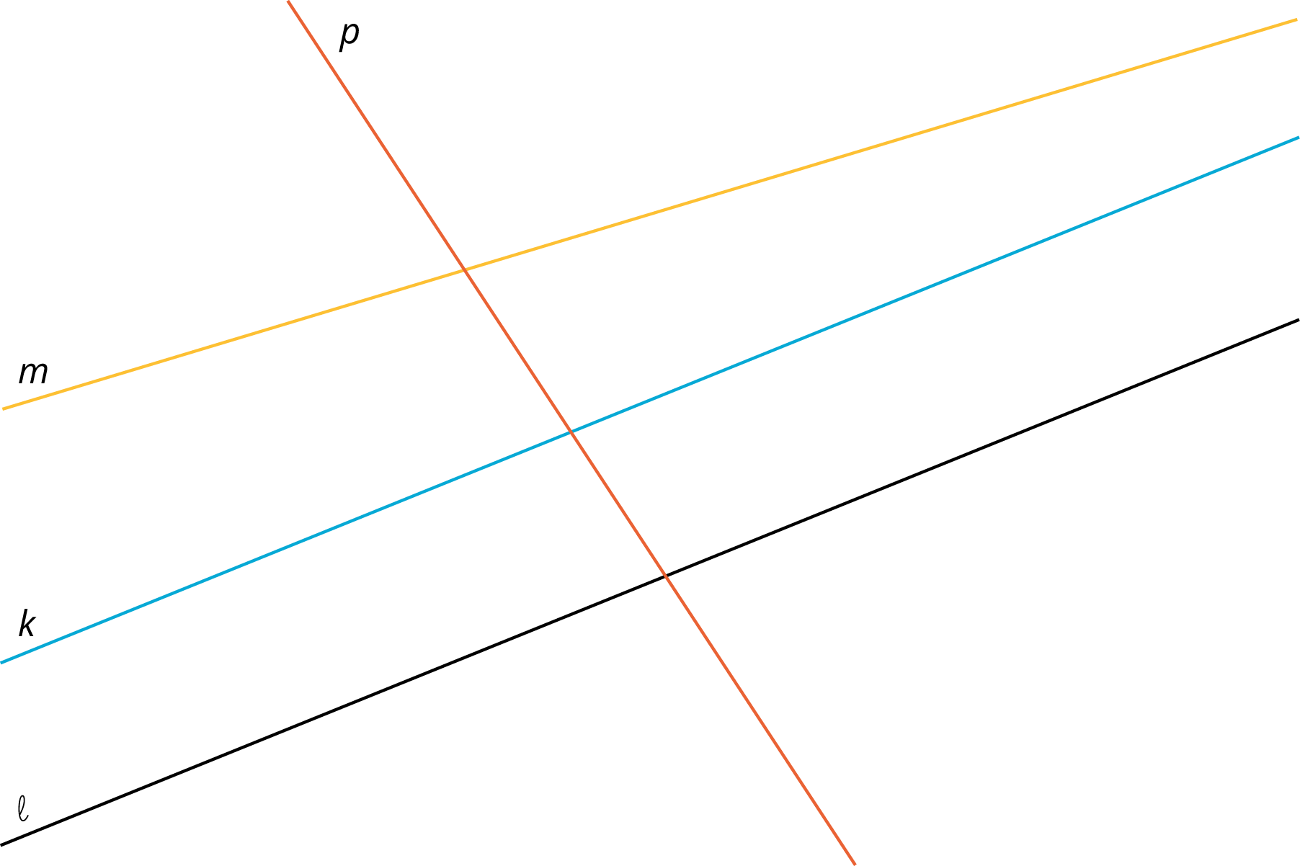
  - Explain how to translate, rotate or reflect line $ℓ$ to obtain line $k$.
  - Explain how to translate, rotate or reflect line $ℓ$ to obtain line $p$.
- (From Unit 1, Lesson 8.)
- Point $A$ has coordinates $(3,4)$. After a translation 4 units left, a reflection across the $x$-axis, and a translation 2 units down, what are the coordinates of the image?
- (From Unit 1, Lesson 5.)
- Here is triangle $XYZ$:
- 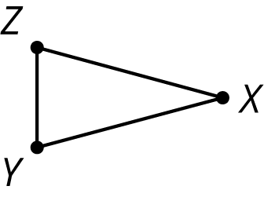

- Draw these three rotations of triangle $XYZ$ together.
  - Rotate triangle $XYZ$ 90 degrees clockwise around $Z$.
  - Rotate triangle $XYZ$ 180 degrees around $Z$.
  - Rotate triangle $XYZ$ 270 degrees clockwise around $Z$.
- (From Unit 1, Lesson 7.)
© CC BY Open Up Resources. Adaptations CC BY IM.

