Lesson 3 Practice Problems
- Use the tape diagram to find the value of $\frac{1}{2}÷\frac{1}{3}$. Show your reasoning.
- 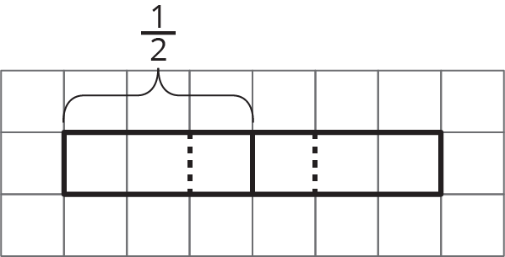
- Use the tape diagram to answer the question: How many $\frac{2}{5}$s are in $1\frac{1}{2}$? Show your reasoning.
- 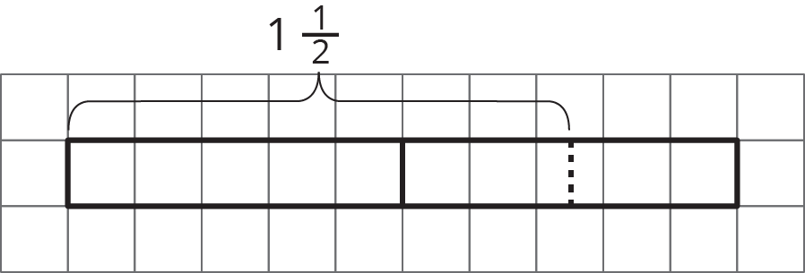
- Write a multiplication equation and a division equation to represent each sentence or diagram.
  - There are 12 fourths in 3.
  - 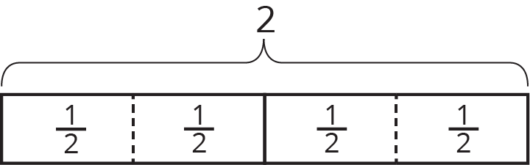
  - How many $\frac{2}{3}$s are in 6?
  - 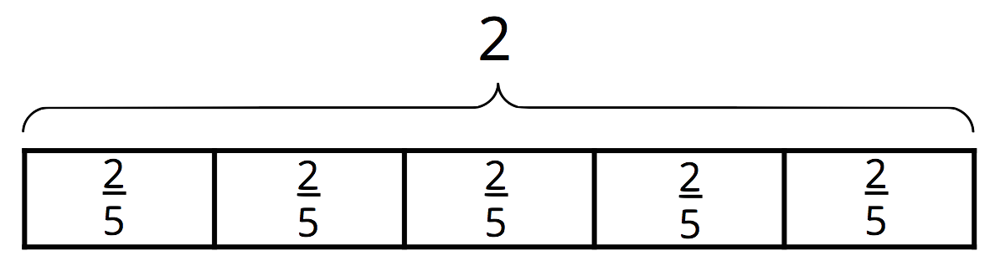
- Diego said that the answer to the question “How many groups of $\frac{5}{6}$ are in 1?” is $\frac{6}{5}$ or $1\frac{1}{5}$. Do you agree with him? Explain or show your reasoning.
- At a farmer’s market, two vendors sell fresh milk. One vendor sells 2 liters for $3.80, and another vendor sells 1.5 liters for $2.70. Which is the better deal? Explain your reasoning.
- (From Unit 2, Lesson 16.)
- Calculate each percentage mentally.
  - What is 10% of 70?
  - What is 10% of 110?
  - What is 25% of 160?
  - What is 25% of 48?
  - What is 50% of 90?
  - What is 50% of 350?
  - What is 75% of 300?
  - What is 75% of 48?
- (From Unit 2, Lesson 23.)
© CC BY Open Up Resources. Adaptations CC BY IM.

