Unit 4 Lesson 20: Strategies for Dividing

Number Talk: Multiplication and Division (Warm up)

Student Task Statement
Find the value of each expression mentally.
- $3×5$
- $6×5$
- $10×5$
- $65÷5$

1 Ways to Divide

Student Task Statement
- Lin, Priya, and Tyler found the value of $78÷3$. Their work is shown. Make sense of each student’s work.
- Lin
- 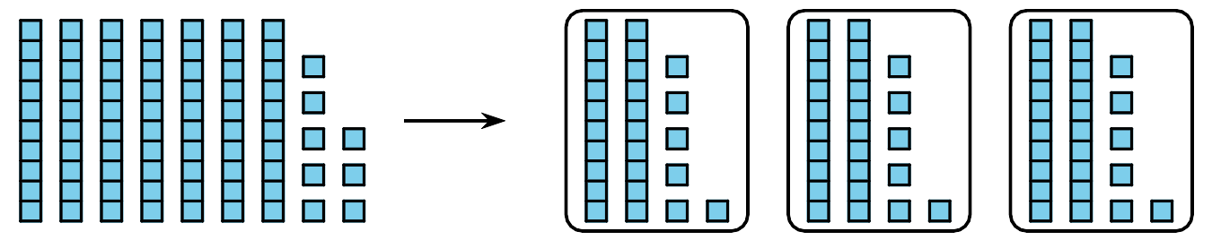
- Priya
- 3×10=303×10=303×06=18 3×26 =78000
- Tyler
- 3×20=603×06=1820+6=78
- How are the three students’ work alike?
- How are they different?

2 How Would You Divide?

Student Task Statement
Find the value of each quotient. Explain or show your reasoning. Organize it so it can be followed by others.
- $80÷5$
- $68÷4$
- $91÷7$
If you have time: Eighty-four students on a field trip are put into groups. Each group has 14 students. How many groups are there?

3 Compare, Divide within 100 (Optional)

Student Task Statement
Play Compare with 2 players.
- Shuffle the cards and split the deck between the players.
- Each player turns over a card.
- Compare the values. The player with the greater value keeps both cards.
- Play until you run out of cards. The player with the most cards at the end of the game wins.
© CC BY 2021 Illustrative Mathematics®

