Lesson 1: Números decimales

Standards Alignments
Addressing | 4.NF.C.6
Building Towards | 4.NF.C.6

Teacher-facing Learning Goals
- Make sense of tenths and hundredths in decimal notation using unit square grids.

Student-facing Learning Goals
- Aprendamos sobre los decimales.

Lesson Purpose
The purpose of this lesson is for students to make sense of tenths and hundredths in decimal notation.
In previous units, students reasoned about the size of fractions, compared them, and wrote equivalent fractions. They performed some operations: multiplying fractions by whole numbers, and adding and subtracting fractions with the same denominator including fractions with denominators of 10 and 100. Students also used their understanding of equivalent fractions to add tenths and hundredths.
In this lesson, students rely on their knowledge of fractions to express tenths and hundredths as decimals. They begin to see connections between fraction notation, the names of fractions in words, and decimal notation. They also start to notice the structure of the decimal notation and how it relates to place value. Students use increasingly precise language to read decimals through this section (MP6). Students will develop this new understanding over several lessons, so they are not expected to name the value of each place of a decimal at this time.

Access for:

Students with Disabilities
- Representation (Activity 1)

English Learners
- MLR2 (Activity 2)

Instructional Routines
Notice and Wonder (Warm-up)

Materials to Gather
- Colored pencils: Activity 1, Activity 2

Lesson Timeline
Warm-up | 10 min
Activity 1 | 20 min
Activity 2 | 15 min
Lesson Synthesis | 10 min
Cool-down | 5 min

Teacher Reflection Question
How readily did students make connections between the fraction notation and decimal notation of tenths and hundredths? How did the use of square grids support the range of learners in making connections?

Cool-down
(to be completed at the end of the lesson) 5min
¿Qué representa?

Standards Alignments
Addressing | 4.NF.C.6

Student-facing Task Statement
- El cuadrado grande representa 1.
- 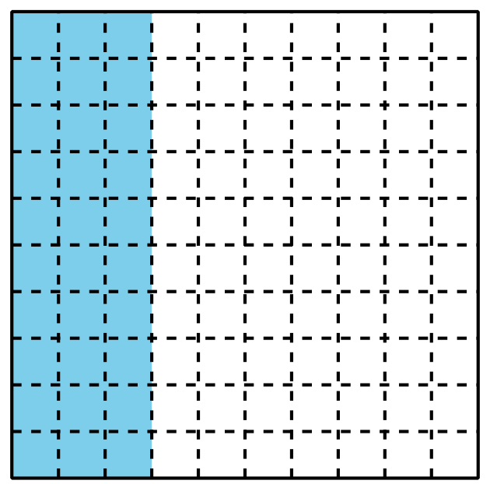
  - ¿Qué fracción está representada por la porción sombreada?
  - Escribe la fracción como un decimal.
- El cuadrado grande representa 1. Colorea el diagrama para representar 0.7.
- 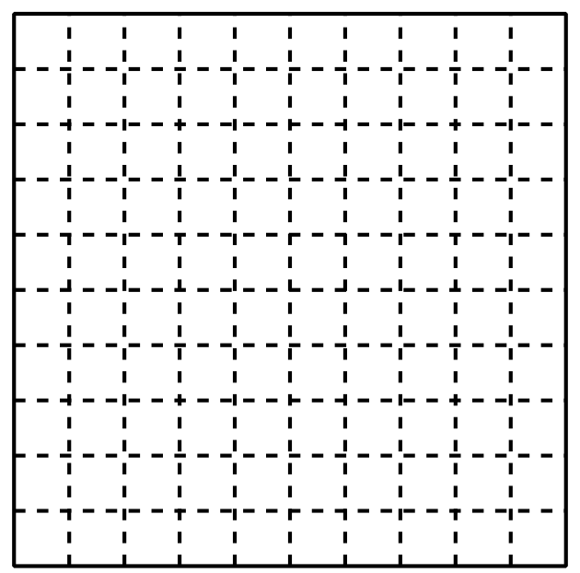

Student Responses

  - $\frac{28}{100}$
  - 0.28
- Sample response:
