Lesson 11: Introducing the Number $i$
- Let’s meet $i$.

11.1: Math Talk: Squared
Find the value of each expression mentally.
${\left(2\sqrt{3}\right)}^{2}$
${\left(\frac{1}{2}\sqrt{3}\right)}^{2}$
${\left(2\sqrt{\text{-}1}\right)}^{2}$
${\left(\frac{1}{2}\sqrt{\text{-}1}\right)}^{2}$

11.2: It is $i$
Find the solutions to these equations, then plot the solutions to each equation on the imaginary or real number line.
- $a^{2}=16$
- $b^{2}=\text{-}9$
- $c^{2}=\text{-}5$
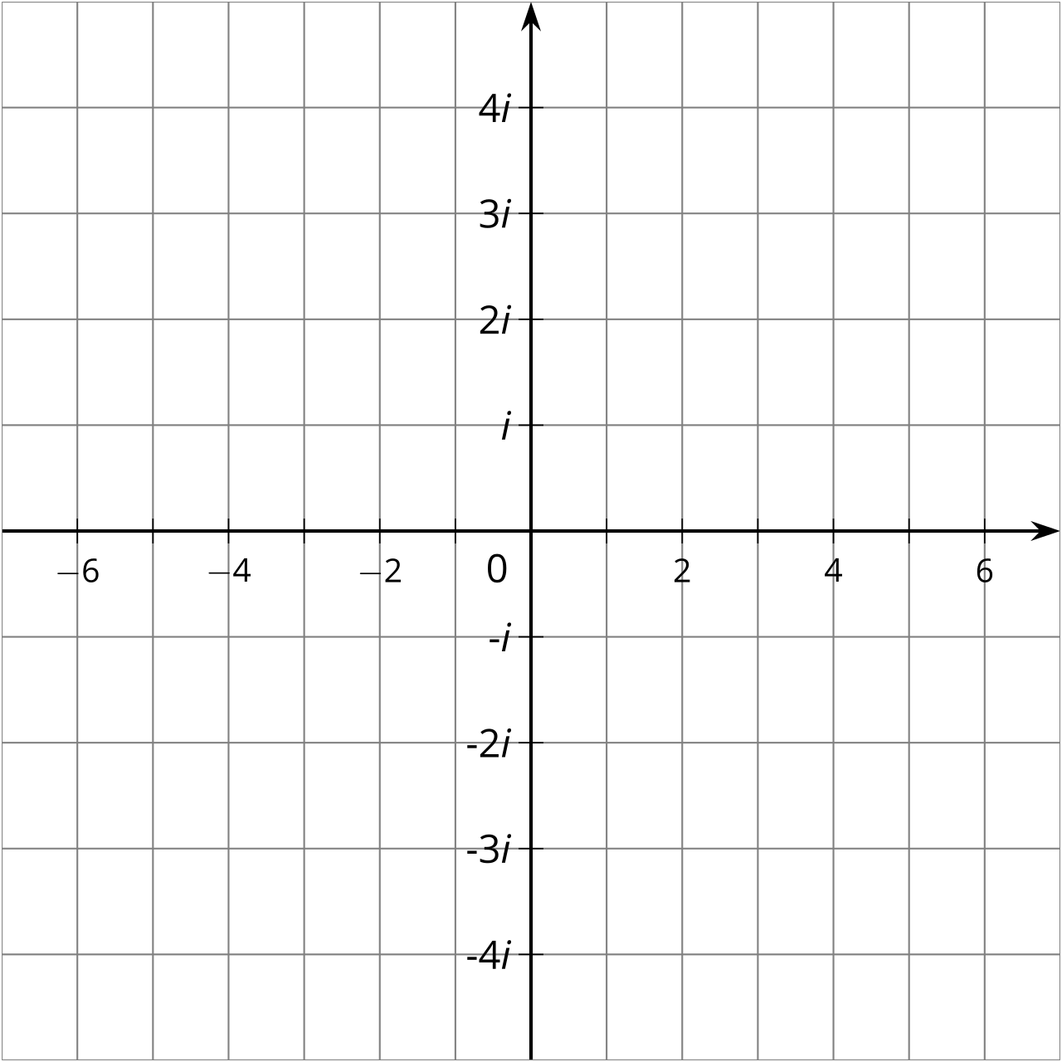

11.3: The $i$’s Have It
Write these imaginary numbers using the number $i$.
- $\sqrt{\text{-}36}$
- $\sqrt{\text{-}10}$
- $\text{-}\sqrt{\text{-}100}$
- $\text{-}\sqrt{\text{-}17}$

11.4: Complex Numbers
- Label at least 8 different imaginary numbers on the imaginary number line.
- 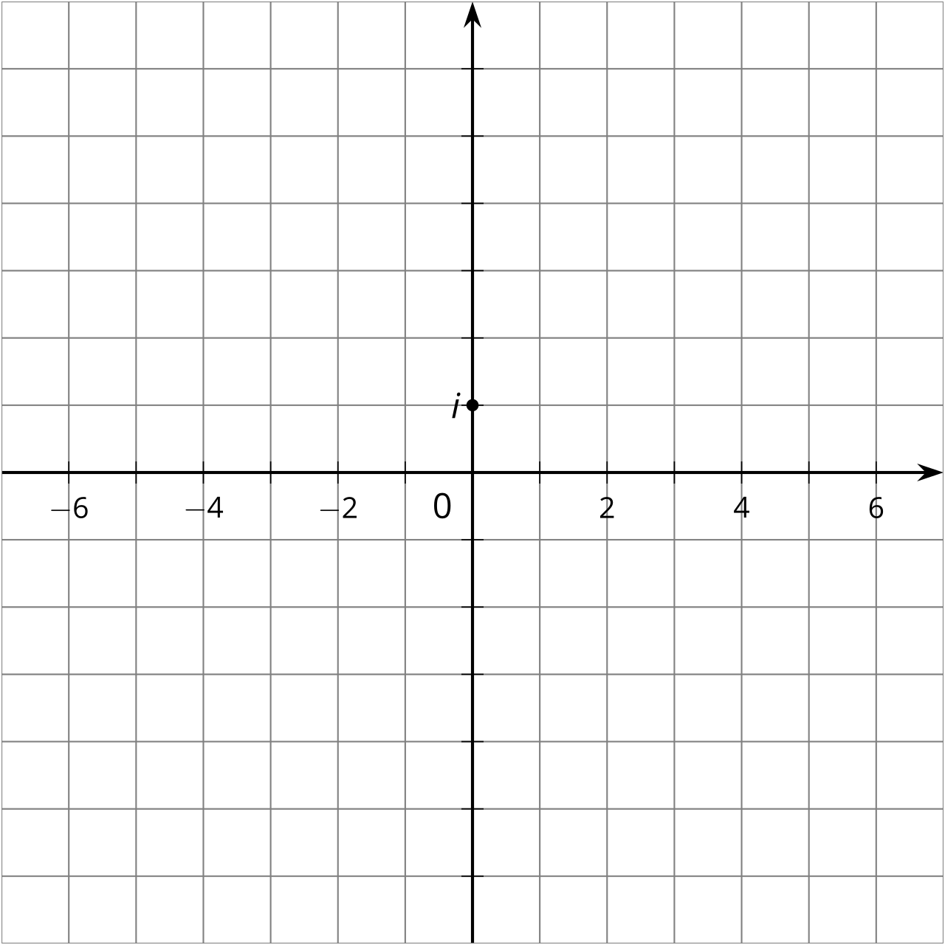
- When we add a real number and an imaginary number, we get a complex number. The diagram shows where $2+i$ is in the complex number plane. What complex number is represented by point $A$?
- 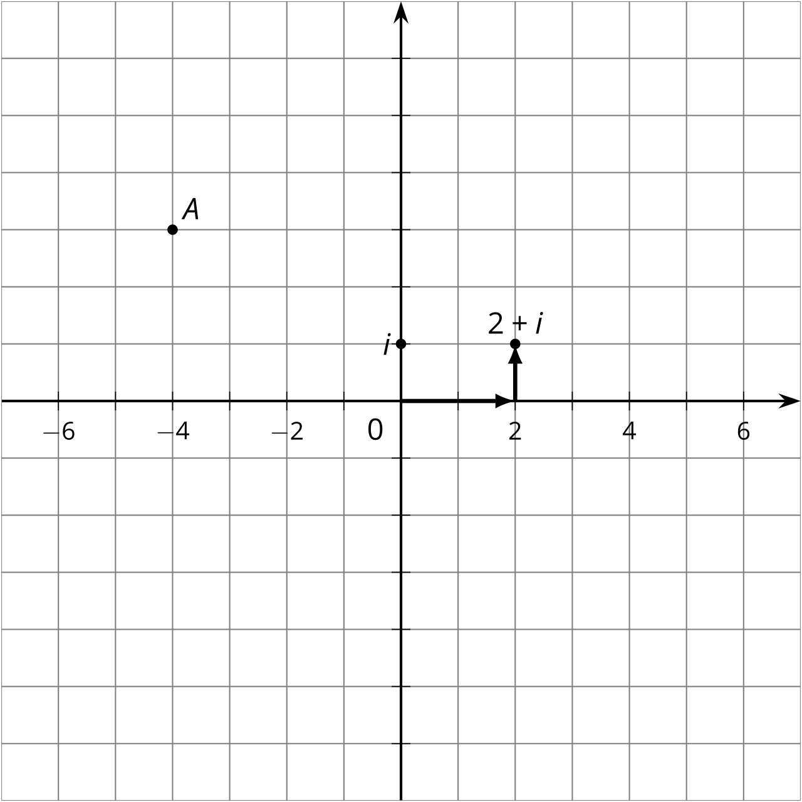
- Plot these complex numbers in the complex number plane and label them.
  - $\text{-}2−i$
  - $\text{-}6+3i$
  - $5+4i$
  - $1−3i$

Are you ready for more?
Diego says that all real numbers and all imaginary numbers are complex numbers but not all complex numbers are imaginary or real. Do you agree with Diego? Explain your reasoning.

Lesson 11 Summary
A square root of a number $a$ is a number whose square is $a$. In other words, it is a solution to the equation $x^{2}=a$. Every positive real number has two real square roots. For example, look at the number 35. Its square roots are $\sqrt{35}$ and $\text{-}\sqrt{35}$, because those are the two numbers that square to make 35 (remember, the $\sqrt{​}$ symbol is defined to indicate the positive square root). In other words, ${\left(\sqrt{35}\right)}^{2}=35$ and ${\left(\text{-}\sqrt{35}\right)}^{2}=35$.
Similarly, every negative real number has two imaginary square roots. The two square roots of -1 are written $i$ and $\text{-}i$. That means that
$i^{2}=\text{-}1$
and
${\left(\text{-}i\right)}^{2}=\text{-}1$
Another example would be the number -17. Its square roots are $i\sqrt{17}$ and $\text{-}i\sqrt{17}$, because
$\begin{matrix}{\left(i\sqrt{17}\right)}^{2} & =17i^{2} \\ & =\text{-}17\end{matrix}$
and
$\begin{matrix}{\left(\text{-}i\sqrt{17}\right)}^{2} & =17{\left(\text{-}i\right)}^{2} \\ & =17i^{2} \\ & =\text{-}17\end{matrix}$
In general, if $a$ is a positive real number, then the square roots of $\text{-}a$ are $i\sqrt{a}$ and $\text{-}i\sqrt{a}$.
Rarely, we might see something like $\sqrt{\text{-}17}$. It’s not immediately clear which of the two square roots it is supposed to represent. By convention, $\sqrt{\text{-}17}$ is defined to indicate the square root on the positive imaginary axis, so $\sqrt{\text{-}17}=i\sqrt{17}$.
When we add a real number and an imaginary number, we get a complex number. Together, the real number line and the imaginary number line form a coordinate system that can be used to represent any complex number as a point in the complex plane. For example, the point shown represents the complex number $\text{-}3+2i$.
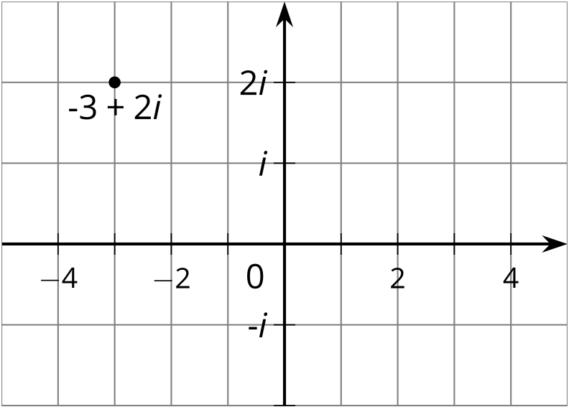
In this context, people call the real number line the real axis and the imaginary number line the imaginary axis. This is different than the coordinate plane you have seen before because those points were pairs of real numbers, like $\left(\text{-}3,2\right)$, but in the complex plane, each point represents a single complex number. Note that since the real number line is part of the complex plane, real numbers are a special type of complex number. For example, the real number 5 can be described as the point $5+0i$ in the complex plane.
© CC BY 2019 by Illustrative Mathematics®

