Lesson 3 Practice Problems
- Which expression is equal to $4^{0}⋅4^{2}$?
  - 0
  - 1
  - 16
  - 64
- Select all expressions are equivalent to $3^{8}$.
  - $8^{3}$
  - $\frac{3^{10}}{3^{2}}$
  - $3⋅8$
  - ${\left(3^{4}\right)}^{2}$
  - ${\left(3⋅3\right)}^{4}$
  - $\frac{1}{3^{\text{-}8}}$
- (From Unit 5, Lesson 1.)
- A bee population is measured each week and the results are plotted on the graph.
- 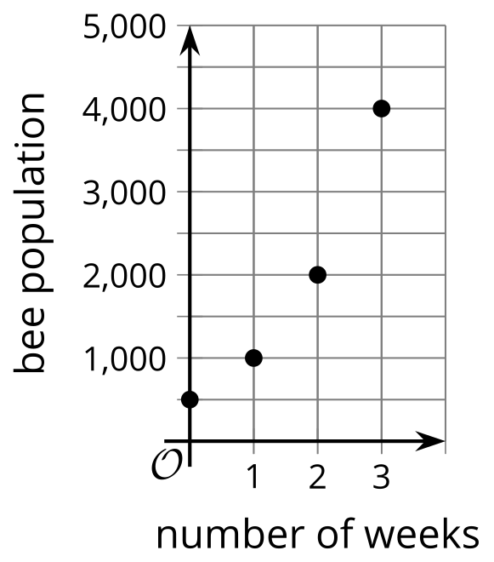
  - What is the bee population when it is first measured?
  - Is the bee population growing by the same factor each week? Explain how you know.
  - What is an equation that models the bee population, $b$, $w$ weeks after it is first measured?
- A bond is initially bought for $250. It doubles in value every decade.
  - Complete the table.
  - How many decades does it take before the bond is worth more than $10,000?
  - Write an equation relating $v$, the value of the bond, to $d$, the number of decades since the bond was bought.
- decades since  bond is bought | - dollar value  of bond
- 0
- 1
- 2
- 3
- $d$
- A sea turtle population $p$ is modeled by the equation $p=400⋅{\left(\frac{5}{4}\right)}^{y}$ where $y$ is the number of years since the population was first measured.
  - How many turtles are in the population when it is first measured? Where do you see this in the equation?
  - Is the population increasing or decreasing? How can you tell from the equation?
  - When will the turtle population reach 700? Explain how you know.
- Bank account A starts with $5,000 and grows by $1,000 each week. Bank account B starts with $1 and doubles each week.
  - Which account has more money after one week? After two weeks?
  - Here is a graph showing the two account balances. Which graph corresponds to which situation? Explain how you know.
  - 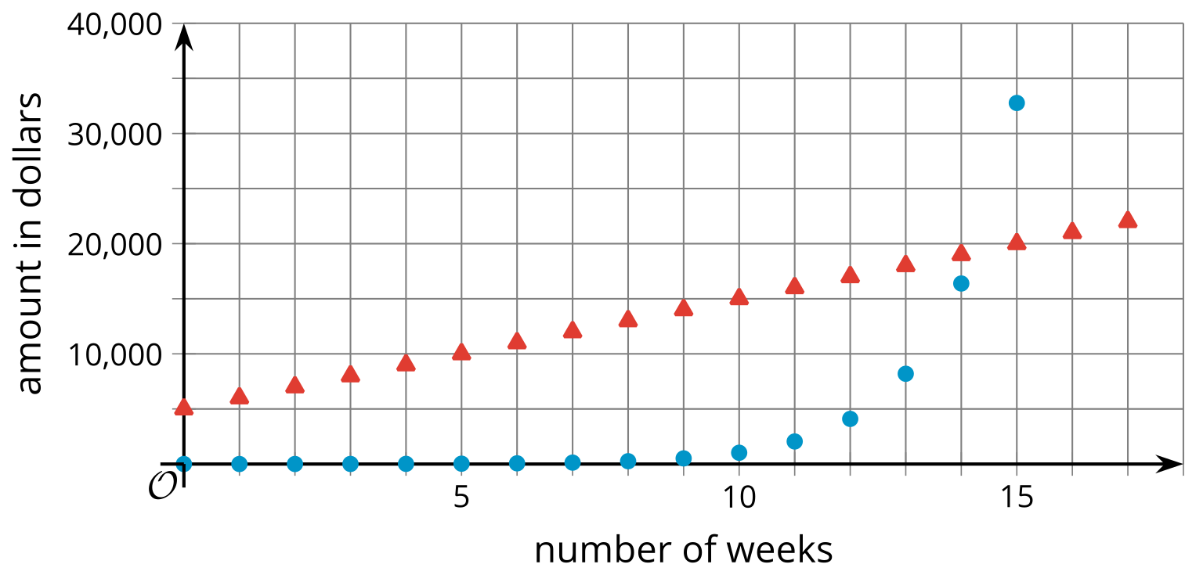
  - Given a choice, which of the two accounts would you choose? Explain your reasoning.
- (From Unit 5, Lesson 1.)
- Match each equation in the first list to an equation in the second list that has the same solution.
  - $y=\frac{2}{5}x+2$
  - $x=\text{-}5−2.5y$
  - $y=\frac{10}{5}−0.4x$
  - $2x=10−5y$
  - $\text{-}5y=2x+10$
  - $x=5−\frac{5}{2}y$
  - $2x+5y=10$
  - $\text{-}2x−5y=10$
  - $\text{-}2x+5y=10$
- (From Unit 2, Lesson 9.)
- Function $F$ is defined so that its output $F\left(t\right)$ is the number of followers on a social media account $t$ days after set up of the account.
  - Explain the meaning of $F\left(30\right)=8,​950$ in this situation.
  - Explain the meaning of $F\left(0\right)=0$.
  - Write a statement about function $F$ that represents the fact that there were 28,800 followers 110 days after the set up of the account.
  - Explain the meaning of $t$ in the equation $F\left(t\right)=100,​000$.
- (From Unit 4, Lesson 3.)
© CC BY 2019 by Illustrative Mathematics®

