Unit 4 Lesson 3: Half an Equilateral Triangle

1 Notice and Wonder: Triangle Slices (Warm up)

Student Task Statement
Sketch an equilateral triangle and an altitude from any vertex in the equilateral triangle.
What do you notice? What do you wonder?

2 Decomposing Equilateral Triangles (Optional)

Student Task Statement
- Here is an equilateral triangle with side length 2 units and an altitude drawn. Find the values of $x$ and $y$.
- 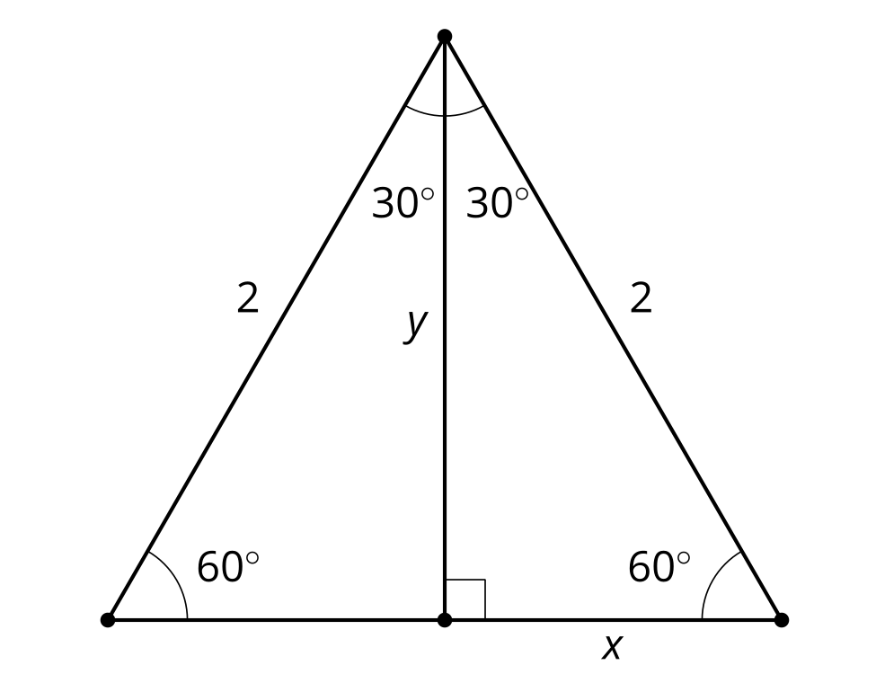
- Measure several more of these “half equilateral triangles” by drawing equilateral triangles and altitudes. Compute the ratios of the side lengths of these new triangles.
- Make a conjecture about side lengths in “half equilateral triangles.”

Activity Synthesis
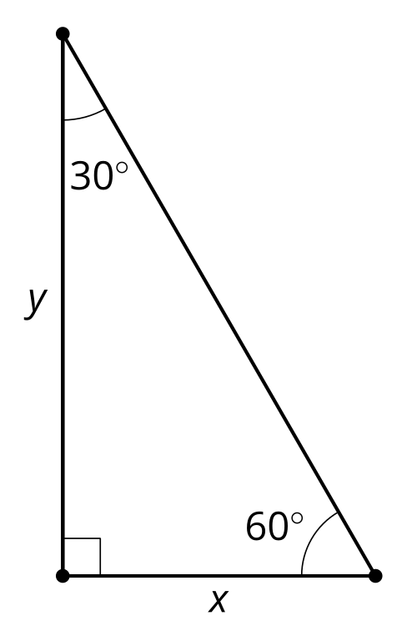

3 Generalize Half Equilateral Triangles (Optional)

Student Task Statement
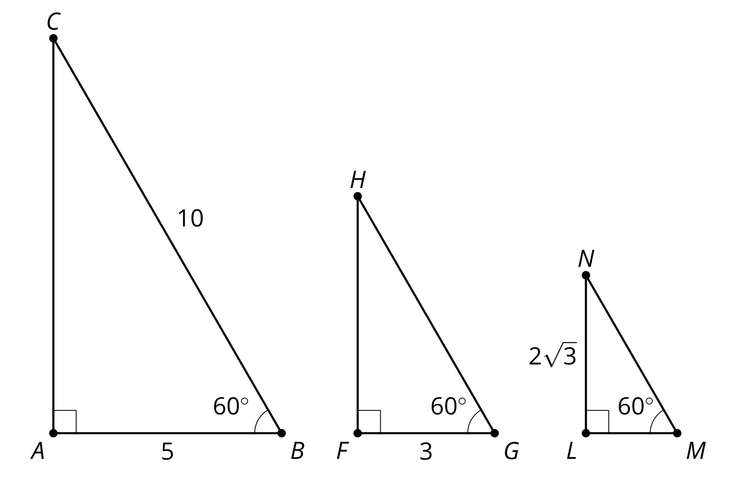
Calculate the lengths of the 5 unlabeled sides.

Images for Activity Synthesis
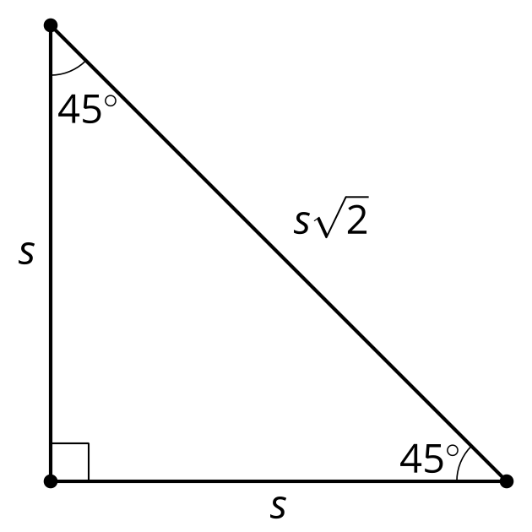
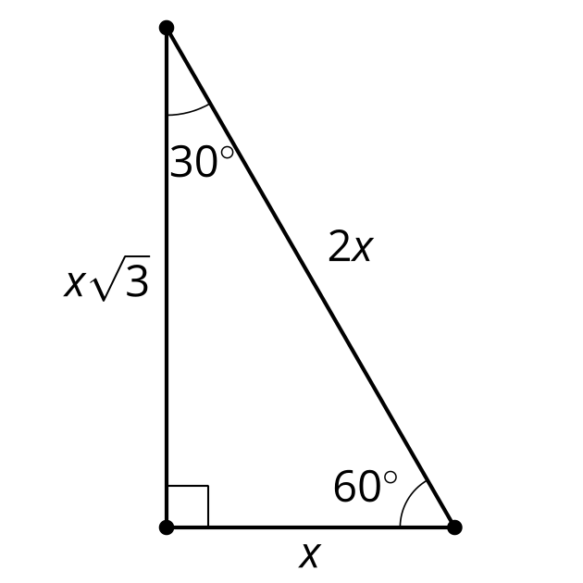
© CC BY 2019 by Illustrative Mathematics®

