Lesson 15 Practice Problems
- Evaluate each expression if $x=3$.
  - $2^{x}$
  - $x^{2}$
  - $1^{x}$
  - $x^{1}$
  - ${\left(\frac{1}{2}\right)}^{x}$
- Evaluate each expression for the given value of each variable.
  - $2+x^{3}$, $x$ is 3
  - $x^{2}$, $x$ is $\frac{1}{2}$
  - $3x^{2}+y$, $x$ is 5 $y$ is 3
  - $10y+x^{2}$, $x$ is 6 $y$ is 4
- Decide if the expressions have the same value. If not, determine which expression has the larger value.
  - $2^{3}$ and $3^{2}$
  - $1^{31}$ and ${31}^{1}$
  - $4^{2}$ and $2^{4}$
  - ${\left(\frac{1}{2}\right)}^{3}$ and ${\left(\frac{1}{3}\right)}^{2}$
- Match each equation to its solution.
  - $7+x^{2}=16$
  - $5−x^{2}=1$
  - $2⋅2^{3}=2^{x}$
  - $\frac{3^{4}}{3^{x}}=27$
  - $x=1$
  - $x=2$
  - $x=3$
  - $x=4$
- An adult pass at the amusement park costs 1.6 times as much as a child’s pass.
  - How many dollars does an adult pass cost if a child’s pass costs:
  - $5?
  - $10?
  - $w$ dollars?
  - A child’s pass costs $15. How many dollars does an adult pass cost?
- (From Unit 6, Lesson 6.)
- Jada reads 5 pages every 20 minutes. At this rate, how many pages can she read in 1 hour?
  - Use a double number line to find the answer.
- 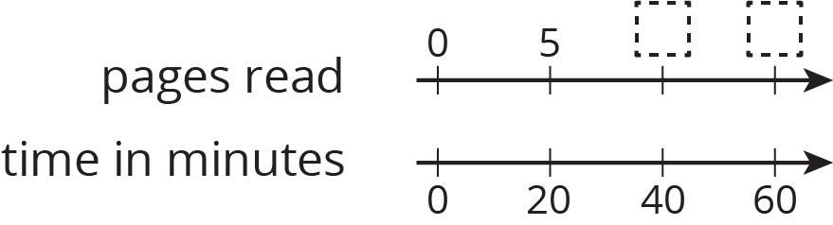
  - Use a table to find the answer.
- pages  read | - time in  minutes
- 5 | - 20
- Which strategy do you think is better, and why?
- (From Unit 2, Lesson 14.)
© CC BY Open Up Resources. Adaptations CC BY IM.

