Unit 6 Lesson 12: Changing the Equation

1 Math Talk: A Negative Input (Warm up)

Student Task Statement
Evaluate each expression when $x$ is -5:
$\text{-}2x$
$x^{2}$
$\text{-}2x^{2}$
$\text{-}x^{2}$

2 Equations and Their Graphs

Student Task Statement
- Two students are evaluating $x^{2}+7$ when $x$ is -3. Here is their work. Do you agree with either of them? Explain your reasoning.
- Tyler:
- $x^{2}+7$
- $\text{-}3^{2}+7$
- $\text{-}9+7$
- -2
- Lin:
- $x^{2}+7$
- ${\left(\text{-}3\right)}^{2}+7$
- $9+7$
- 16
- Evaluate each expression when $x$ is -4:
  - $x^{2}$
  - $\frac{1}{2}x^{2}$
  - $\text{-}\frac{1}{8}x^{2}$
  - $\text{-}x^{2}−8$
- Using graphing technology, graph $y=x$. Then, experiment with the following changes to the function. Record your observations (include sketches, if helpful).
  - Adding different constant terms to $x$ (for example: $x+4$, $x−3$).
  - Multiplying $x$ by different positive coefficients greater than 1 (for example: $6x,2.5x$).
  - Multiplying $x$ by different positive coefficients between 0 and 1 (for example: $0.25x,0.1x$).
  - Multiplying $x$ by negative coefficients (for example: $\text{-}9x,\text{-}4x$).
- Use your observations to sketch these functions on the coordinate plane, which currently shows $y=x$.
  - $y=\text{-}0.5x+2.1$
  - $y=2.1x−0.5$
  - 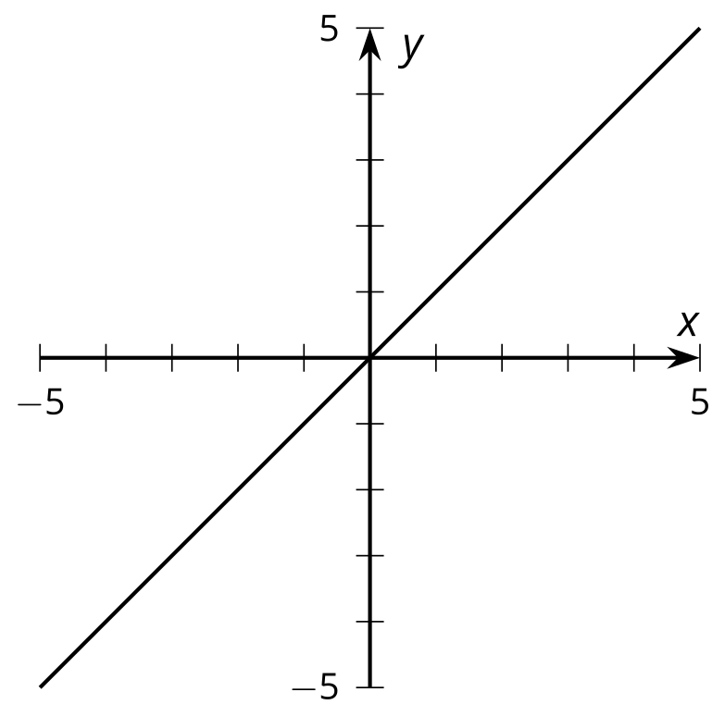

3 Match the Graphs

Student Task Statement
- Evaluate each expression when $x$ is -3.
  - $x^{2}$
  - $\text{-}x^{2}$
  - $x^{2}+20$
  - $\text{-}x^{2}+20$
- For each graph, come up with an equation that the graph could represent. Verify your equation using graphing technology.
- 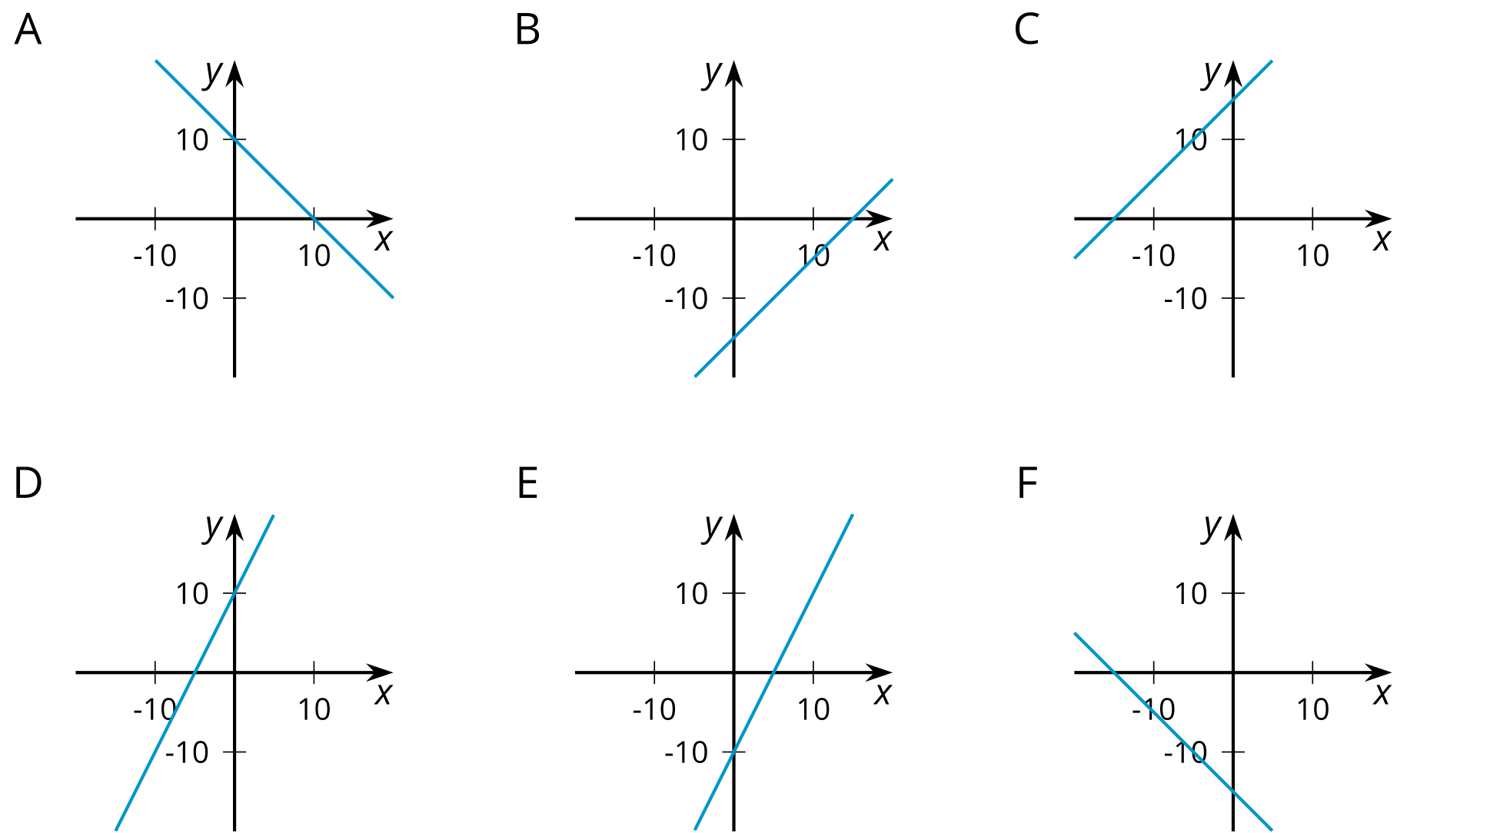
© CC BY 2019 by Illustrative Mathematics®

