Lesson 7 Practice Problems
- The point $\left(6,y\right)$ is the same distance from $\left(4,1\right)$ as it is from the $x$-axis. What is the value of $y$?
- A parabola is defined as the set of points the same distance from $\left(6,2\right)$ and the line $y=4$. Select all points that are on this parabola.
  - $\left(1,\text{-}2\right)$
  - $\left(2,\text{-}1\right)$
  - $\left(6,2\right)$
  - $\left(7,3\right)$
  - $\left(8,2\right)$
- Compare and contrast the parabolas with these definitions.
  - parabola A: points that are the same distance from $\left(0,4\right)$ and the $x$-axis
  - parabola B: points that are the same distance from $\left(0,\text{-}6\right)$ and the $x$-axis
- Find the center and radius of the circle represented by the equation $x^{2}+y^{2}−8y+5=0$.
- (From Unit 6, Lesson 6.)
- Match each expression with the value needed in the box in order for the expression to be a perfect square trinomial.
  - ​​​​x2+14x+3
  - ​​​​x2−12x+3
  - c2−10c+3
  - ​​​​z2+z+3
  - $\frac{1}{16}$
  - 49
  - 25
  - $\frac{1}{4}$
- (From Unit 6, Lesson 6.)
- Write each expression as the square of a binomial.
  - $x^{2}−12x+36$
  - $y^{2}+8y+16$
  - $w^{2}−16w+64$
- (From Unit 6, Lesson 5.)
- Write an equation of a circle that is centered at $\left(1,\text{-}4\right)$ with a radius of 10.
- (From Unit 6, Lesson 4.)
- The density of water is 1 gram per cm³. An object floats in water if its density is less than water’s density, and it sinks if its density is greater than water’s. Will a solid bar of soap shaped like a rectangular prism with mass 1.048 kilograms and dimensions 5.6 centimeters, 13 centimeters, and 16 centimeters float or sink? Explain your reasoning.
- (From Unit 5, Lesson 17.)
- Jada has this idea for bisecting angle $ABC$. First she draws a circle with center $B$ through $A$. Then she constructs the perpendicular bisector of $AD$.
- 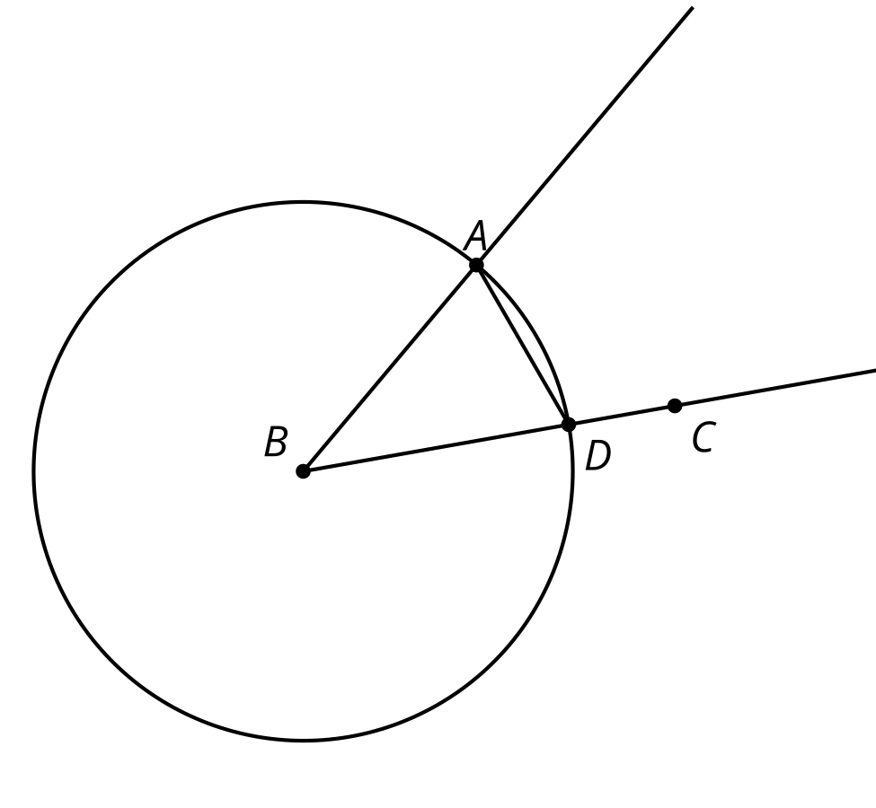
- 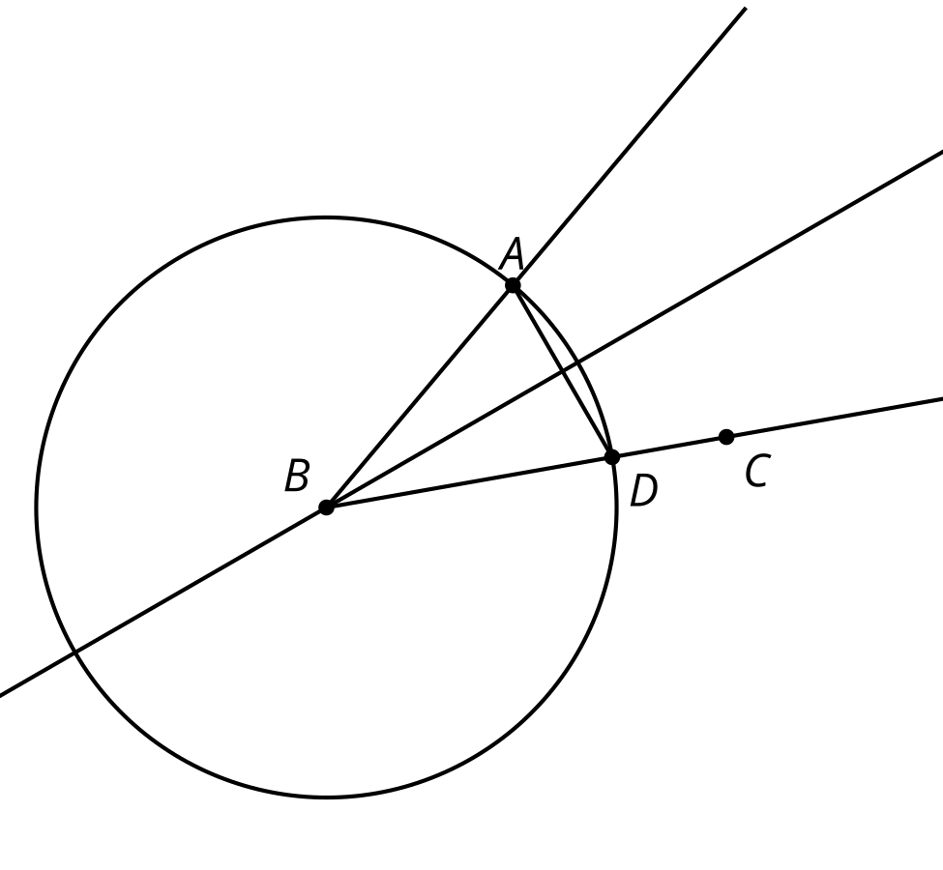
- Does Jada's construction work? Explain your reasoning. You may assume that the perpendicular bisector of line segment $AD$ is the set of points equidistant from $A$ and $D$.
- (From Unit 1, Lesson 5.)
© CC BY 2019 by Illustrative Mathematics®

