Lesson 17: Center Day 3
- Let’s count large groups of objects and play games to practice adding and creating graphs.

Warm-up: Number Talk: Add Ten More
Find the value of each sum mentally.
- $27+10$
- $27+10+10$
- $27+30$
- $37+30$

17.2: Centers Choice Time
Choose a center.
What's Behind My Back?
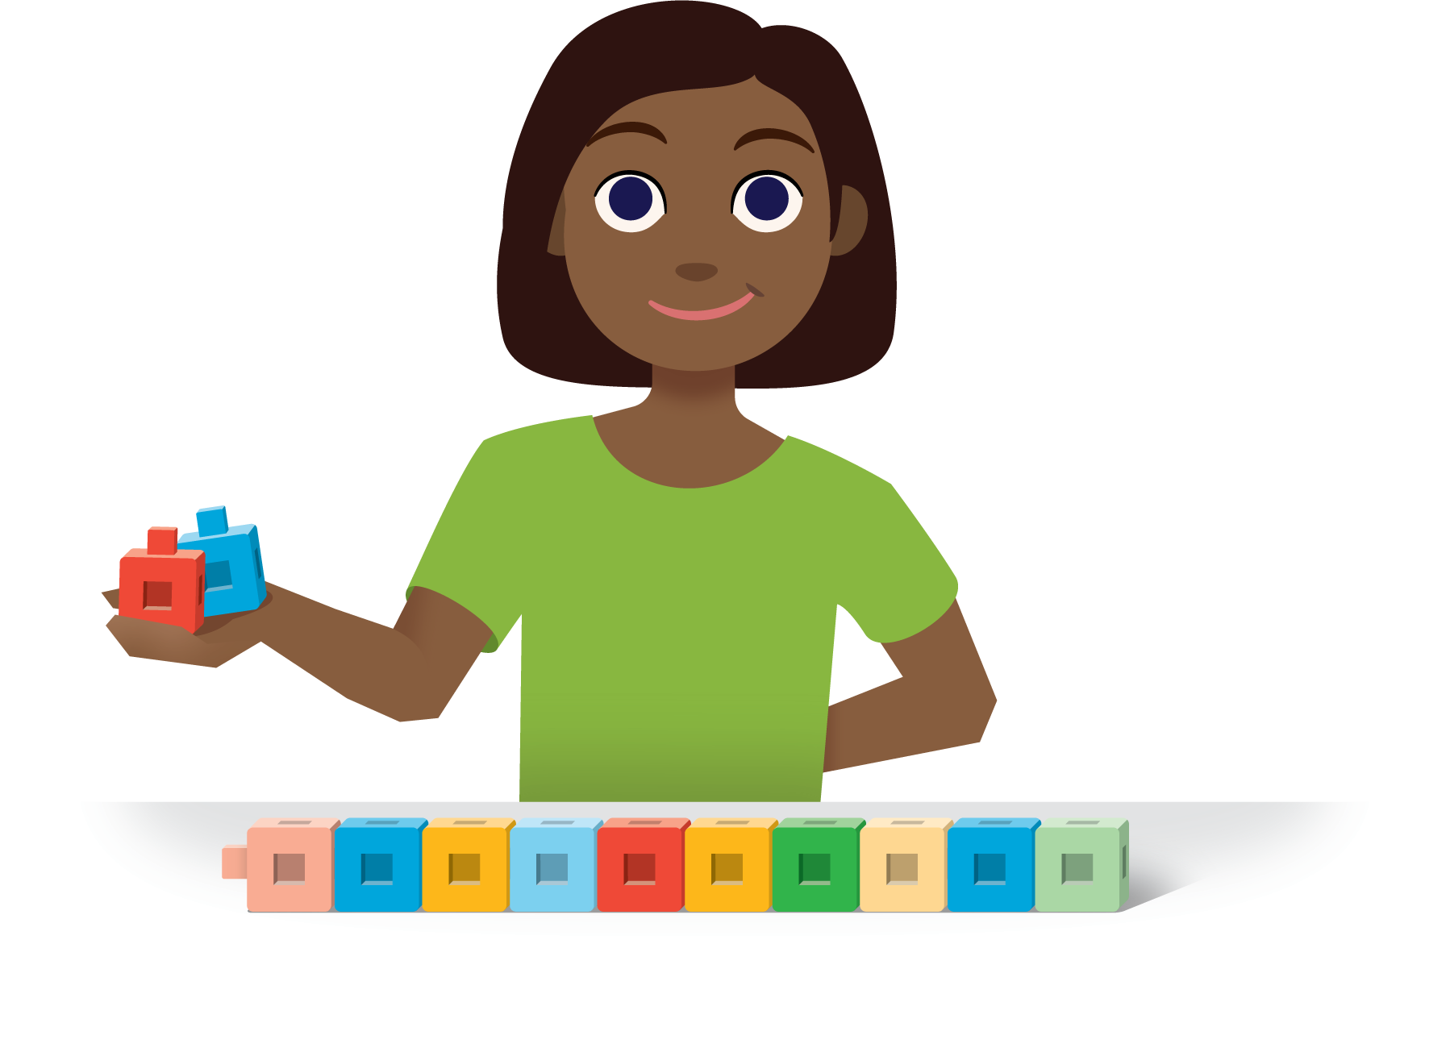
How Close?
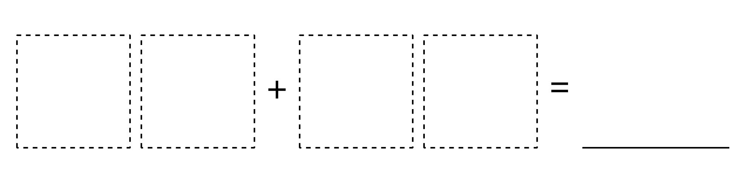
Number Puzzles
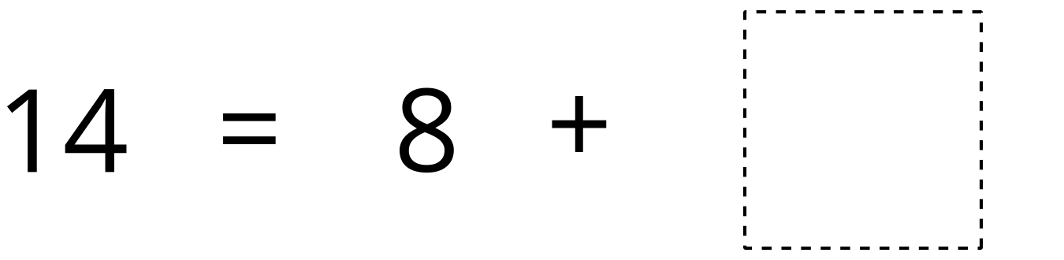
Sort and Display
© CC BY 2021 Illustrative Mathematics®

