Unit 3 Lesson 2: Addition and Subtraction Situations

WU Notice and Wonder: Two Curious Tables (Warm up)

Student Task Statement
What do you notice? What do you wonder?
+ | 10 | 20 | 30 | 40 | 50
10 |  |  | 40
20 |  |  | 50
30 | 40 | 50 | ? | 70 | 80
40 |  |  | 70
50 |  |  | 80

+ | 10 | 20 | 30 | 40 | 50
10 | 20 |  |  |  | 60
20 |  | 40 |  | 60
30 |  |  | ?
40 |  | 60 |  | 80
50 | 60 |  |  |  | 100

1 Monuments and Falls

Student Task Statement
Solve each problem. Explain or show your reasoning.
- Iguazu Falls in South America marks the border between Paraguay, Brazil, and Argentina. It is the largest waterfall in the world.
- The waterfall has two parts. The water falls 115 feet in the first part and 131 feet in the second part. How far down does the water fall altogether?
- 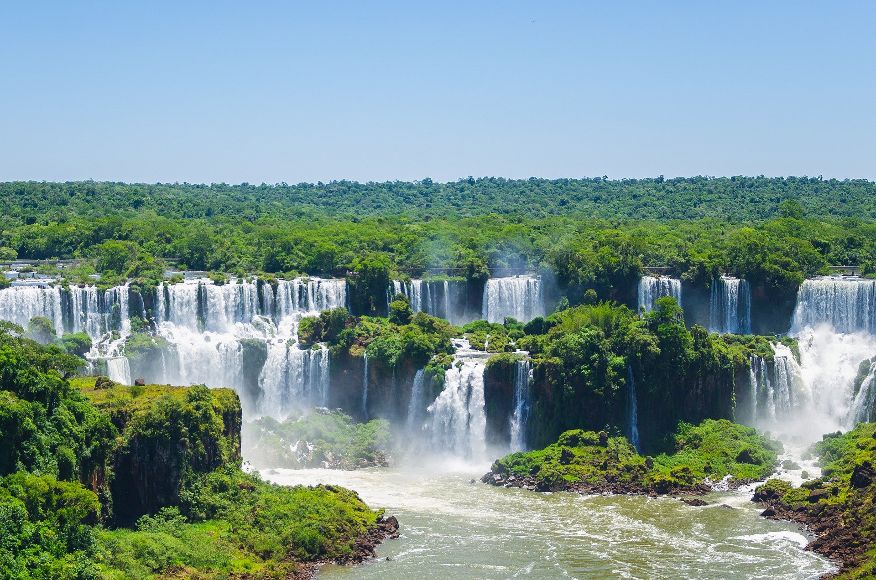
- In Washington, D.C., there are many monuments that honor important people in American history.
- The Lincoln Memorial is 99 feet tall. The Washington Monument is 555 feet tall.
- 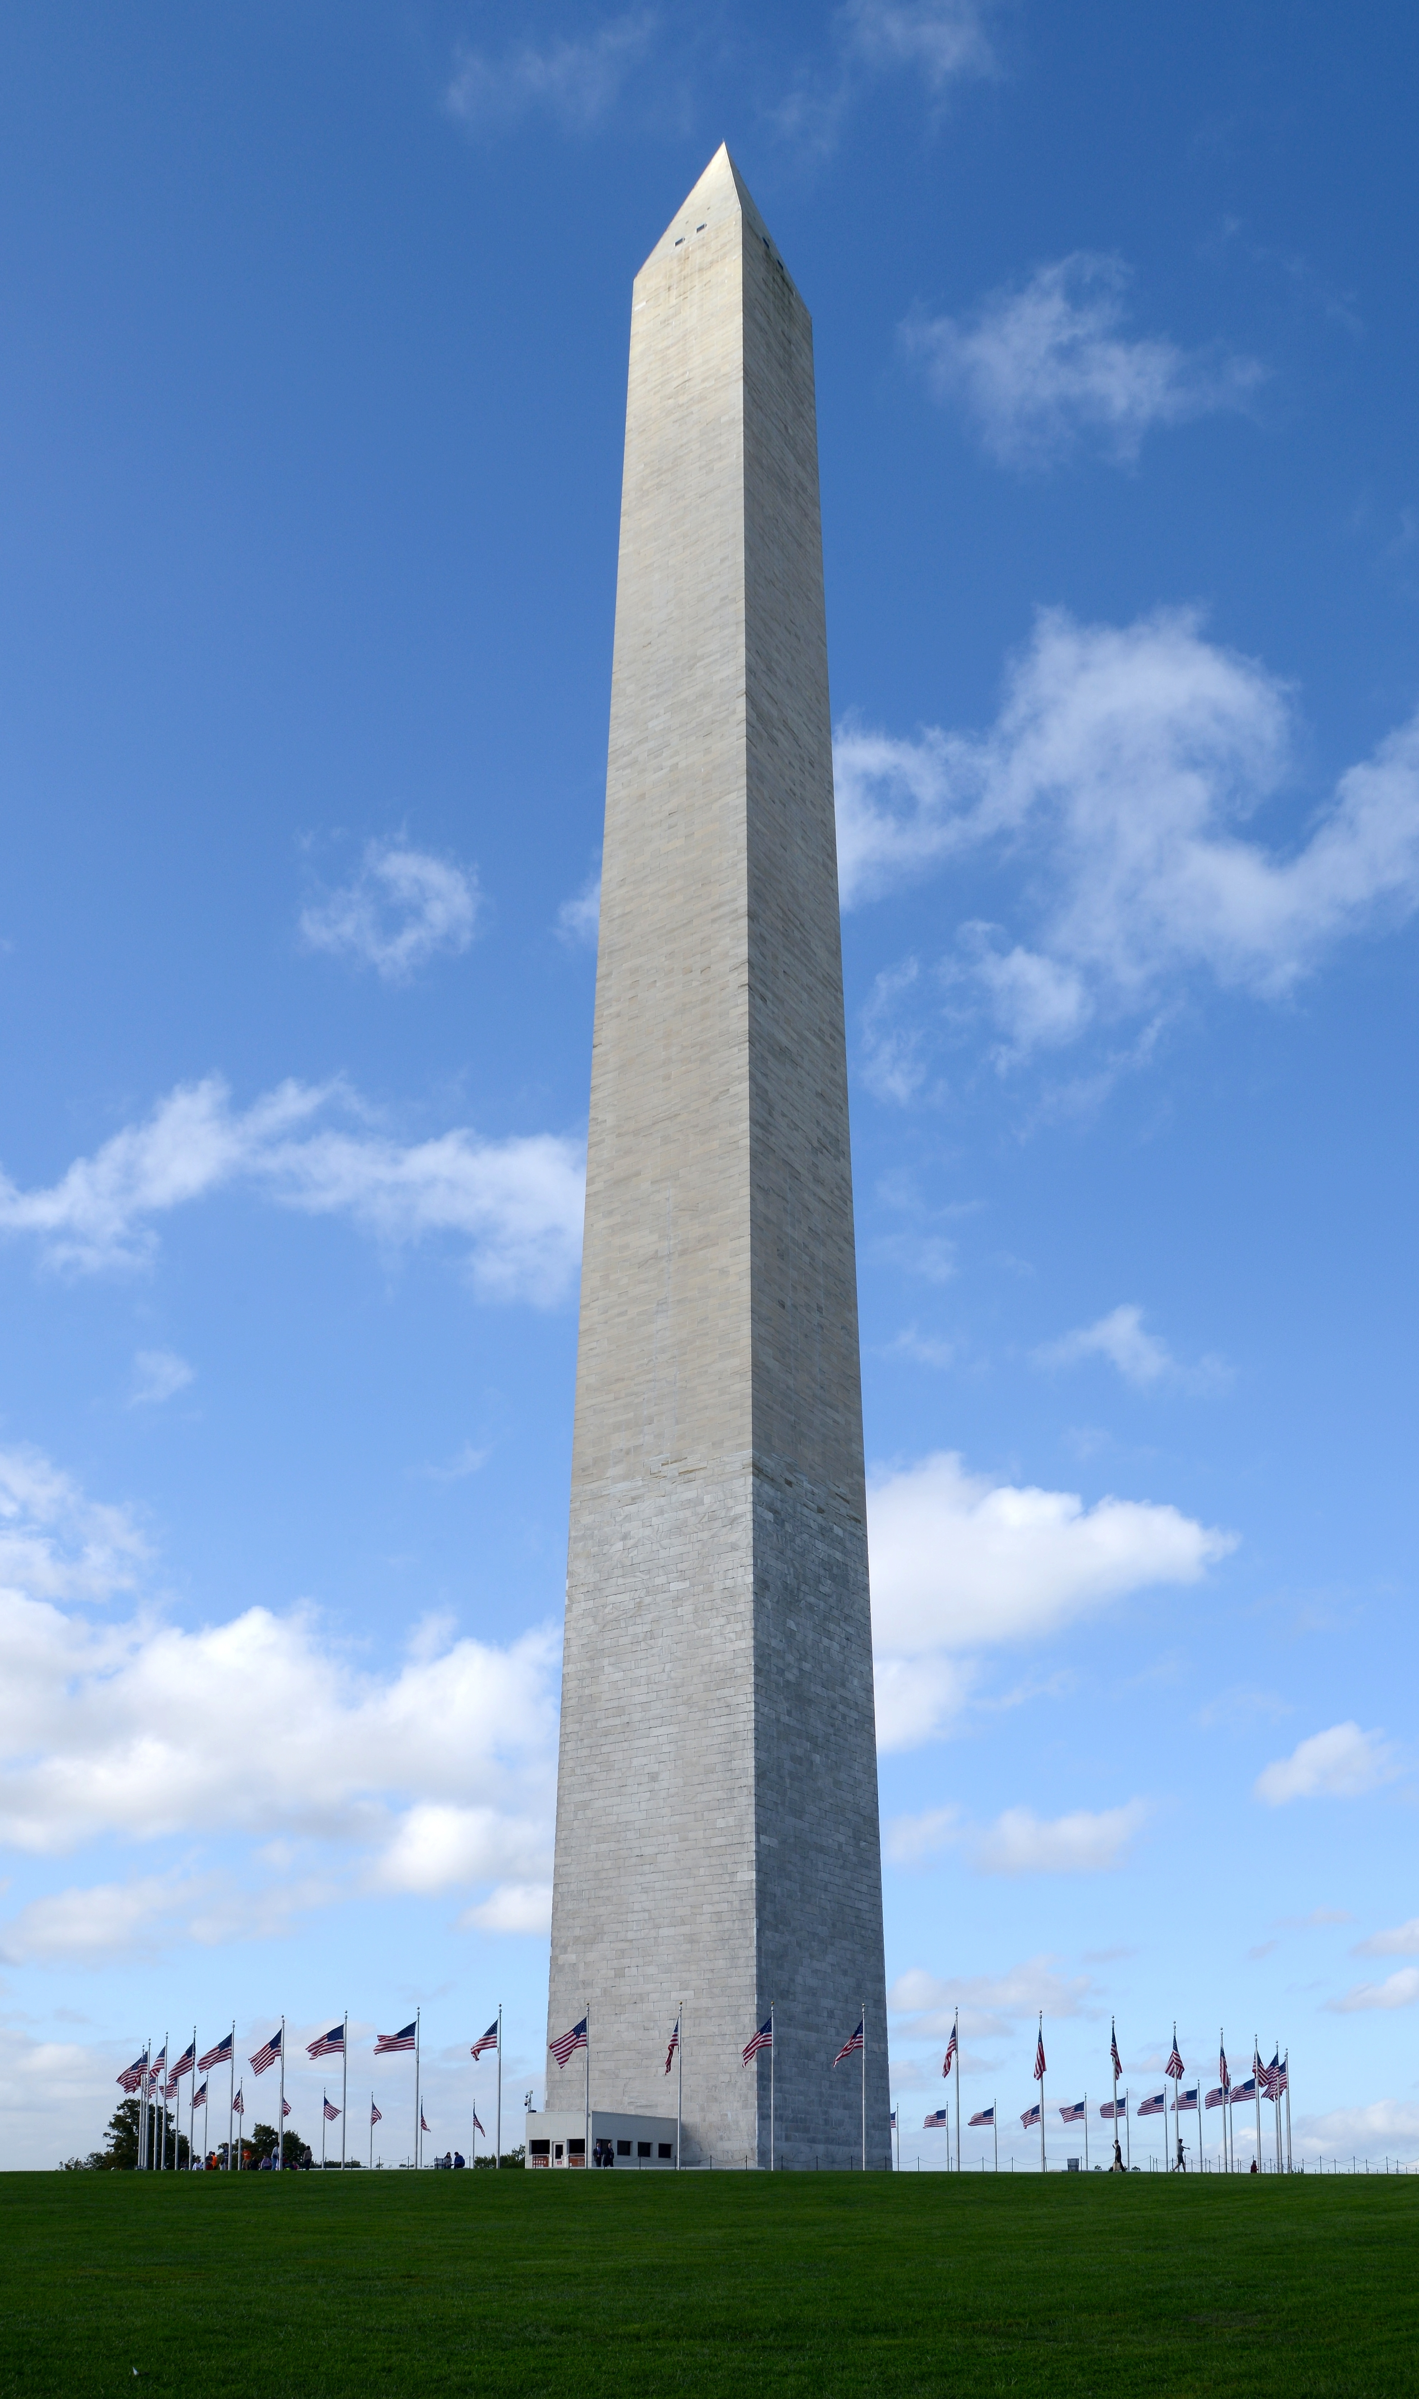
- How much taller is the Washington Monument than the Lincoln Memorial?
- The Eiffel Tower in Paris, France, has 674 steps that go from the ground to the second floor. There are 328 steps from the ground to the first floor.
- How many steps are there from the first floor to the second floor?
- 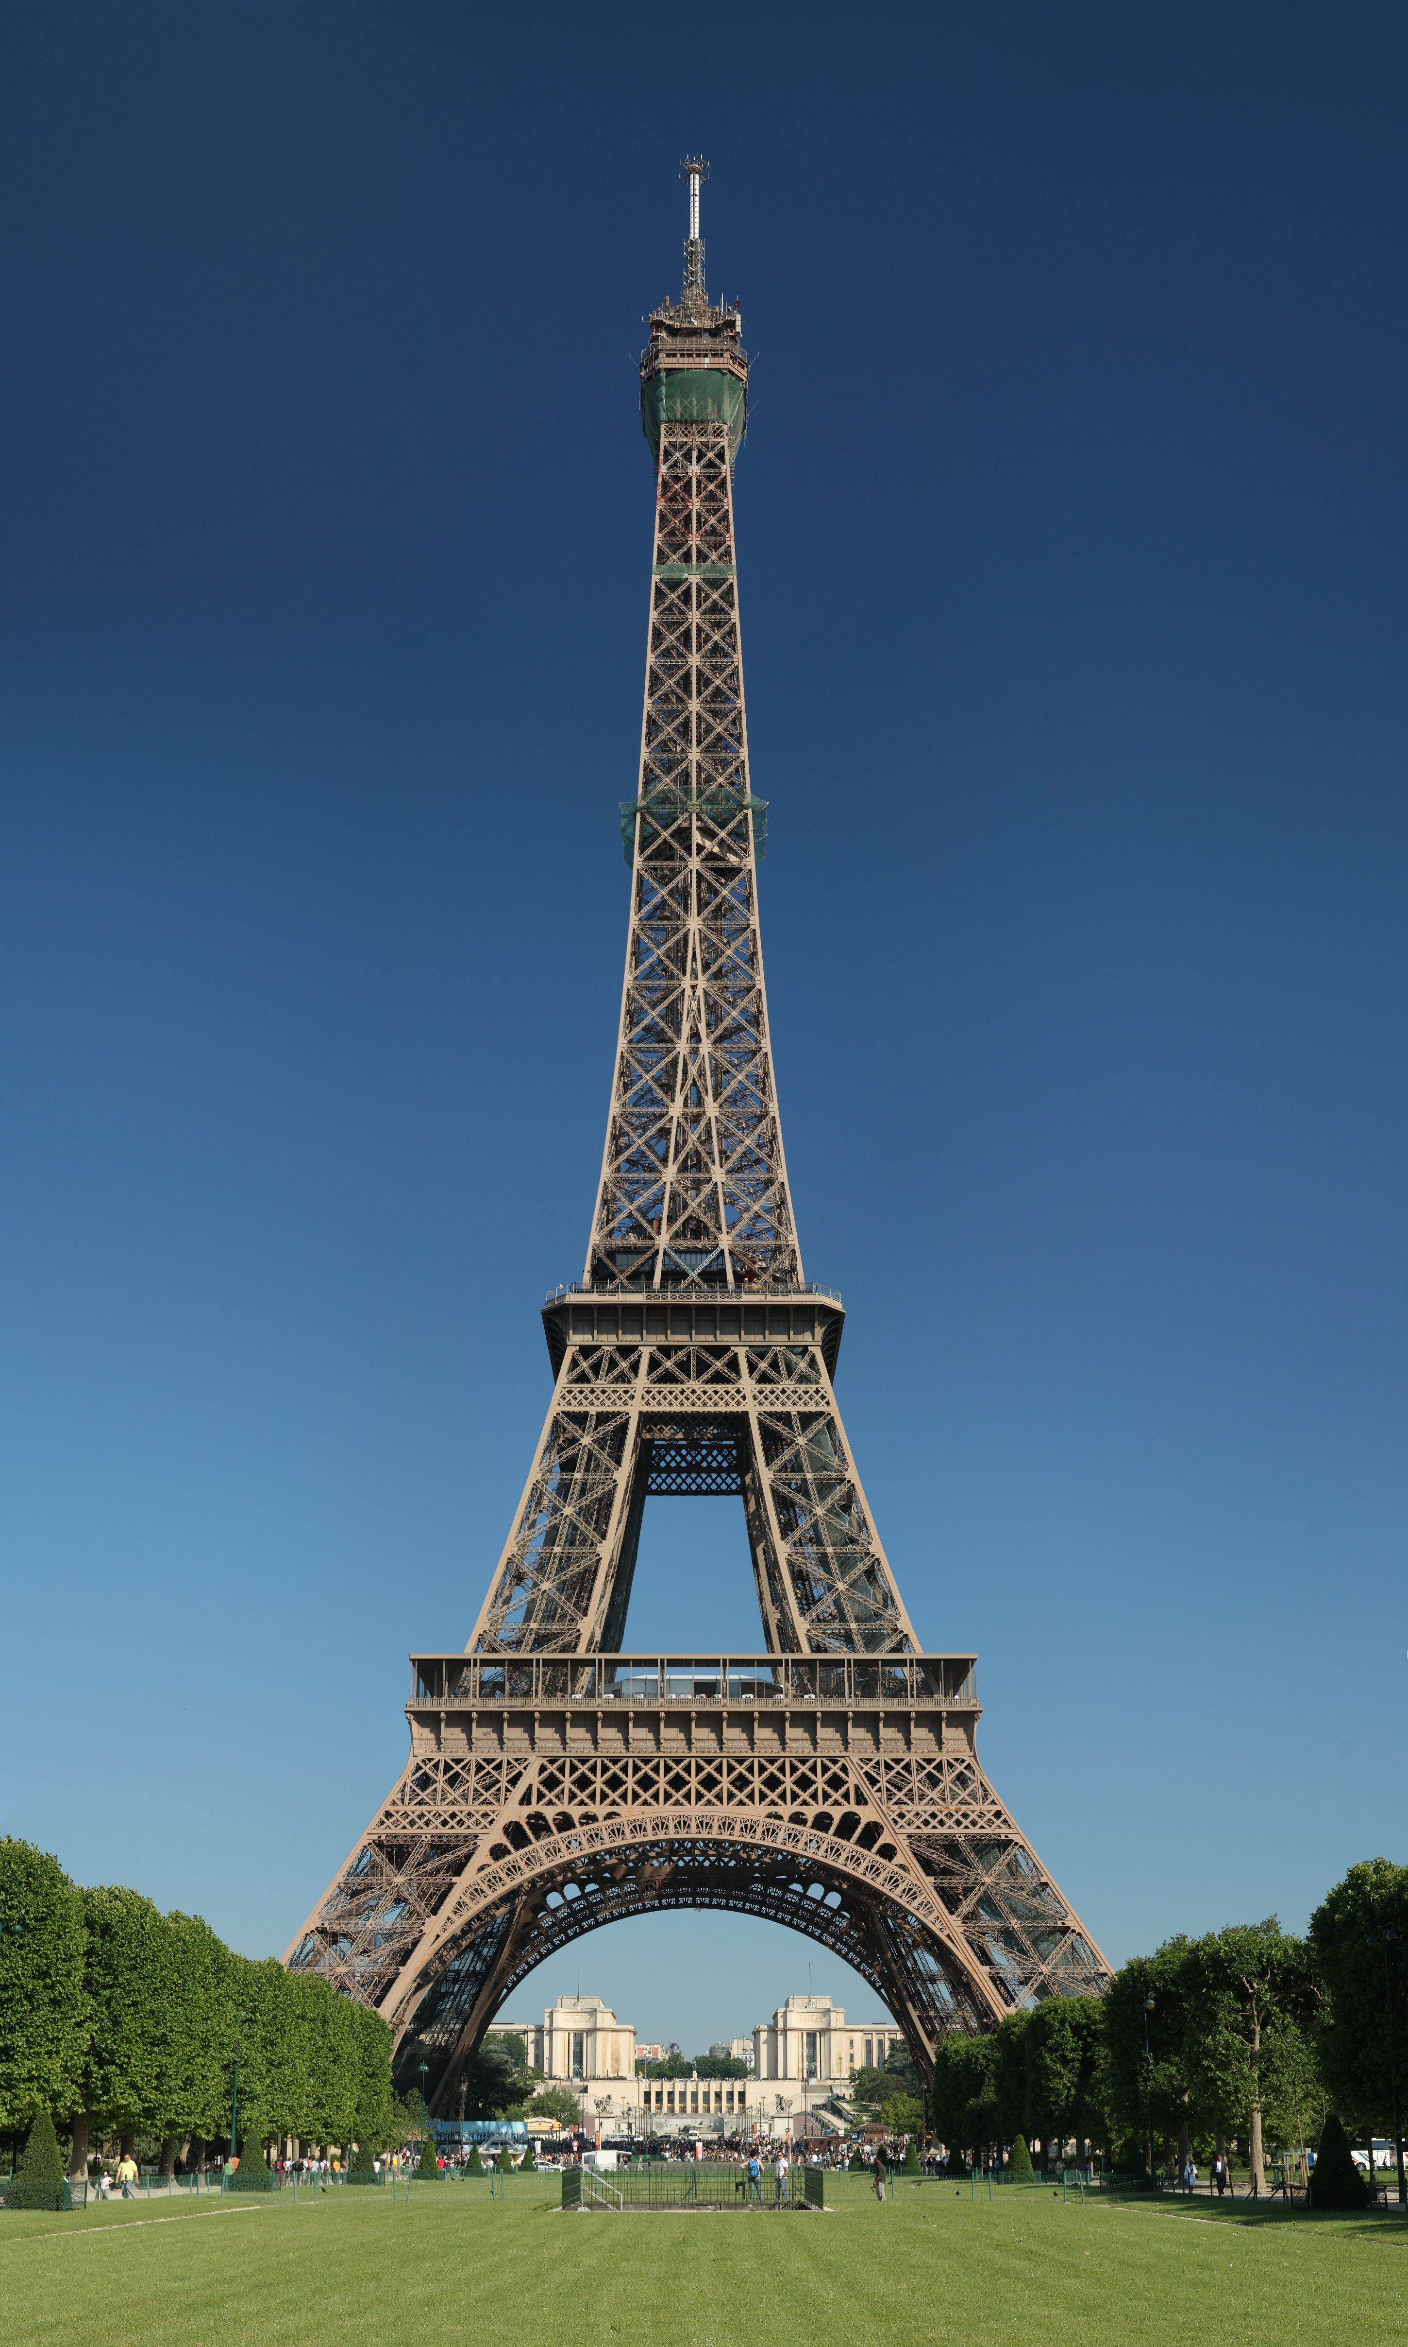

2 Journal About Connections

Student Task Statement
Respond to one of these journal prompts:
- What math did you do today that connected to something you did in an earlier grade?
- Describe something you really understand after today's lesson.
- Describe something that was confusing, challenging, or that you’d like to learn more about.
© CC BY 2021 Illustrative Mathematics®

